**Course 4:**

CLOUD MANAGEMENT

**CONTENTS**

|  |  |  |  |
| --- | --- | --- | --- |
| **SR.**  **NO.** | **PRACTICAL TITLE** | **DATE** | **SIGNATURE** |
| 01 | Managing Hyper-V Environment with SCVMM 2012 | 31-01-2017 |  |
| 02 | Provisioning Self-Service with AppController | 14-02-2017 |  |
| 03 | Managing Private Cloud with AppController | 23-02-2017 |  |
| 04 | Using Data Protection Manager for Backup and Recovery | 28-02-2017 |  |
| 05 | Using Operations Manager for Real-time Monitoring | 10-03-2017 |  |
| 06 | Using Advisor for Proactive Monitoring | 14-03-2017 |  |
| 07 | Using Service Manager to Standardize | 21-03-2017 |  |
| 08 | Using Orchestrator for Automation | 24-03-2017 |  |
| 09 | Implement Windows Azure Pack | 25-03-2017 |  |
| 10 | Using Configuration Manager 2012 for Managing and Maintaining | 05-04-2017 |  |

**PRACTICAL NUMBER** ➔ **1**

**MANAGING HYPER-V ENVIRONMENT WITH SCVMM 2012**

**Pre requisites** needs to be installed for **SCVMM 2012**. They are -

1. Adding Roles and Features, renaming local server, turning off firewall
2. Domain Creation (with Administrator login)
3. Install and configure SQL Server 2012
4. ADK-9600 (it’s a Windows Toolkit)
5. Creating user in Active Directory Users and Computers
6. Creating object in ADSI Edit

Follow the steps shown in the below screenshots for detailed installation of Pre-requisites and SCVMM installation.

# Step 1: Roles and Features

To add the required roles and features go to **Server Manager**. In left pane select **Dashboard**

(default), in the right pane click on **“Add roles and features”**.

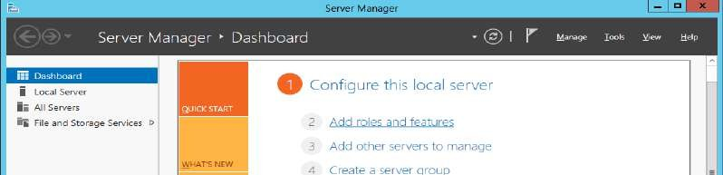

At the **Add Roles and Features Wizard** window, at the first screen click on **“Next”** button.

In the next step select **“Role-based or feature-based installation”** option and click on **“Next”**

button.

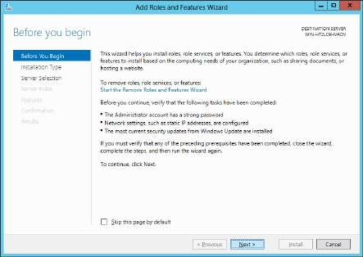 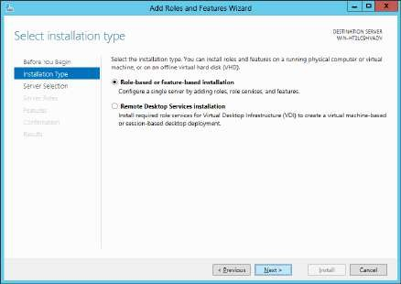

At the **Select destination server** step keep the default selections and click on **“Next”** button.

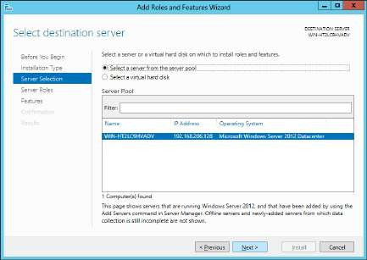

At the **Select server roles** screen click on the **“Active Directory Domain Services”** and click on **“Next”** button. Then click on the **“Add Features”** button at the confirmation step.

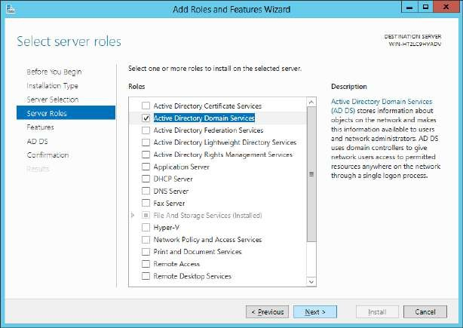 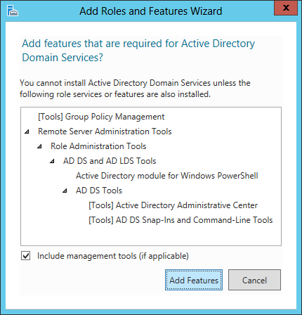

At the **Features** screen click on the **“.NET Framework 3.5 Features”** and **“Group Management Policy”** and click on **“Next”** button.

At **AD DS** step click on **“Next”** button.

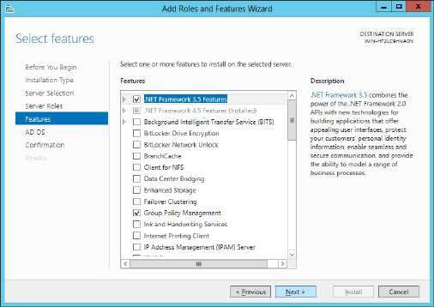 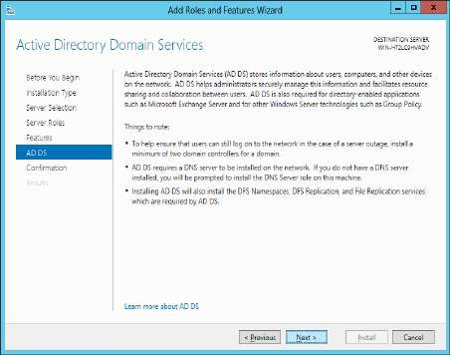

At the **Confirmation** step all the roles and features are listed that was selected to install. Click on **“Install”** button. After the installation is complete **“Close”** the **Add Roles and Features Wizard**.

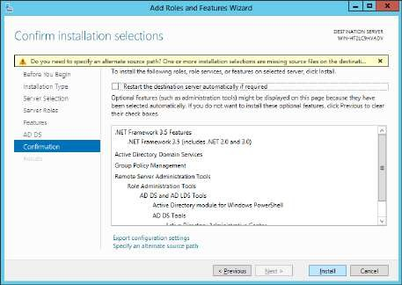 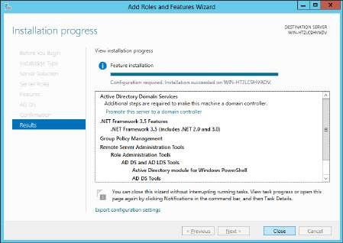

# Step 2: Change Server name and turn Firewall off

Now at **Server Manager** go to **Local Server** in the left pane. Here the Server (Computer) name, domain, firewall, etc. details are available. Click on the **Computer name’s** value.

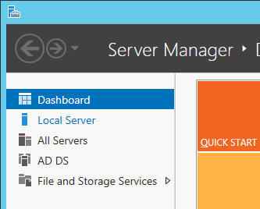 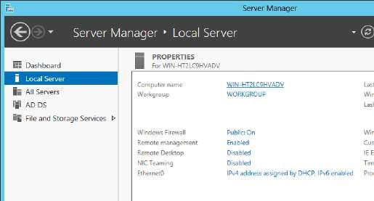

In **System Properties** window click on the **“Change”** button to **rename** the Computer (Server) name.

At the **Computer Name/Domain Changes** window enter a name for your computer. Here it is,

**“WINSERVER2012”**. Click on **“OK”** button.

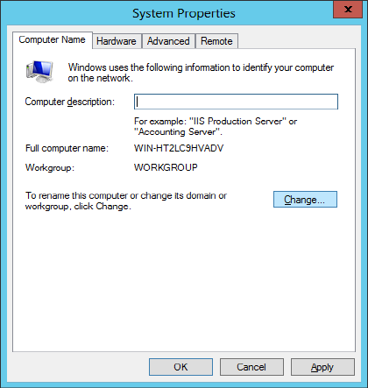 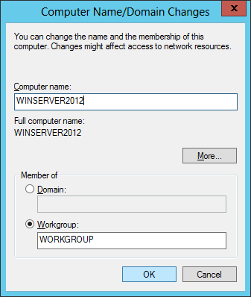

Then click on **“Apply”** button at the **System Properties** window.

At **Server Manager**, in **Local Server** click on **Windows Firewall** value **“Public: On”**.

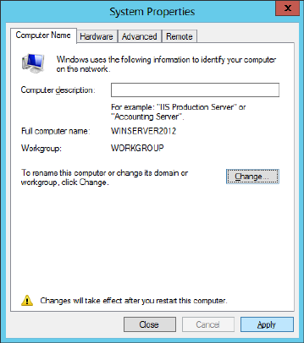 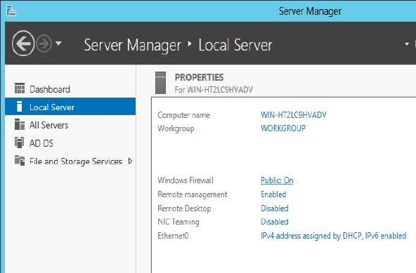

At the **Windows Firewall** window click on **“Turn Windows Firewall on or off”**. **Turn Off the private and public firewalls** and click on **“OK”**.

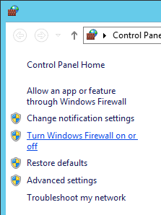 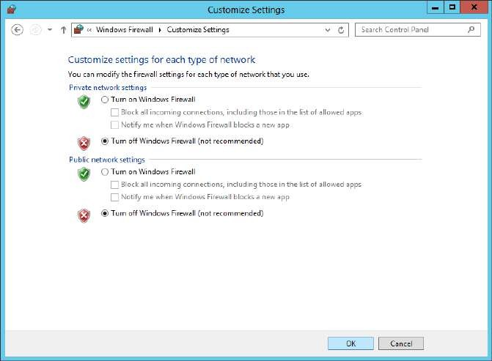

***Note: Restart*** *your Server (Windows Server 2012 VM) and sign in as* ***“Administrator”*** *(administrator login needed for domain creation and further all the components (SCVMM, SCAC, SCDPM, SCOM, SCA, SCO, SCSM, SCCM) installation needs Administrator login) enter a password and keep this* ***password common for all further account/group/user*** *creation which will help remember the password.*

# Step 3: Domain Creation (Administrator login is needed):

After the restart open **Server Manager**. Go to the **Notification flag** as it will be showing a warning sign. There are **two notifications**: one is for **feature installation completion** and second is for **Post-deployment Configuration**. In the Post-deployment configuration notification click on the given link **“Promote this server to a domain controller”**

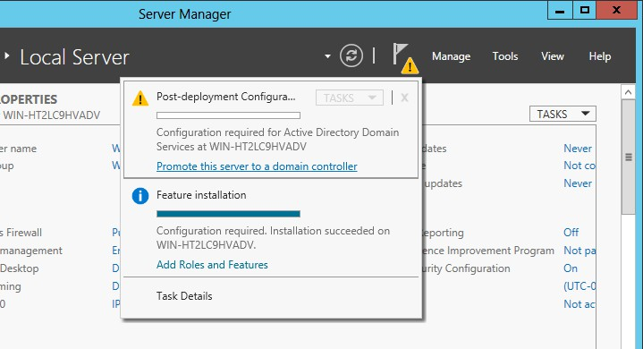

In the **Active Directory Domain Services Configuration Wizard** select **“Add a forest”** option, enter a name for the new domain (here it is, **WINCMDOMAIN1.COM**) [domain name always ends with .com/.org/.edu, etc., here **.com** is preferable] to be created then click on **“Next”** button.

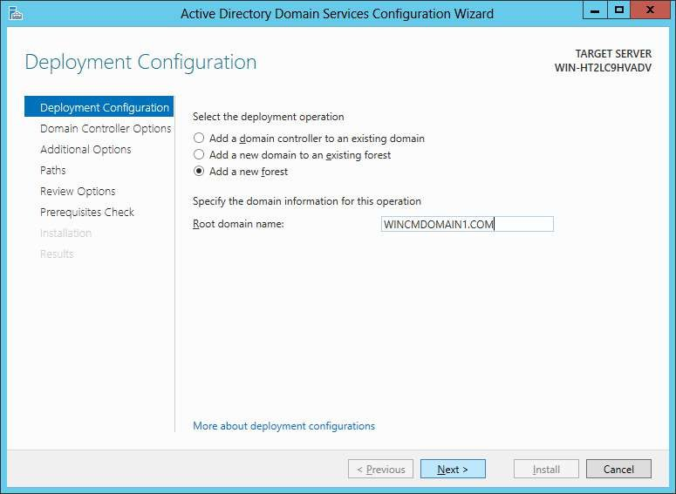

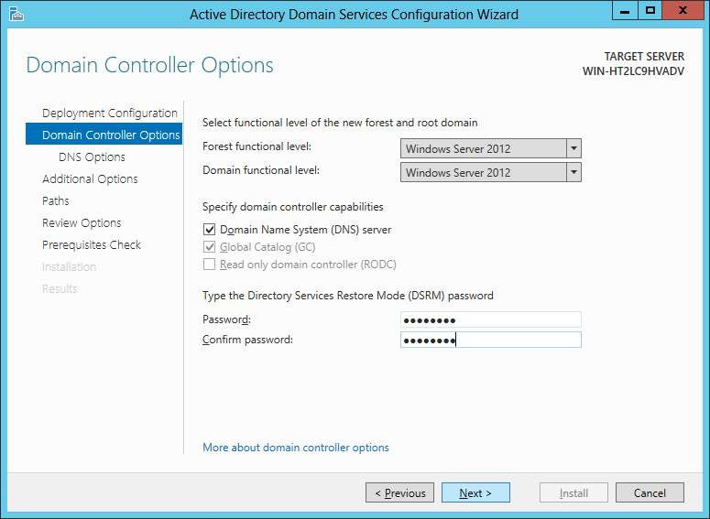In the next step enter a **password** for the domain (keep it same as the administrator password, recommended). Click on **“Next”** button.

At **DNS Options** step just click on **“Next”** button.

At **Additional Options** step keep the **default** changes and click on **“Next”** button.

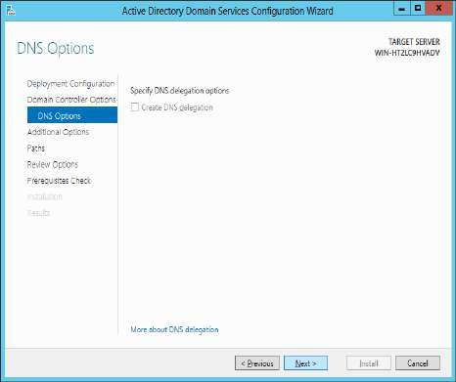 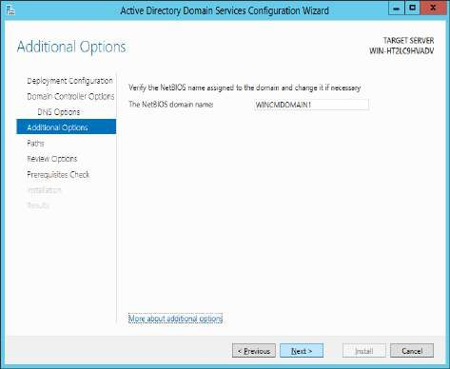

At the next step **paths** to different folders are listed. Click on **“Next”** button. Next is **Review Options** step, here click on **“Next”** button.

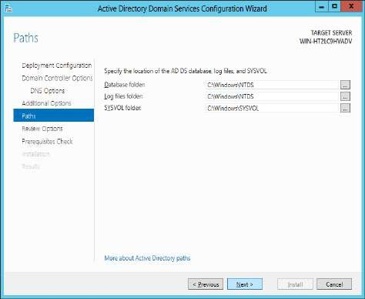 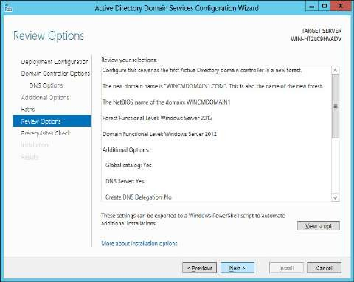

Next step checks for pre-requisites. **It should pass all the pre-requisites check**. Click on

**“Install”** button.

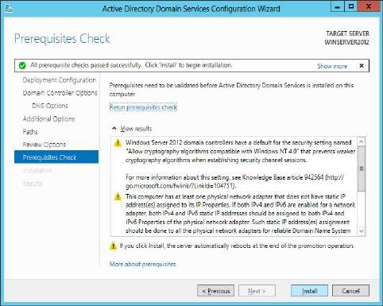 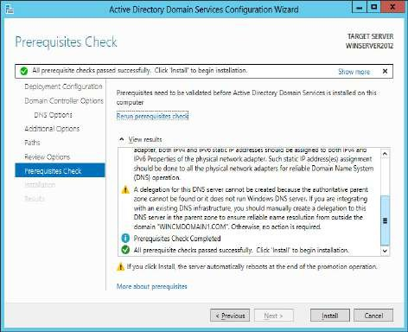

The installation process is time consuming…

**Close** the window after installation.

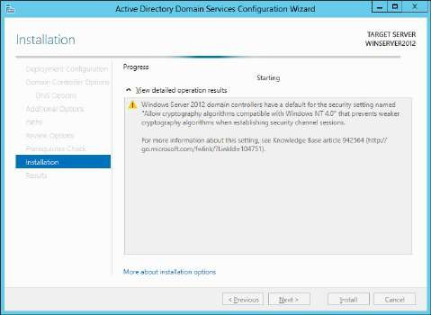 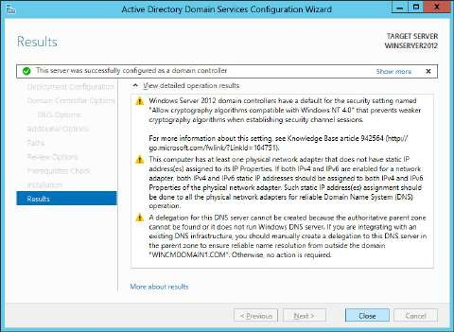

The Server may need to be restarted at this point as the system may get slow. The next installation is SQL Server 2012 which takes long time to be processed. Restarting the system may help reduce the time consumed for this process

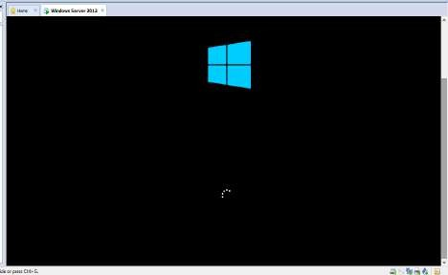 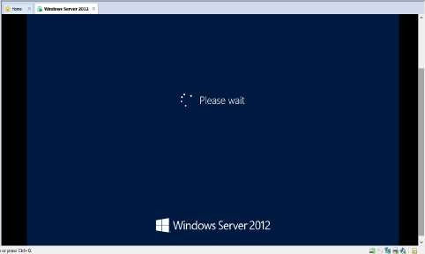

# Log in as Administrator.

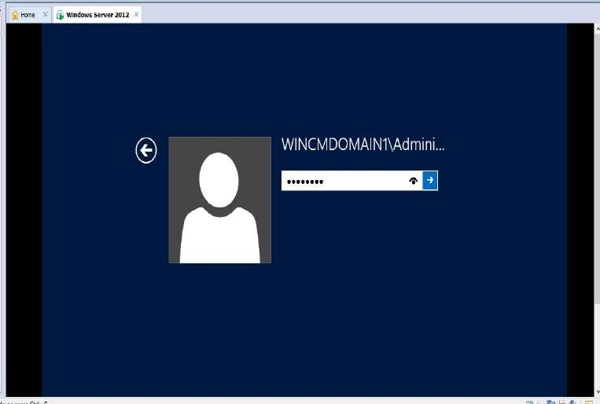

**Step 4: Installing and configuring SQL Server**

Check whether the VMware tools (needed to perform some basic tasks between the **host and the VM directly** such as the **copy-paste operation**.) are installed or not. Go to **VM** menu and check for the option as shown below.

Here it is already showing the option as **"Reinstall VMware Tools..."** that is the VMware tools are already installed. If the tools aren't installed then the option is showed as **"Install the VMware Tools"**. Click on this option to do the installation. Then follow the further steps.

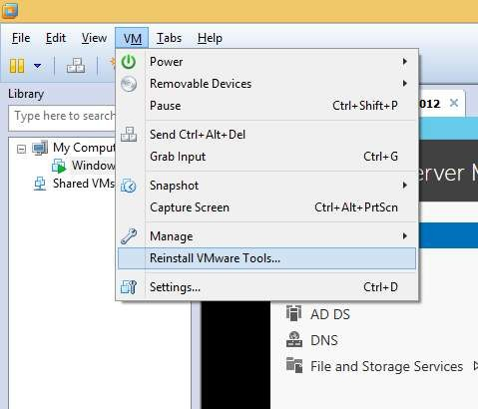

Copy-paste **SQL server .iso** file from host to VM (Windows Server 2012).

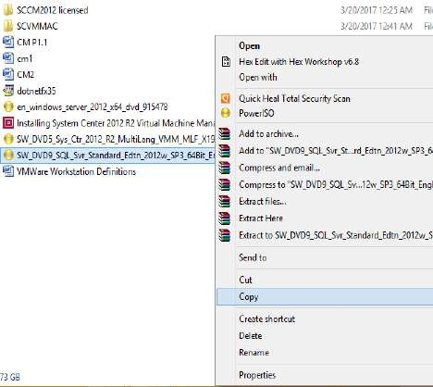 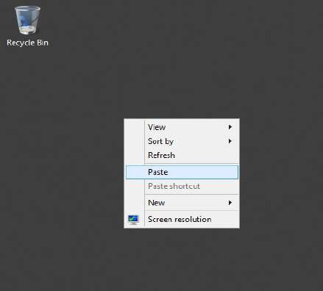

First the ISO file is copied from host to the VMware workstation then to the VM (Windows server 2012)

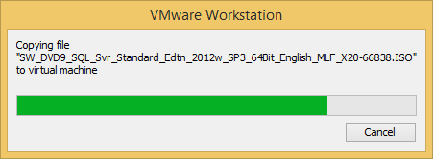 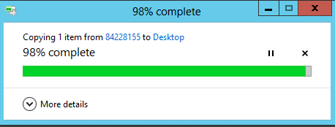

Then right click on the **ISO file** and select **“Mount”** option. The ISO file is opened in **File explorer**. Run the **setup** file.

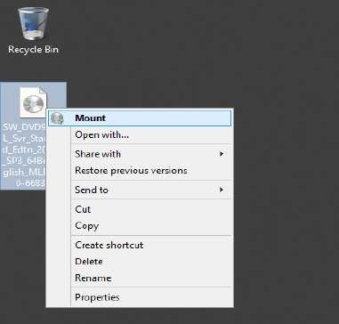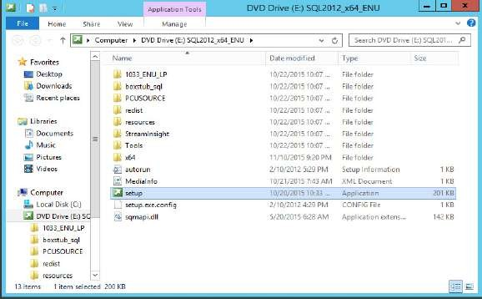

At the **SQL Server Installation Center** window click on Installation step in the left pane. In the right pane click on the first option “New SQL Server stand-alone installation or add features to an existing installation”.

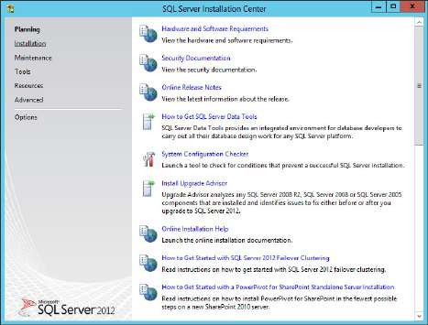 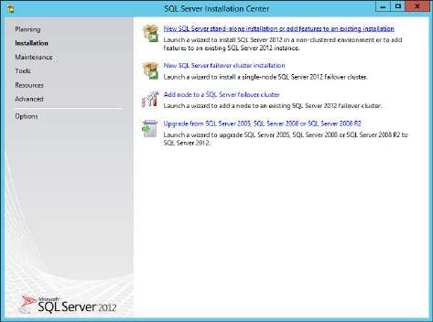

In the **SQL Server 2012 Setup** window setup support files are executed, after completion click on **“OK”** button.

In next step select **“Enter the product key”** option and type a product key in the given textbox. Click on **“Next”**

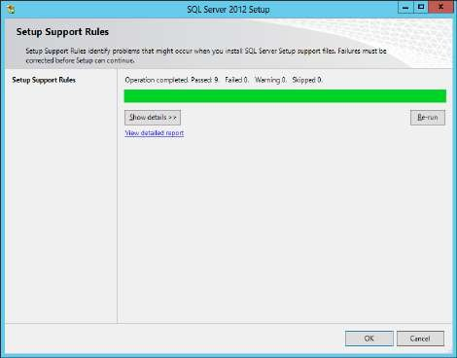 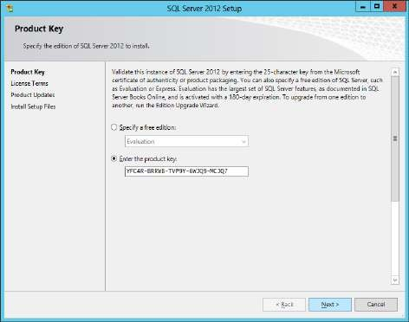

Accept the License Terms and click on **“Next”** button. It then installs the setup files.

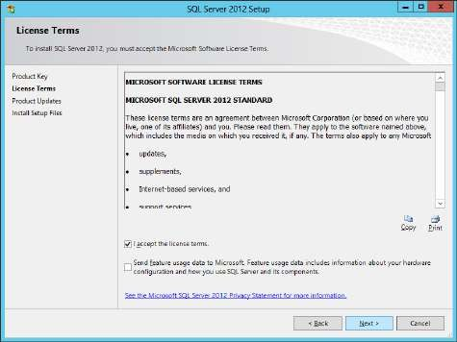 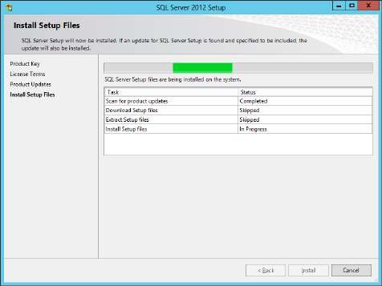

Next it runs the **setup for support rules**. **Status** for the Rules should be **passed or warning**

too is acceptable. Click on **“Next”** button.

In the **Setup Role** step select **“SQL Server Feature Installation”** (default) and click on **“Next”**

button.

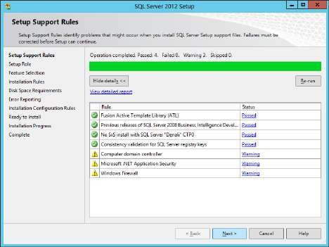 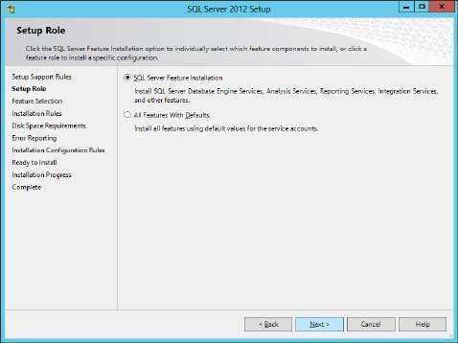

In next step various **features** need to be selected. Such as,

1. Database Engine Services
2. Reporting Services – Native
3. Reporting Services SharePoint
4. Reporting Services Add-in for SharePoint products
5. Client Tools Connectivity
6. Management Tools – Basic
7. Management Tools – Complete
8. Then click on “Next” button.

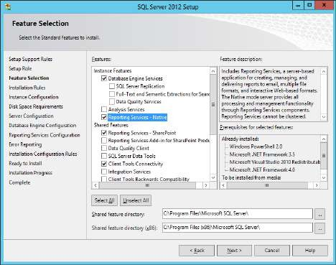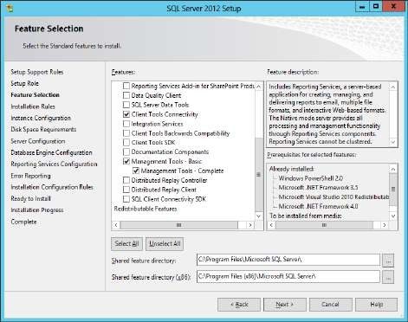

The **Installation Rules** are run, click on **“Next”** button after its completion

At the **Instance Configuration** step select **“Default Instance”** (default), and keep the **Instance ID** default, (note the Instance ID as it is needed later for other components installation and connectivity). The **Instance ID is MSSQLSERVER**. Click on “Next” button

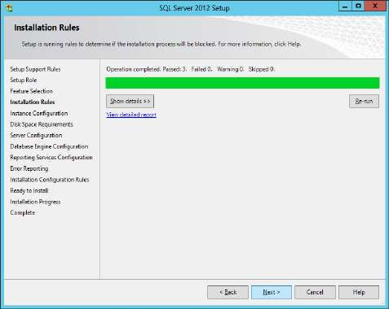 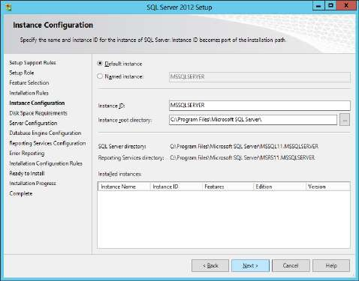

At the **Disk Space Requirements** step just click on **“Next”** button.

At the **Server Configuration** step, under **Service Account** tab keep the default values. Go to

**Collation** tab.

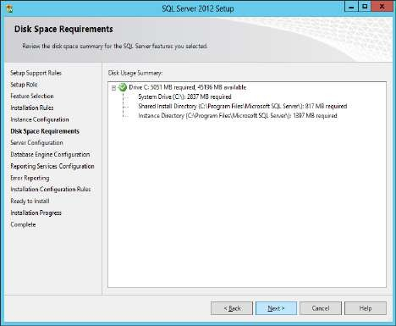 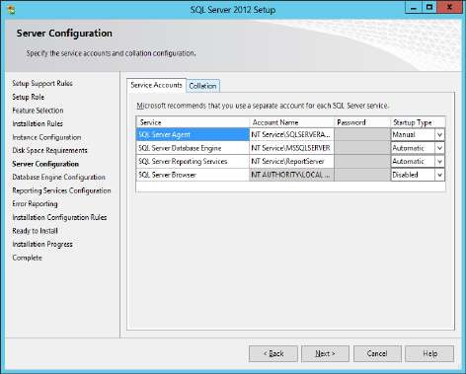

In **Collation** tab click on **“Customize”** tab.

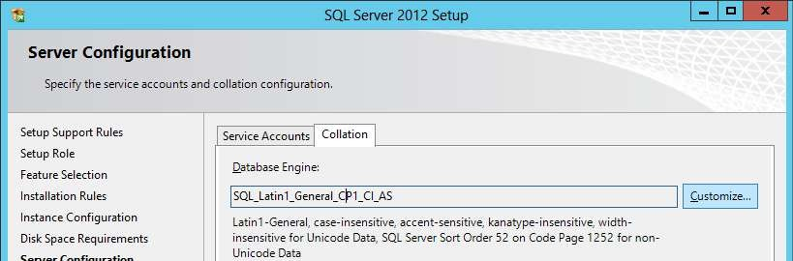

In **Customize the SQL Server 2012 Database Engine Collation** window, select the option **“SQL_Latin1_General_CP437_CI_AS”** under **SQL Collation, used for backwards compatibility**. Then click on **“OK”** button.

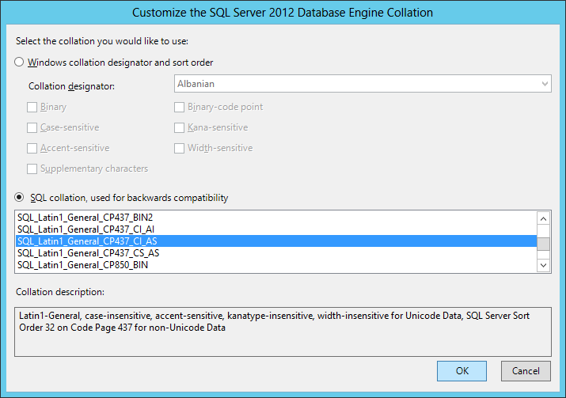

At the **Server Configuration** step then click on **“Next”** button

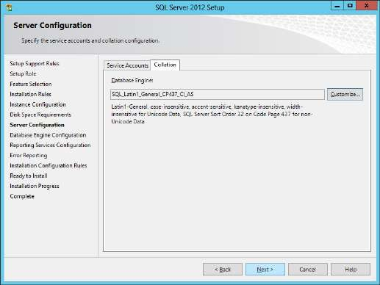

At **Database Engine Configuration** step click on **“Add Current User”** button.

It adds the **Administrator** user (displayed with domain name). Click on **“OK”** button.

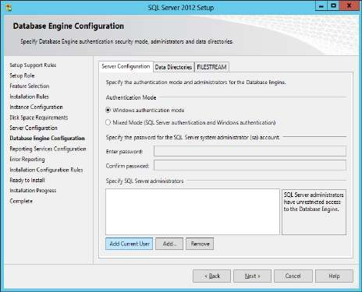 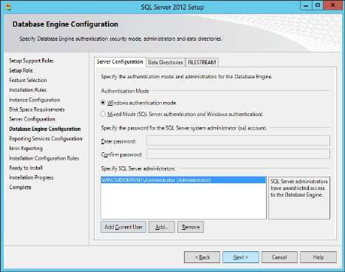

At the **Reporting Services Configuration** step select **“Install and configure”** for **Reporting Services Native Mode** and **“Install only”** for **Reporting Services SharePoint Integrated Mode**. Click on **“Next”** button.

At **Error Reporting** step click on **“Next”** button.

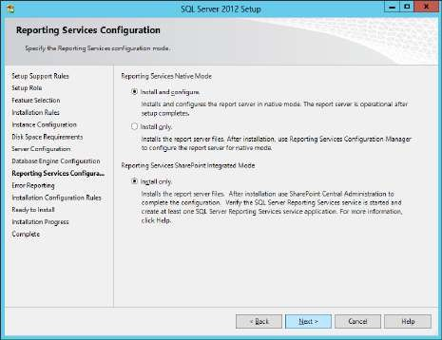 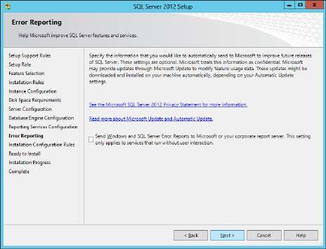

The **Installation Configuration Rules** are run. The next step is **Ready to Install** step, click on

**“Install”** button.

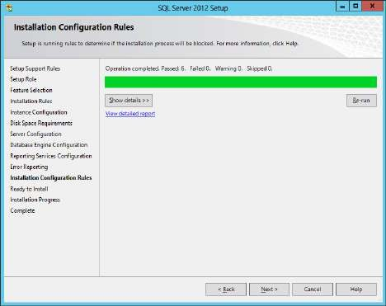 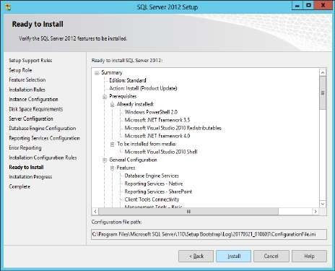

At **Completion** step all the features are installed successfully. **Close** the setup wizard.

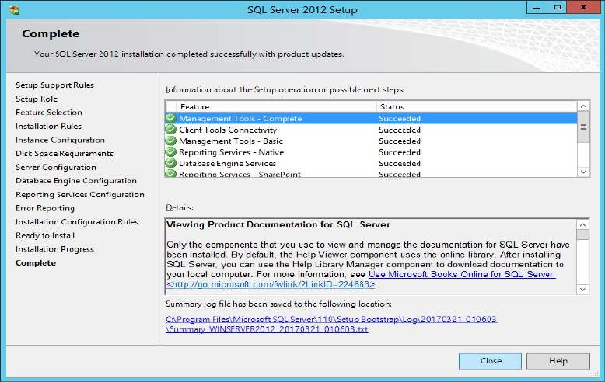

# Step 5: Extracting and Installing ADK-9600 (Windows toolkit for Windows 8.1)

Copy the ADK-9600.rar file from the host and paste it in the VM server.

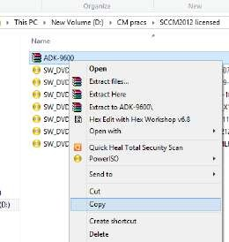 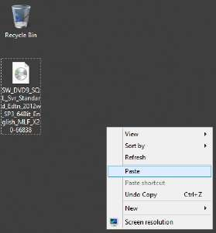 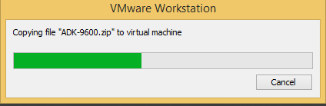

Right click on the **ADK-9600.rar** file and select **“Extract All”** option. Click on **“Extract”** button at the **Extract compressed (Zipped) Folders**.

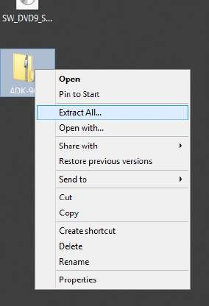 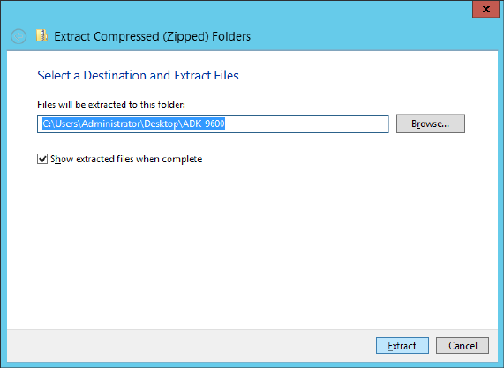

After the extraction run the **“adksetup”** setup file

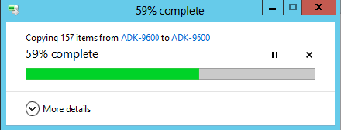 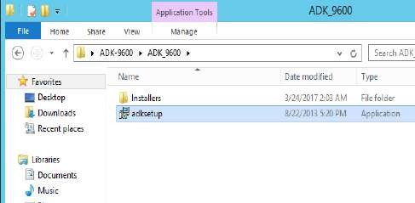

At the **Windows Assessment and Development Kit for Windows 8.1** window keep the default location and click on **“Next”** button.

In next step select **“No”** and click on **“Next”** button.

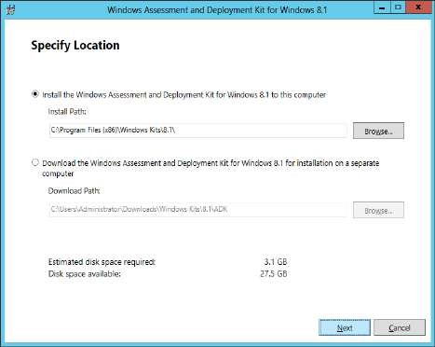 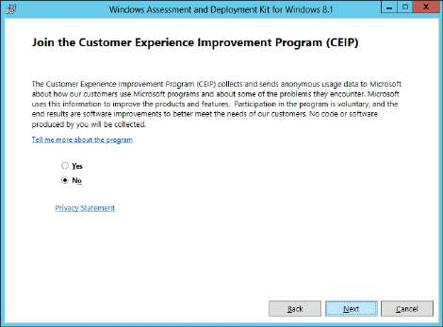

At **License Agreement** screen click on **“Accept”** button. At the **feature selection** step select the following features:

1. Deployment Tools
2. Windows Preinstallation Environment (Windows PE)
3. 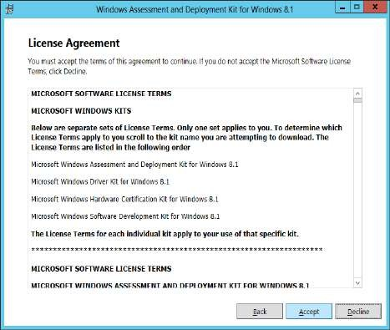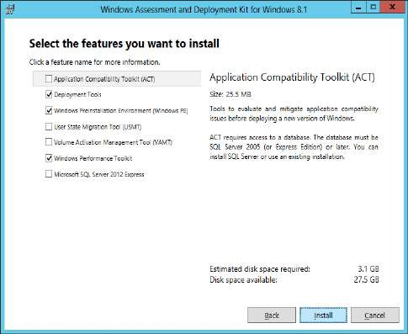Windows Performance Toolkit Click on **“Install”** button.

After the installation is complete close the installation wizard.

# Step 6: Creation of User

Launch **Server Manager**. Go to **Tools**→**Active Directory Users and Computers**.

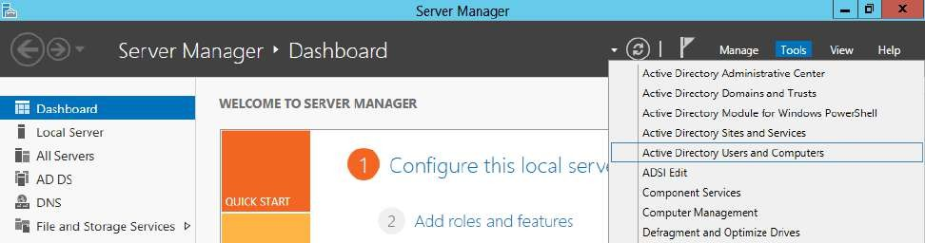

At the **Active Directory Users and Computers** window, in the left pane **expand the domain** that was created earlier in this practical. In that right click on **Managed Service Accounts** and select **New**→**Use**r option.

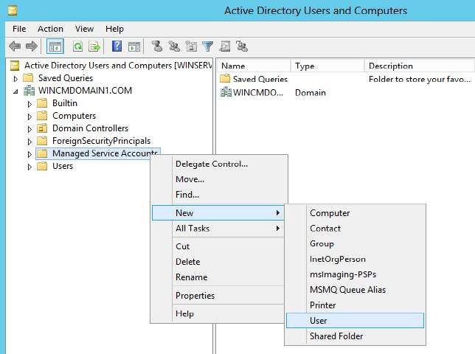

At the **New Object - User** window enter a name for the new use (here it is **VMMService**), enter a user logon name and click on **“Next”** button

In the next step it asks for a password for the user and an option **“User must change password at next login”** is selected

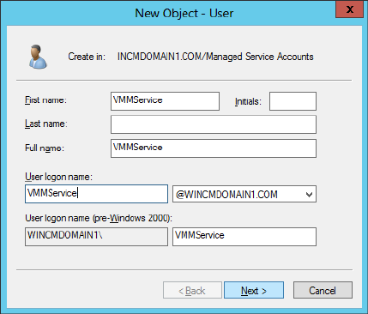 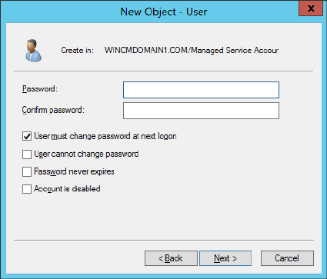

Enter the **password** (same as other passwords), select **“Password never expires”** option and click on **“Next”** button.

At last screen click on **“Finish”** button.

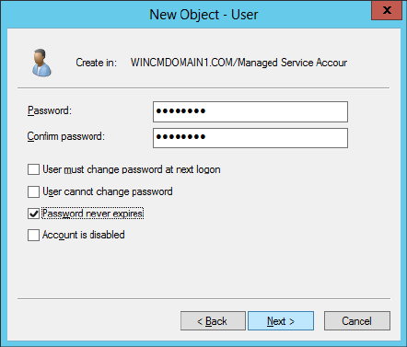 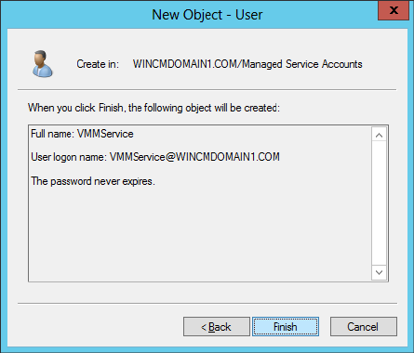

The **“VMMService”** user is listed at the main window of **Active Directory Users and Computers**.

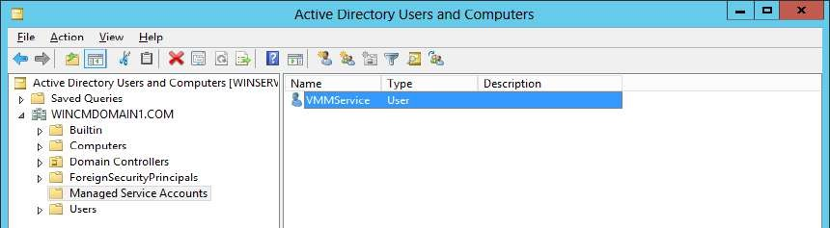

**Right click** on user and select **“Add to a group”** option.

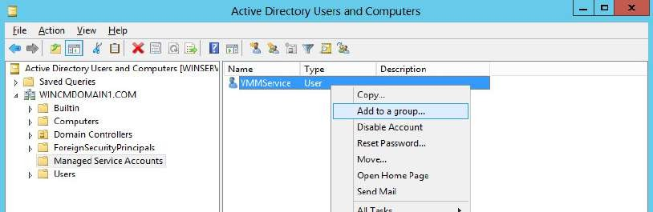

At the **Select Groups** window type the initial letters of Administrators user and click on **“Check Names”** window. The **“Administrators”** user is displayed, click on **“OK”** button.

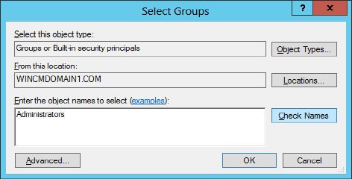 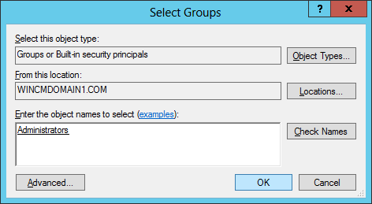

The user is added to the group. Close Active Directory Users and Computers window.

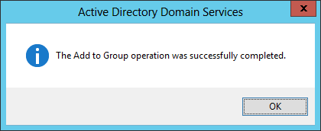

# Step 7: Connecting SQL Server to Windows Server 2012 (system server)

Launch SQL Server Management Studio.

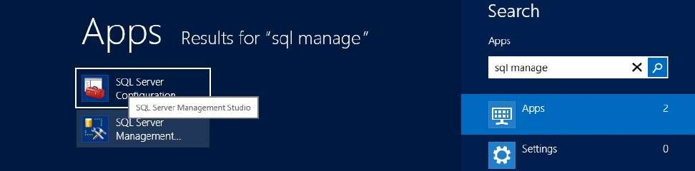

At the **MS SQL Server Management Studio (Administrator)** application, in the **Connect to Server** window check the server name, it should be your system name. Click on **“Connect”** button.

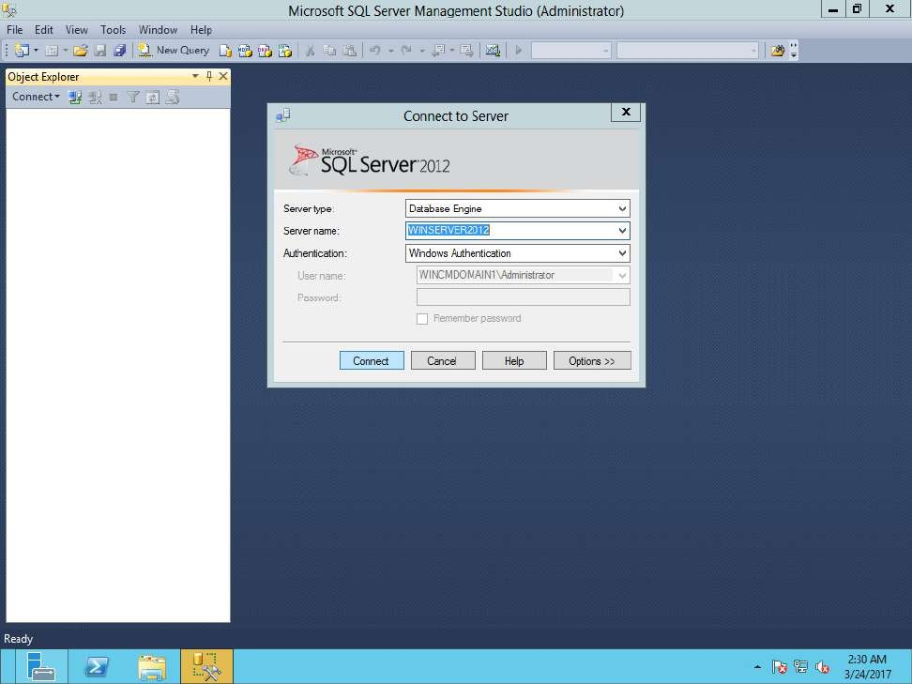

In **Object Explorer** go to **Security**→**Logins**→**New Login…**

At the **Login – New** window click on **“Search”** button.

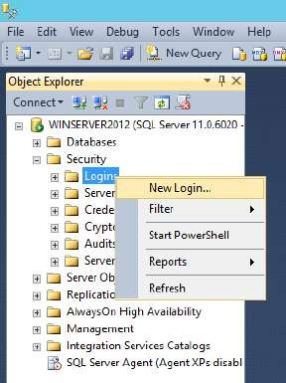 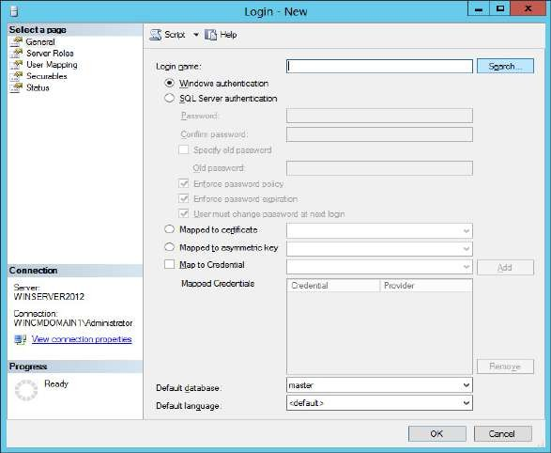

At the **Select User** window type the user that was created in the **Active Directory Users and Computers** and click on **“Check Names”** window.

The **username with the domain name** to which it belongs is displayed and click on **“OK”** button.

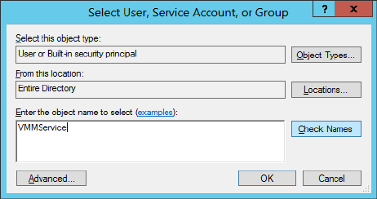 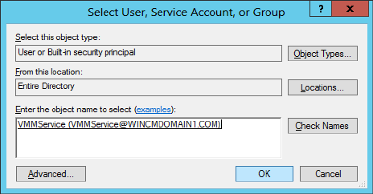

In **Server Roles** step **public** is selected by default. Select three more roles: **dbcreator, processadmin** and **securityadmin**. Then click on **“OK”** button.

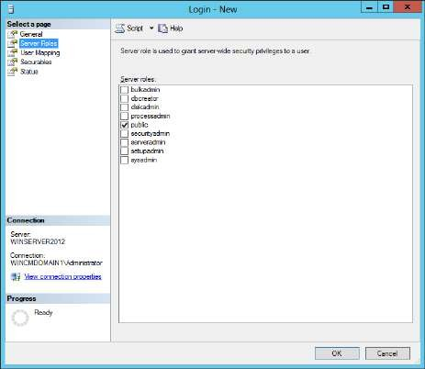 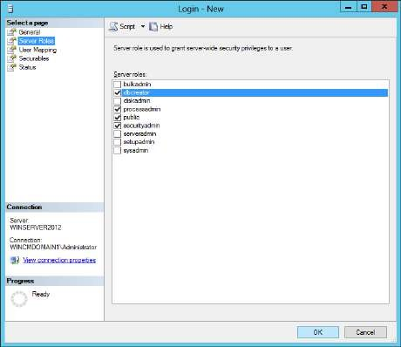

# Close SQL Server Management Studio.

**Step 8: Creating object in ADSI Edit**

In **Server Manager** go to **Tools**→**ADSI Edit**

At the **ADSI Edit** window go to **Action**→**Connect to…**

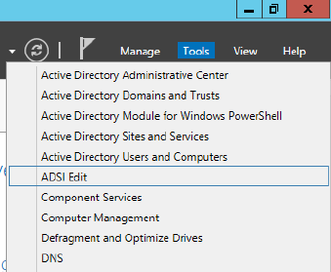 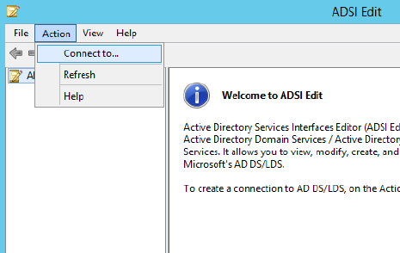

At the **Connection Settings** window keep the default settings and click on **“OK”** button.

At **ADSI Edit** window expand **Default naming context** by double clicking on it in the left pane.

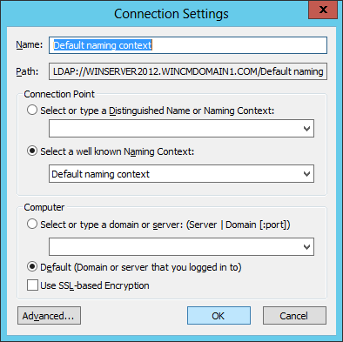 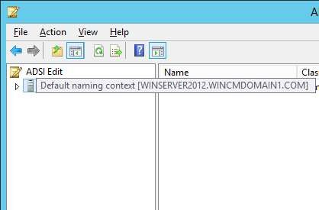

In the left pane under **Default naming context** your domain is listed as **“DC=domainname…”**

Right click on it, select **New**→**Object…** option

At the **Create Object** window select the **“container”** class and click on **“Next”** button.

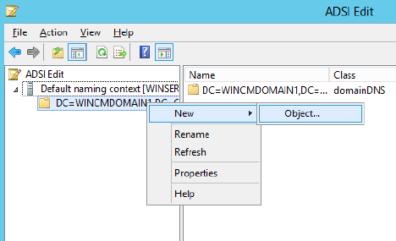 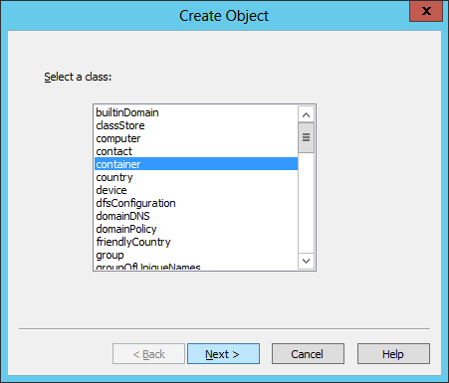

Enter the value for the object. (here it is, **VMMObjectContainer**). Click on **“Next”** button. At the Final window click on **“Finish”** window.

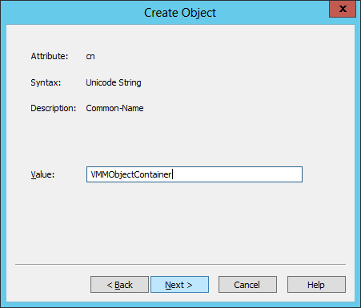 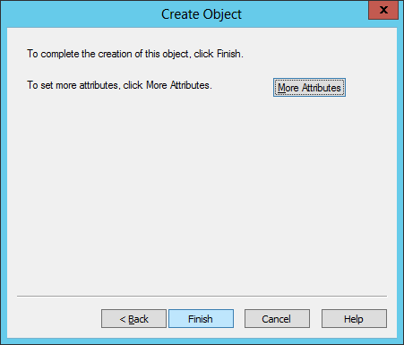

At the ADSI Edit double click on **"DC=domainname,DC=com"**

In the middle pane the objects are listed. Select the object that you just created. **Right click** on it and select **Properties** option.

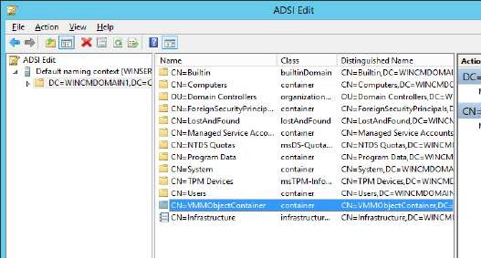 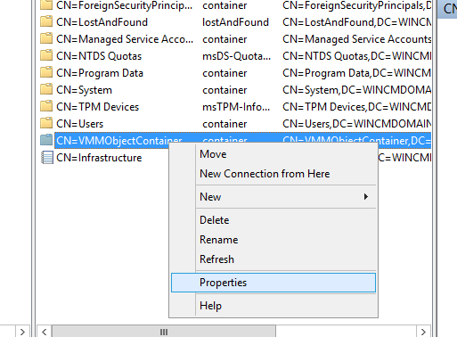

At the **Properties** window of the object select the **distinguishedName** attribute and click on **“View”** button. At the **String Attribute Editor** screen copy the **Value** content *(and keep it saved as it will be needed during SCVMM installation)*. Click on **“OK”**, **close ADSI Edit** window

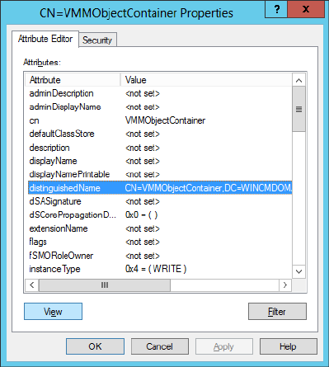 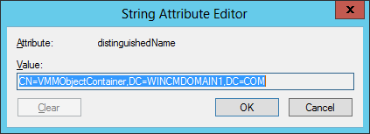

# Step 10: SCVMM setup

{The **distinguishedName** of object created in ADSI Edit (my system’s): CN=VMMObjectContainer,DC=WINCMDOMAIN1,DC=COM}

Copy the **ISO file of VMM** from the host system and paste it in the VM (Windows Server 2012)

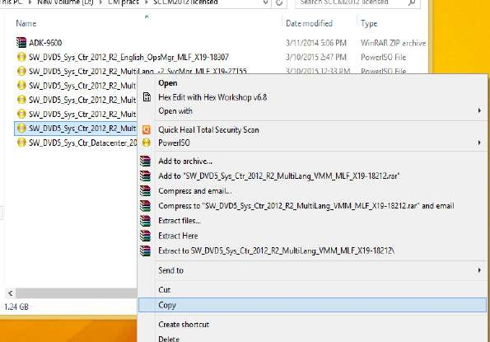 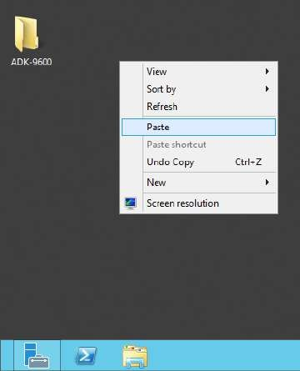

Then right click and **mount the VMM ISO file**. Then **run the setup** file.

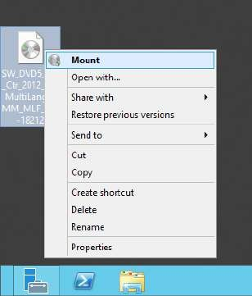 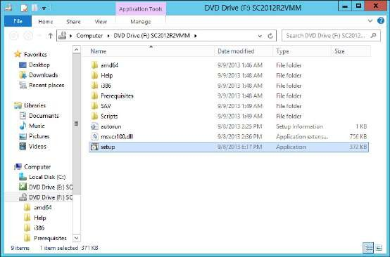

Click on **“Install”**

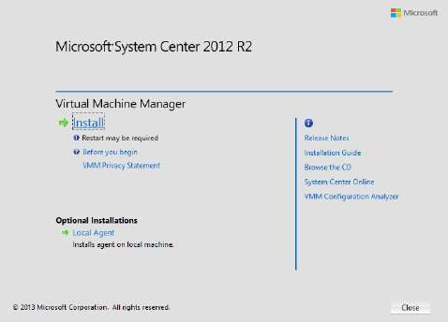 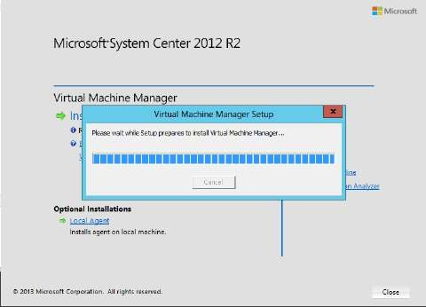

At the first screen select **“VMM management server”** option (the **“VMM console”** gets selected automatically) and click on **“Next”** button.

Don’t enter any product key, just click on **“Next”** button. *(It works for 180 days on trial)*

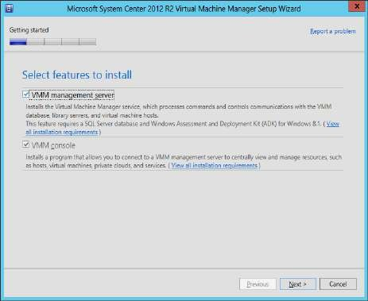 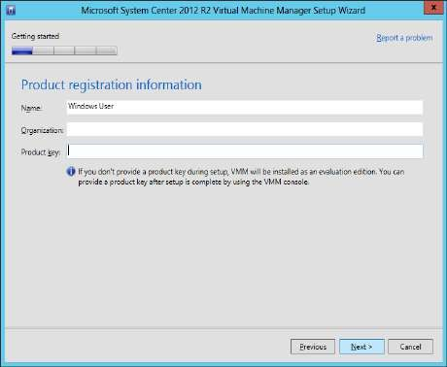

**Select the checkbox** below the license terms and click on **“Next”** button. For **CEIP** step select **“No…”** option and click on **“Next”** button.

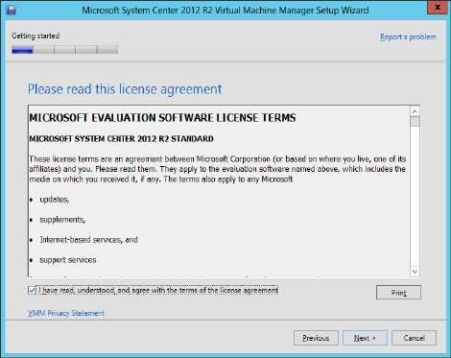 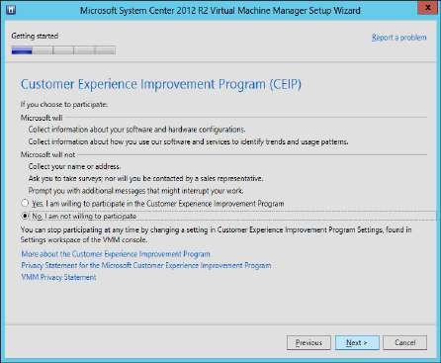

For the **Microsoft Update** select **“Off”** and click on **“Next”** button. Keep the **default** location for installation and click on **“Next”** button.

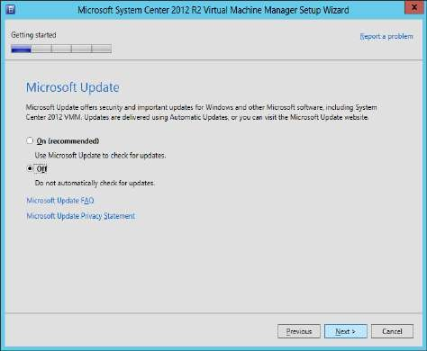 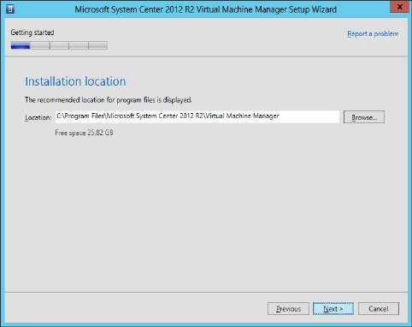

The screen shows **prerequisite warnings**. The warnings can be **passed**, if there is an **error it has to be solved** and then the installation should be continued, click on **“Next”**

Next step is for Database Configuration. The Server name is displayed by default. It is your server’s (system’s) name. Other details should be filled manually.

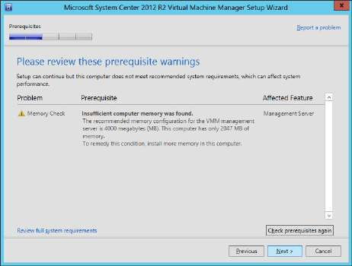 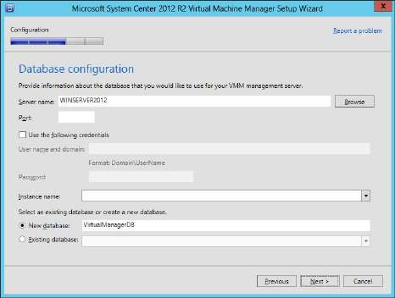

Select the **“Use the following credentials”**. Enter the **username** (that was **created in Active Directory Users and Computers** and later configured it in the SQL Server under Security→Logins) with domain, enter the password for that user. Enter the Instance name of the SQL server that was configured, by default the instance name is **MSSQLSERVER** while the installation of SQL Server. (We continued with the default settings in SQL Server at instance creation step). The Instance name remains same as **“MSSQLSERVER”**. Click on **“Next”**

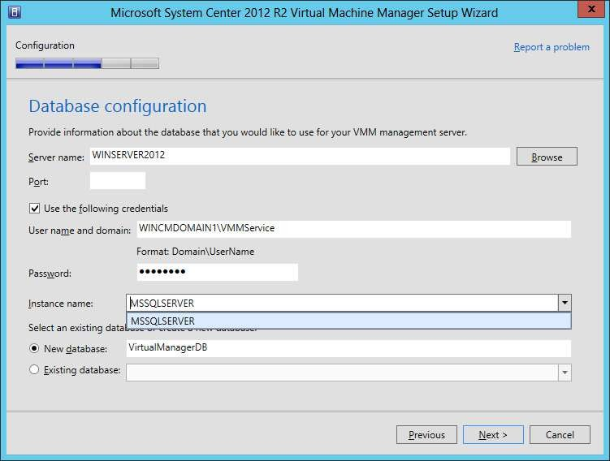

The next step is for **service account configuration and distributed key management**. Select the **“Domain account”** option, enter the username with domain name as shown in below screenshot.

Select the **“Store my keys in Active Directory”**, and enter the **distinguishedName** (that was earlier copied and saved) value of the **VMMService** (user created in Active Directory Users and Computers) in the text box provided at the bottom of the screen. (Here **distinguishedName: CN=VMMObjectContainer,DC=WINCMDOMAIN1,DC=COM**) Click on **“Next”** button.

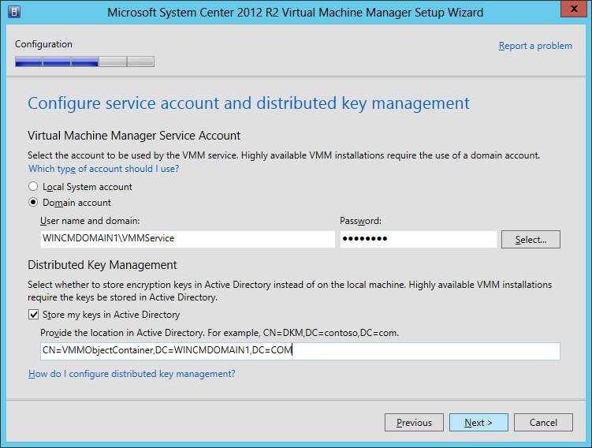

Next step it **port configuration**. Keep the **defaul**t settings and click on **“Next”** button.

Next step is for **Library configuration** VMM **creates** its own library. Just click on **“Next”** button

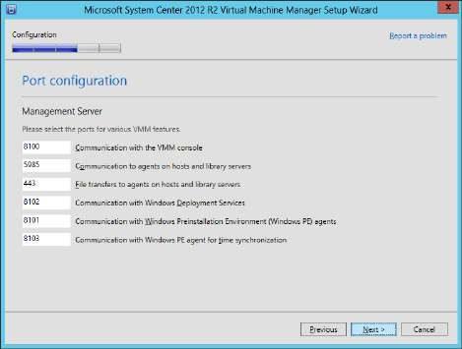 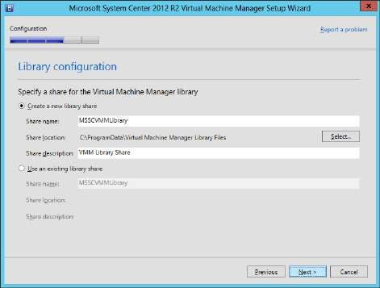

At the **Installation Summary** screen click on **“Install”** button. After installation click on **“Close”** button.

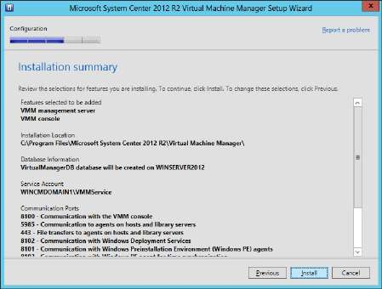 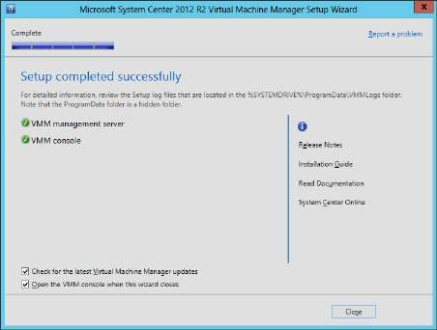

At **VMM’s Connect to Server** window select **“Specify credentials”** option. Enter the **Administrator username with the domain name** and give the administrator **password**. Click on **“Connect”** button.

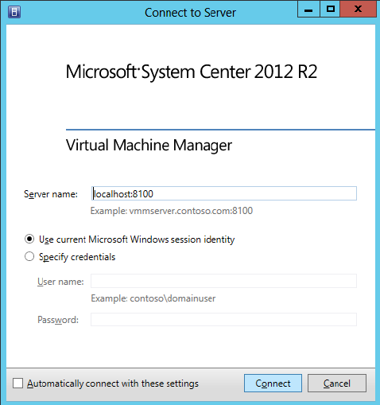 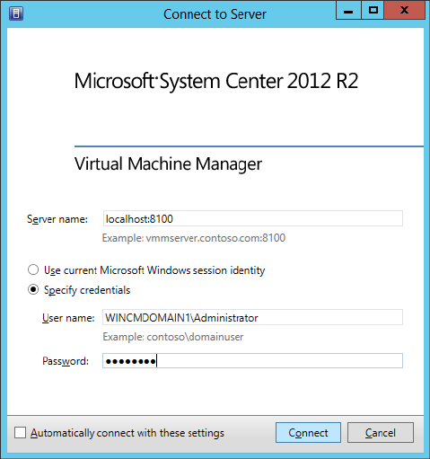

It may take few minutes to process and start the VMM…

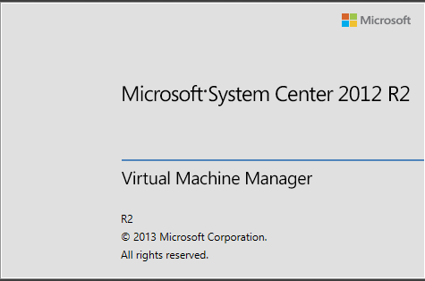

The main window of Virtual Machine Manager (VMM) looks like…

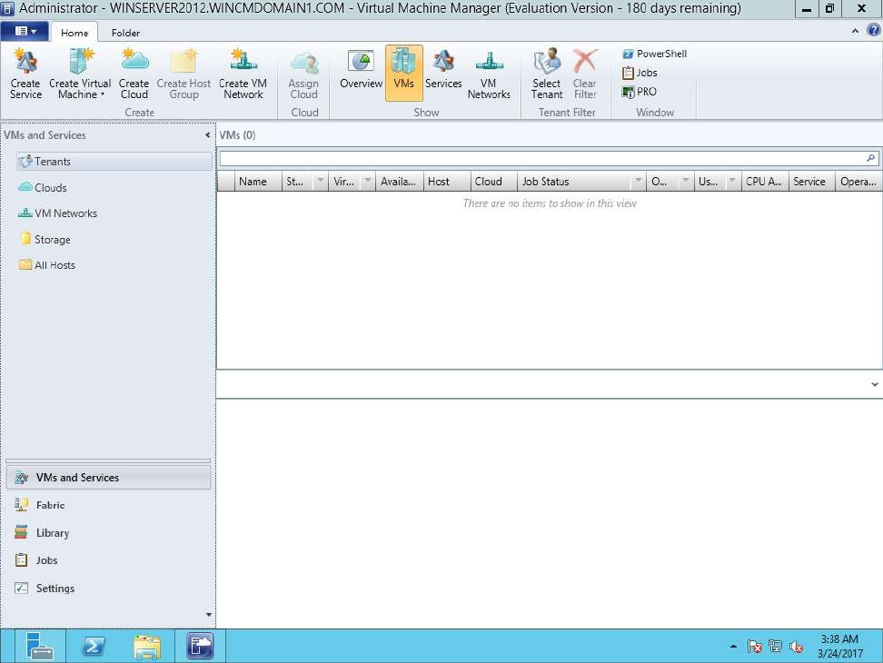

# Step 11: Managing Host Group in VMM

In VMM go to **Fabric** in the left bottom pane, then the top left pane lists available options under Fabric. There go to **Servers**→**All Hosts** (there are no hosts). To create a host group **right click** on All Hosts and select **“Create Host Group”** option.

By default the new group’s name is **“New host group”**. Give a name to suit the group (here it is, **“HOST_GRP1”**).

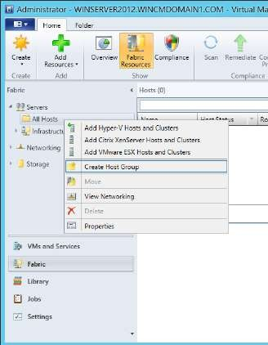 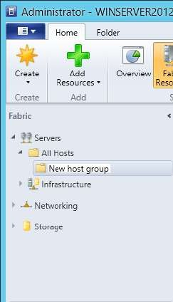 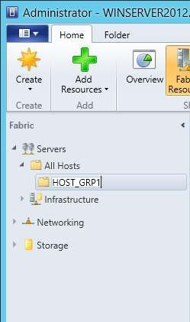

# Step 12: Create VM template

To create a new VM template go to Library in the left bottom pane and in the VHD tab click on “Create VM Template”.

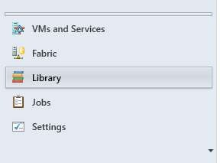 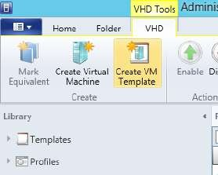

At the **Create VM Template Wizard** window enter a name for the VM template. Click on **“Next”**

button.

In next step, in compatibility select **Hyper-V**, for memory enter the value as **128MB** (default is

**512MB**) and click on **“Next”** button.

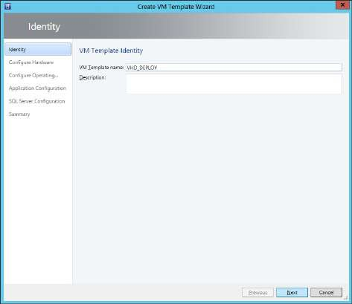 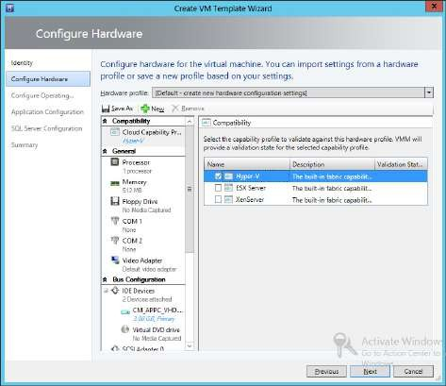

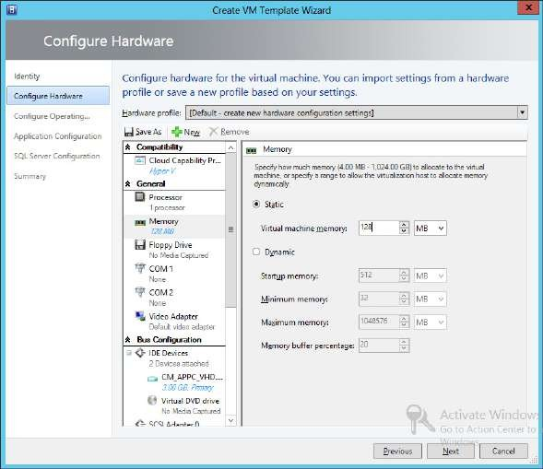

At the **OS configuration** step keep default settings and click on **“Next”** button. At **Summary** step click on **“Create”** button.

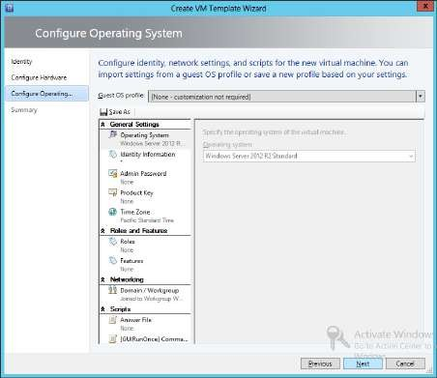 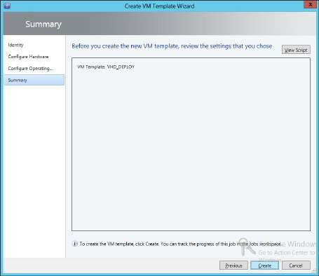

It shows the Jobs window with the completed tasks/jobs.

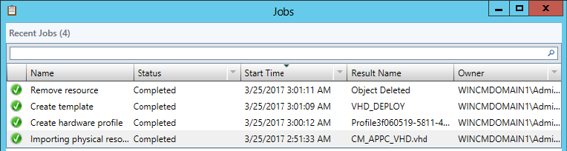

In VMM to check the VM template go to **Library** in left bottom pane, in the top left pane go to **Templates**→**VM Templates**. The new VM Template is listed in the right pane. Clicking on the created template shows its details in the right bottom pane

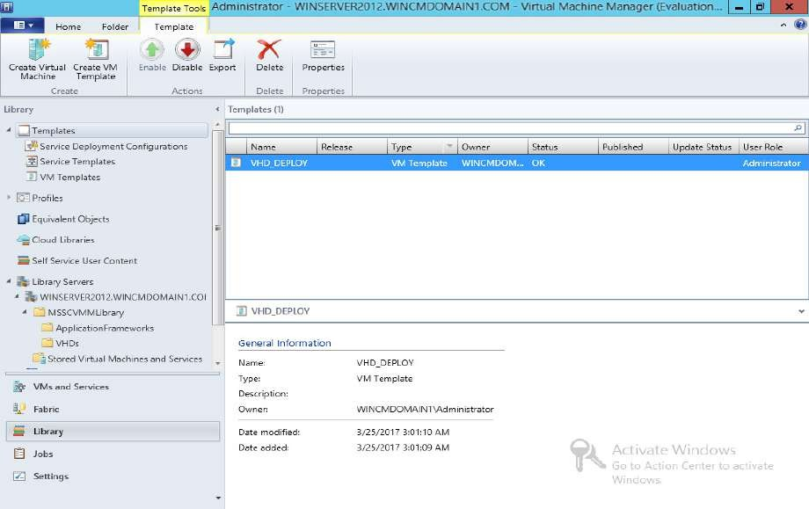

# Step 13: Live Migration of VM OR Move VM

(Migration has to be performed with the VM (not VM Template) running. Depending on the size of the allocated HDD space of the VM the migration will take some time)

* To migrate a VM from one location to another **right click** on that virtual machine and select **“Migrate Virtual Machine”** option
  1. **Select the destination server** for the VM. (Migration takes place between two HyperV servers only, for example HyperV1 (host server) to HyperV2 (destination server)).
  2. **Select the path** that is storage location on the host for the VM files
  3. **Select the network** that is which virtual switches to use for the VM
  4. It displays **summary**, click on **Move**
  5. The VM is migrated

# Step 14: Cloning VM

* To clone a VM, **right click** on it and select **Create**→**Clone** option
  1. Give the VM a **name**, for example VM Clone
  2. **Configure the destination** of the clone that is select the destination host
  3. **Select the Destination** server
  4. **Select the network** that is which virtual switches to use for the VM
  5. Confirmation of settings, **summary** window, click on **Create**
  6. The clone is **created** at the destination.
  7. The cloned VM will now be visible inside the **VM list Step 15: Creating a Failover Cluster**

# Steps to add a Role in Server Manager:

1. In the **Server Manager** go to **Dashboard** and select the option **“Add roles and features”**.
2. In the **“Add Roles and Features Wizard”** click on **“Next”** button.
3. In the next window select the **installation type** as **“Role-based or feature-based Installation”**. Then click on **“Next”** button.
4. Next window is for **Server selection**. Keep the **default** settings and click on **“Next”**

button.

1. In the **Server Roles selection** window select **Active Directory Certificate Services** and **Active Directory Domain Services** (here it is already installed) option and click on the **“Next”** button.
2. In the **Features selection** screen, select the feature as **“Failover clustering”**. And click on **“Next”** button.
3. A dialog box appears asking to **“Add features that are required for Failover Clustering?”** Click on the **“Add Features”** button.
4. In the **“Add Roles and Features Wizard”** check the **“Failover Clustering”** option then click on the **“Next”** button.
5. On the Final Screen of **“Add Roles and Features Wizard”** click on the **“Install”** button.
6. After the installation is complete click on the **“Close”** button.

***Note:*** *Create another VM with Windows Server 2012 with the same configurations as given above. Create a domain in first created VM1, and in VM2 just add the VM to the existing domain that was created on VM1.*

Now go to **Tools** and click on **Failover Cluster Manager** option.

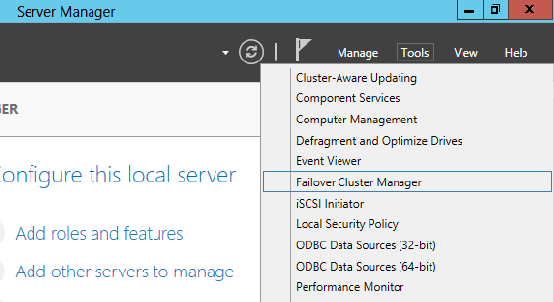

At **Failover Cluster Manager** select **“Validate Configuration…”** option

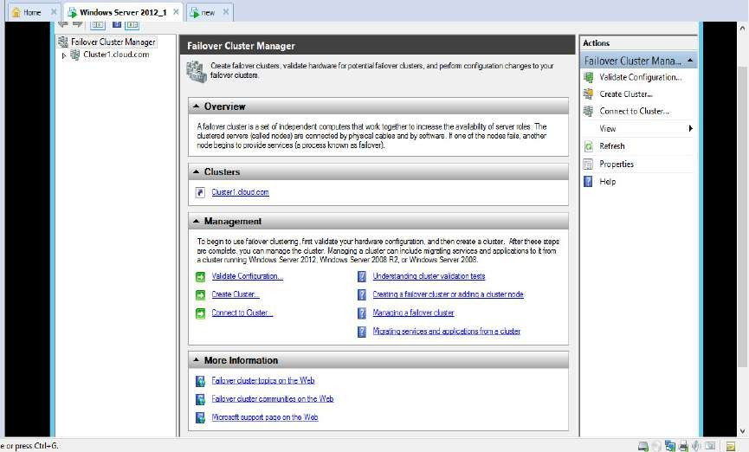

In the **Validate a Configuration Wizard**, just click on the **“Next**” button.

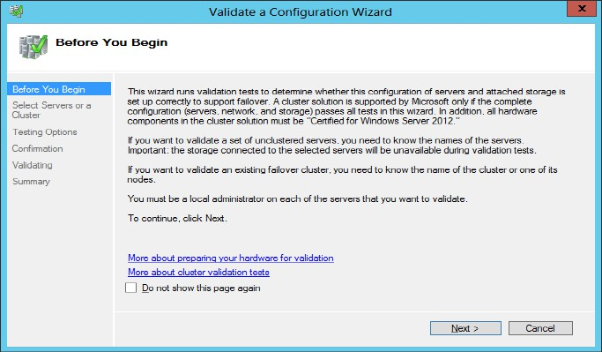

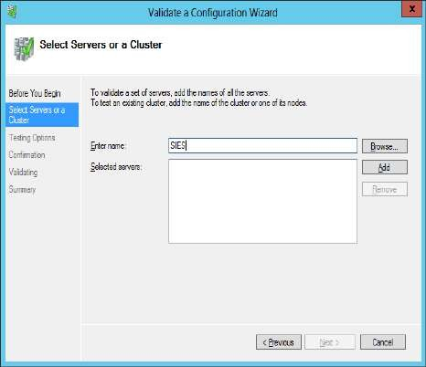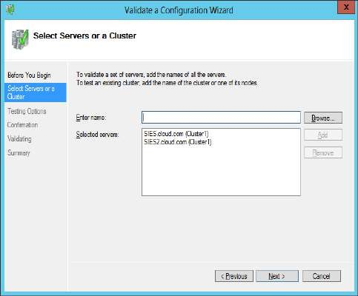In the next step select the servers or clusters by entering a already created cluster and click on the **“Add”** button. After the clusters are selected click on the **“Next”** button.

In the **Testing Options** select the second radio option **“Run only tests I select”** Click on

**“Next”**button.

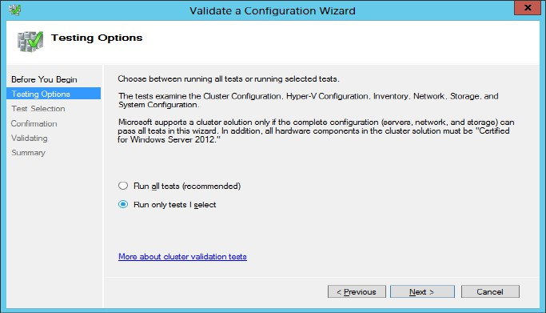

In the **Test Selection** select all the available options and click on the **“Next”** button. In the Confirmation click on the **“Next”**button to confirm the tests to be performed.

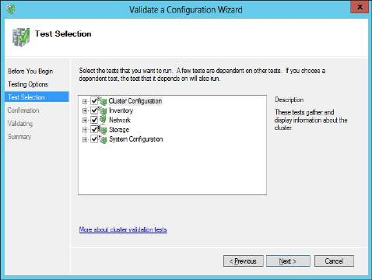 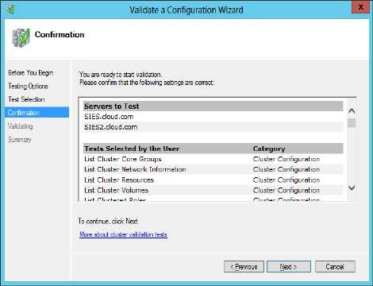

In the next window access is validated from the cluster for sharing operation. Click on the

**“Next”** button.

The last window displays the **summary**. Click on the **“Finish”** button.

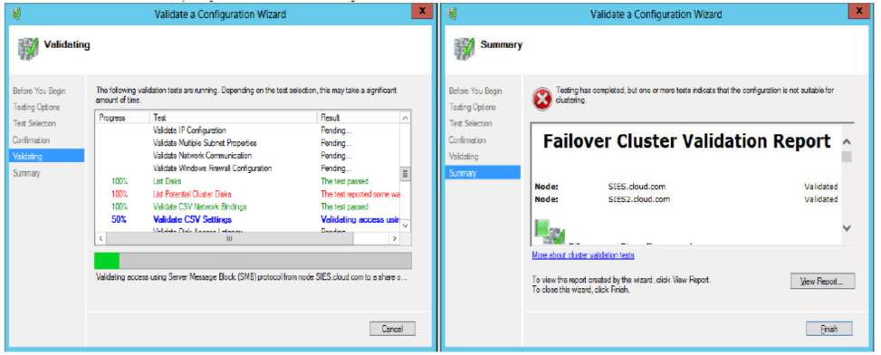

The configuration of the clusters is been **tested** and **validated**.

**Prerequisites:**

**PRACTICAL NUMBER** ➔ **3**

**MANAGING PRIVATE CLOUD WITH APPCONTROLLER**

1. SQL SERVER 2012
2. SCVMM 2012 (with a VM Template created in it)
3. Add Web Server (IIS) role and .NET Framework 3.5 feature

**Step 1: SQL Server Installation (steps given in practical 1)**

**Step 2: SCVMM Installation and creation of VM Template in VMM (check practical 1) Step 3: Adding IIS role, its services and .NET Framework 3.5 feature (refer practical 2) Step 4: Create cloud in VMM (refer practical 2)**

**Step 5: Connect App Controller with VMM (refer practical 2)**

**Step 6: Deploy Template in SCAC**

Launch App Controller. **Login** to App Controller using **administrator username with its domain name** and enter the **passwords**. Click on **“Sign In”**.

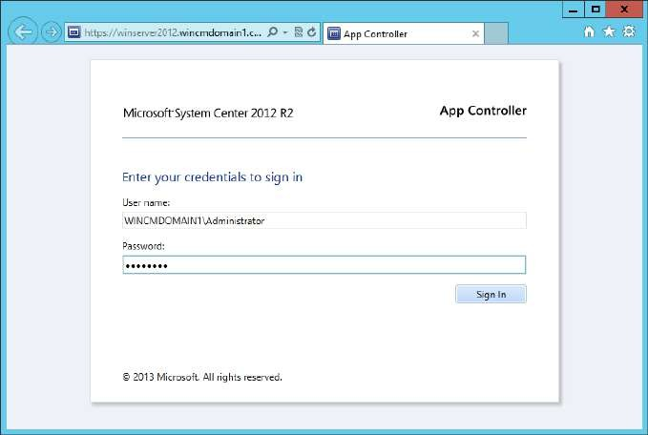

In the AppController go to **Virtual Machines** in the left pane. In the right pane click on **“Deploy”**

button.

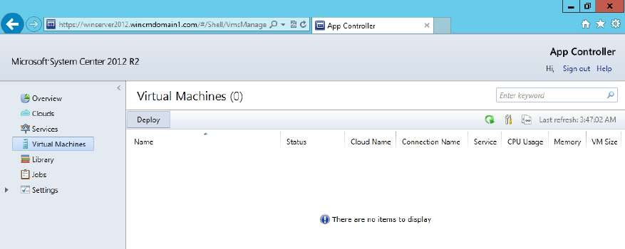

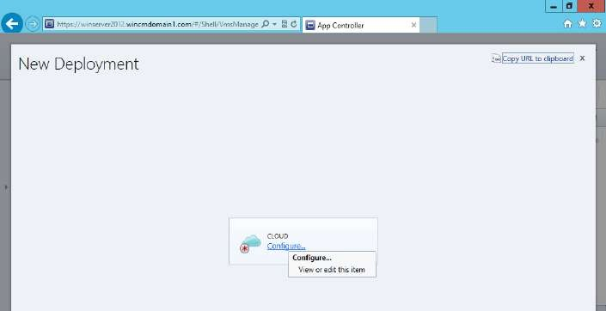In the **New Deployment** screen under **CLOUD** click on **Configure…**

In the next step select the cloud that was created in VMM (here the cloud is **VMM_CLOUD1**) and click on **“OK”**

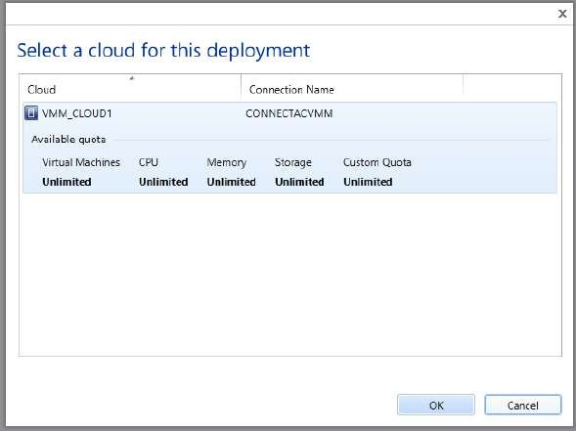

In the next step click on **“Select a template…”** under **TEMPLATE**

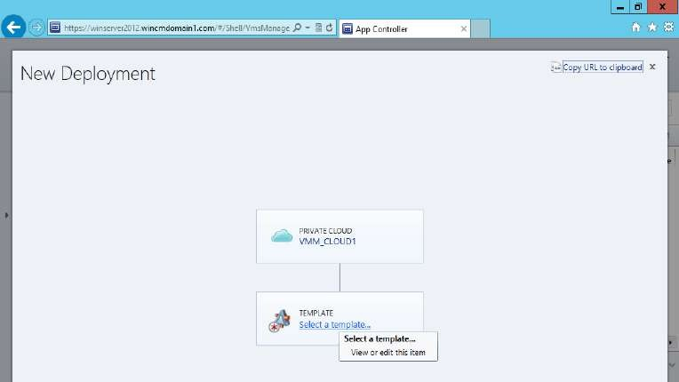

In the **Choose a template** step select the template that you had created in VMM (here the VM template is **VHD_DEPLOY**). Click on **“OK”**

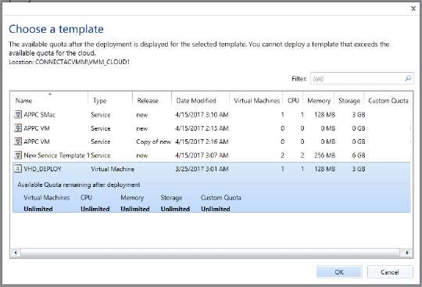

In the next step click on **“Configure…”** under **VIRTUAL MACHINE**

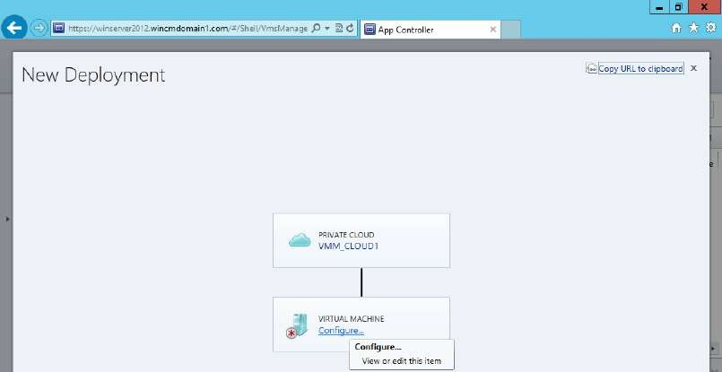

Give a name to the VM (here it is, **APPC_VM1**) and the memory size as **128MB**. Click on **“OK”**

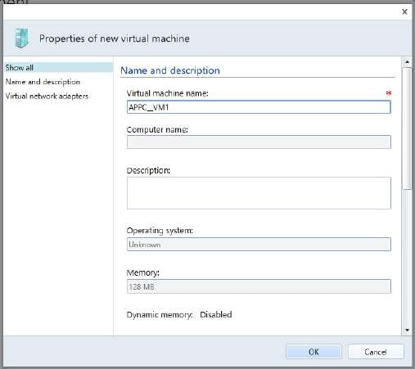

Click on **“Deploy”** in the **New Deployment** screen. The VM is deployed.

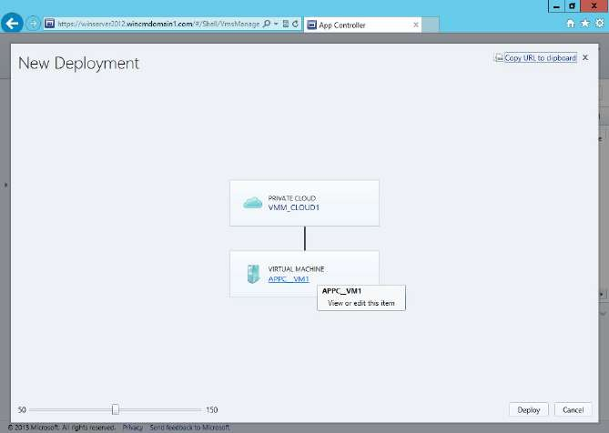

# Step 6: Creating a VHD

Now to create VHD go to **Server Manager**→**Tools**→**Computer Management**

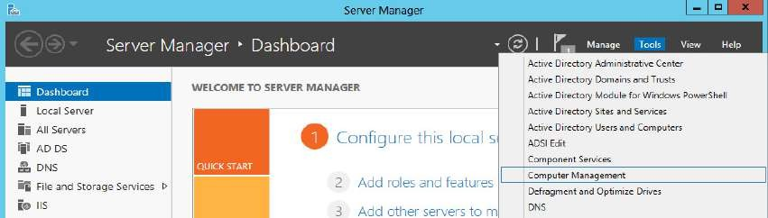

In **Computer Management** window select **Disk Management** from the left pane under **Storage** section. Its details are displayed in the right and bottom panes. Now **right click on Disk Management** and select **“Create VHD”**.

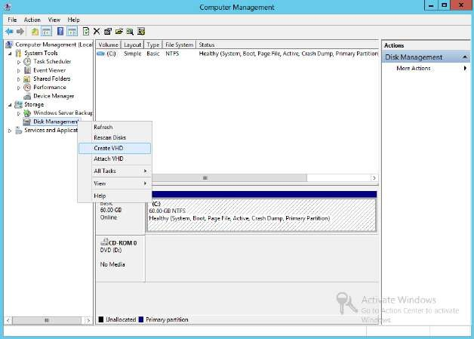

At the **Create and Attach Virtual Hard Disk** window click on **“Browse…”** button. Select a location to save the VHD (here dektop), enter a name (here **CM_APPC_VHD**) and click on **“Save”**

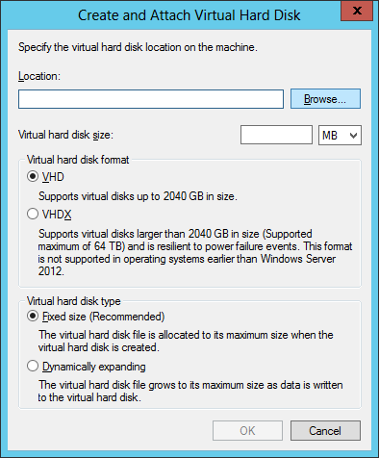 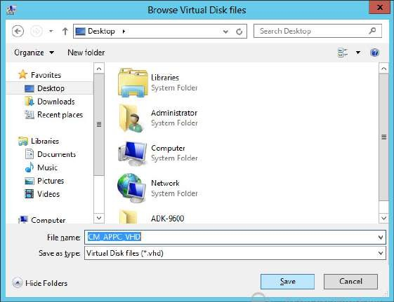

Enter the disk **size**→**3 GB, VHD format**→**VHD, VHD type**→**Dynamically expanding**, then click on **“OK”**

At bottom pane of Computer Management window the newly created Disk1 can be seen.

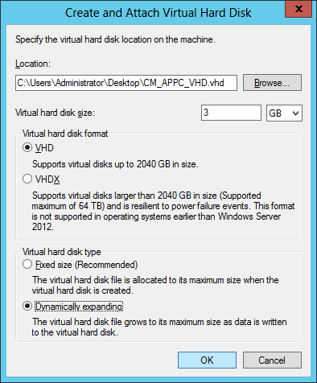 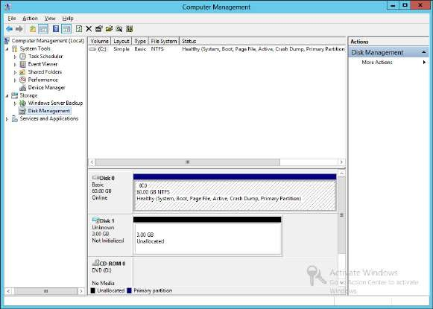

**Right click** on **Disk1** and select **Detach VHD** from Computer Management

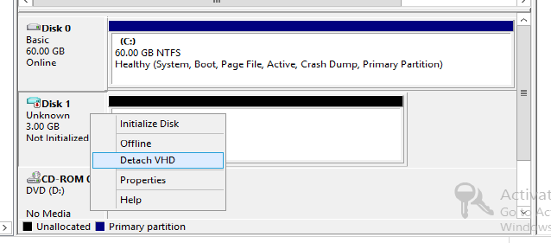

At the **Detach Virtual Hard Disk** window click on **“OK”** to confirm the detachment

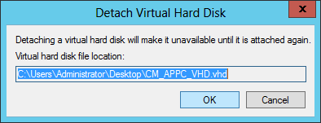

At **Computer Management** window in the bottom pane the **Disk1** is removed.

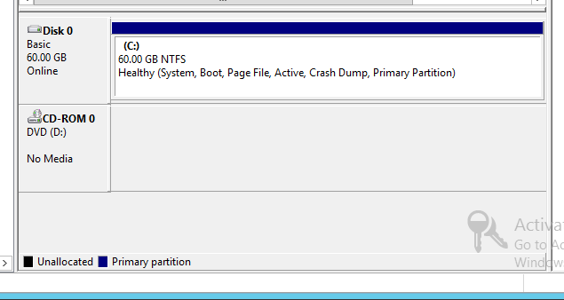

Close the Computer Management window.

At desktop we can see the **"CM_APPC_VHD"** file of **size 12.0KB**

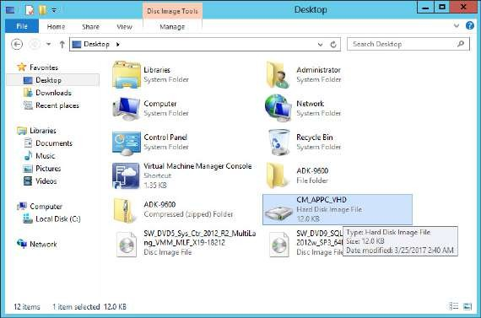

# Step 7: Import VHD in VMM

In VMM, go to Library in the left below pane.

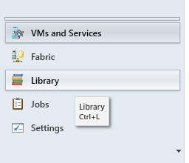

Then in the top left pane go to Library **Servers**→**server.domain (here WINSERVER2012.WINCMDOMAIN1.COM)**→**MSSCVMMLibrary**→**VHDs** as shown in the below screen. In the right pane 4 existing (already created by VMM) VHDs are listed.

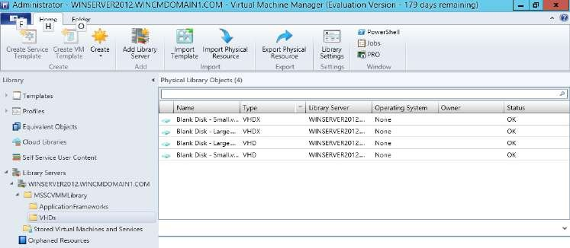

In **Home** tab click on **“Import Physical Resources”**. In the **Import Library Resources** window click on **“Add resource…”** button.

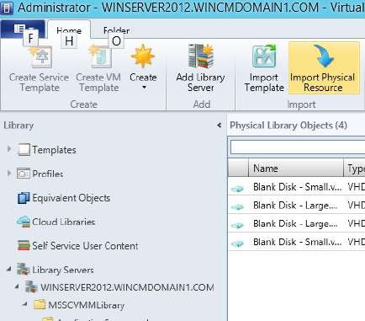 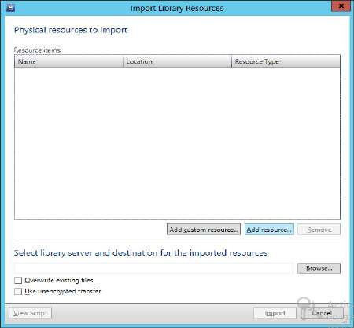

At the **Select resource items** window **add the VHD** that you had created (here **CM_APPC_VHD**, location **Desktop**). Click on **“Open”**. At the **Import Library Resources** window click on **“Browse…”** button.

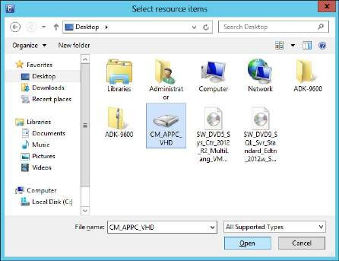 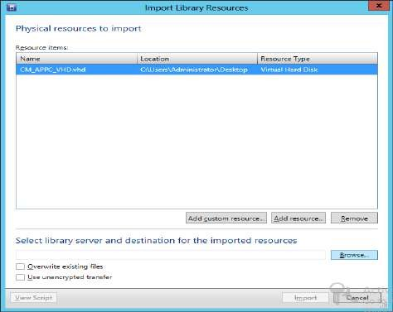

At the **Select Destination Folder** select the **VHDs** folder and click on **“OK”** button. At the **Import Library Resources** window click on **“Import”** button.

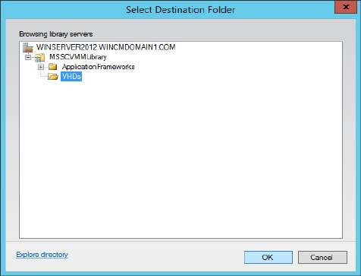 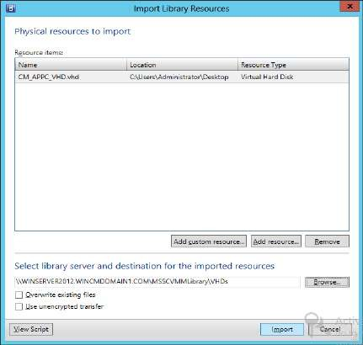

At the **Jobs** window the Import is shown as successful.

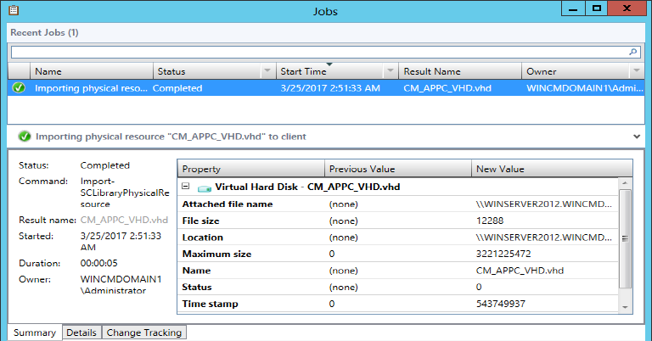

At the main window of VMM the VHD is seen, and selecting it shows its details in the below pane.

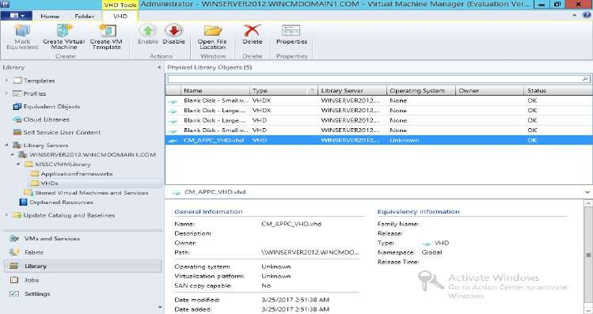

**PRACTICAL NUMBER** ➔ **4**

**USING DATA PROTECTION MANAGER FOR BACKUP AND RECOVERY**

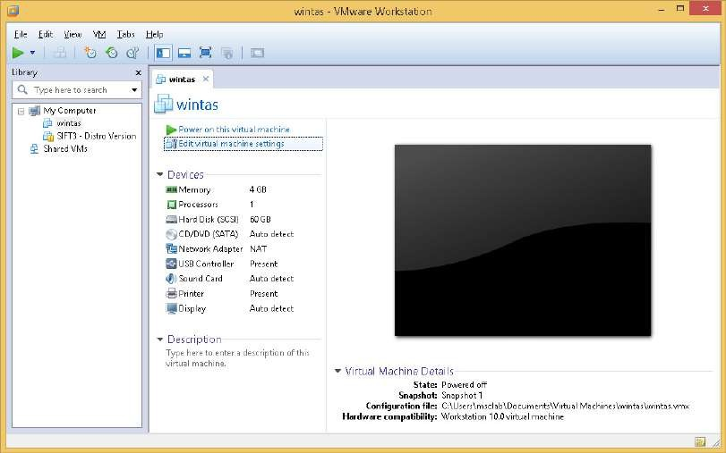At VMware Workstation, click on your Windows Server 2012 VM so the options for it are displayed. Click on **“Edit virtual machine settings”**

Adjust Memory Size to 4GB.

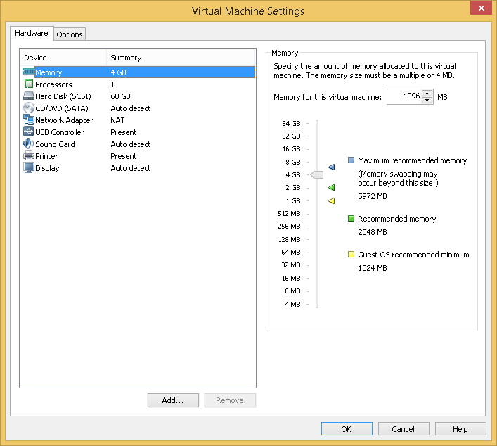

Go to Hard Disk. At **Add Hardware Wizard** select Hard Disk and click on **“Next”**

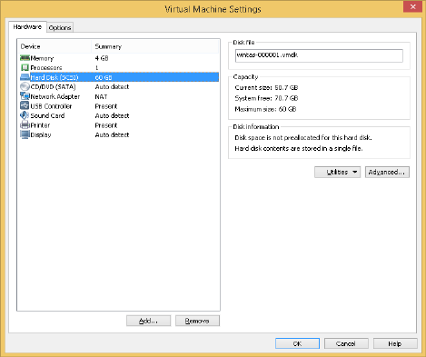 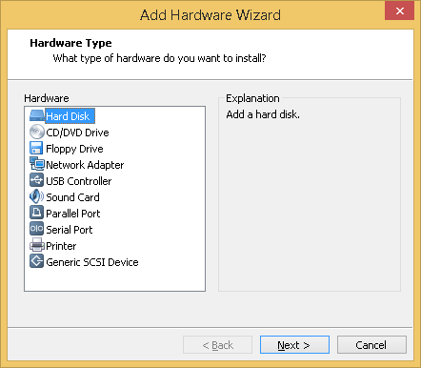

At next step select **“SCSI”** and click on **“Next”**

At next step select **“Create a new virtual disk”** and click on **“Next”**

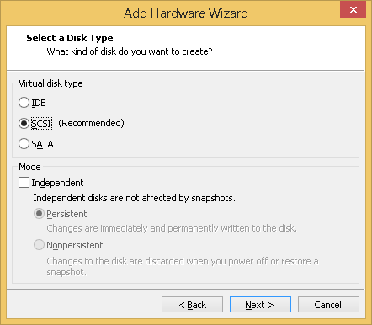 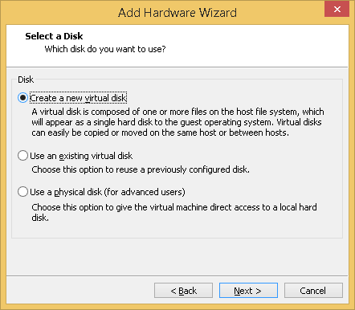

In next step select **“Store virtual disk as a single file”** and click on **“Next”**

At next step just click on **“Finish”**

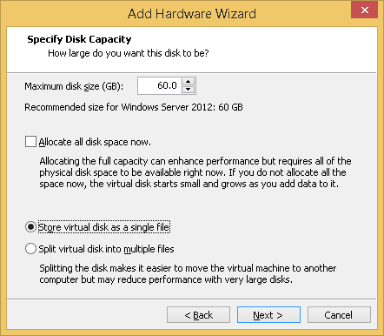 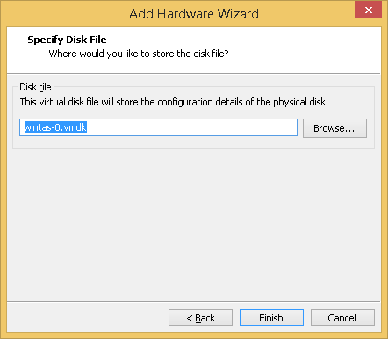

A new Hard Disk is created. Click on **“OK”**

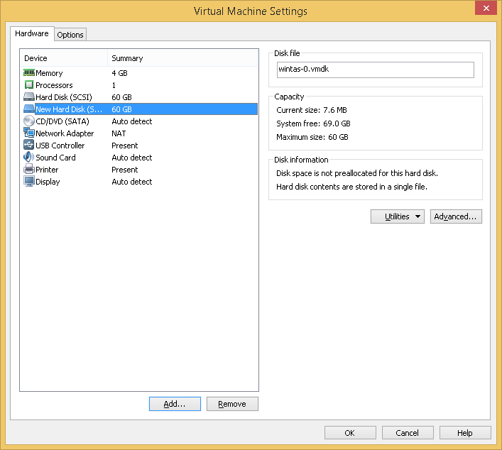

Power on the virtual machine. Go to **Server Manager**→**Tools**→**Computer Management**

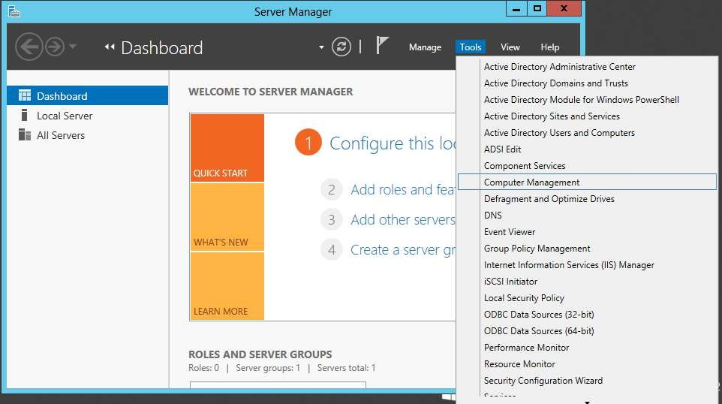

At **Computer Management** window go to **Disk Management**, two disks are listed at the bottom pane.

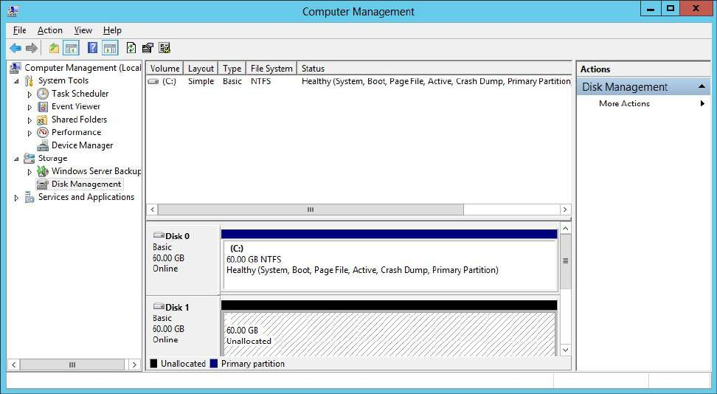

Right click on the **Disk 1** and select **“Connect to GPT Disk”** option.

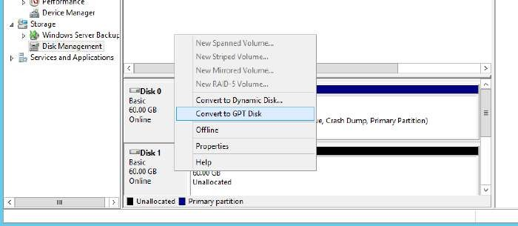

**Close** Computer Management window.

# Prerequisites

1. SQL Server:

SQL Server Reporting Service SQL Server Agent

1. Creating users in “Builtin” DPMR$Kings, MSDPM, DPMSCOM
2. Creating groups DPMDBReaders$Kings,
3. DPMDBAdministrators$Kings, DPMRADCOMTrustedMachines$Kings, DPMRADmTrustedMachines$Kings, MSDPMTrustedMachines MSDPMTrustedUers$Kings

DPMSCOM$Kings

The MSDPMTrustedMachines$KINGS group is not present in the current domain.DPM cannot be installed until the group is created.

The DPMR$KINGS user is not part of the DPMDBReaders$KINGS group.DPM cannot be installed until this user is added to the DPMDBReaders$KINGS group.

The MSDPMTrustedUsers$KINGS group is not present in the current domain.DPM cannot be installed until the group is created.

Copy the ISO of DPM from host to VM. Mount it, run the setup file Click on **“Install”**. Accept the **License Agreement**, click on **“Next”**

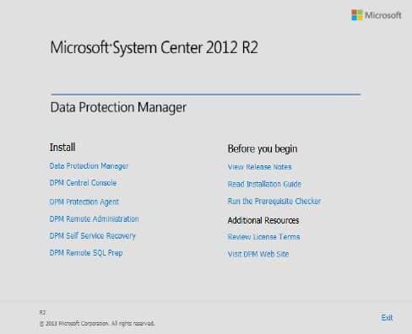 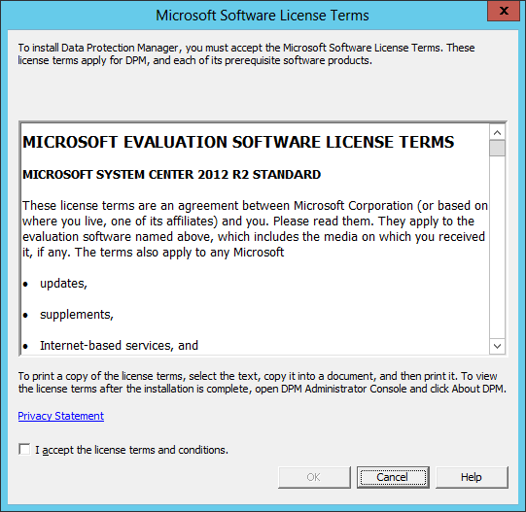

Click on **“Next”** at the Welcome screen. In next step keep the **default** settings and click on **“Next”**

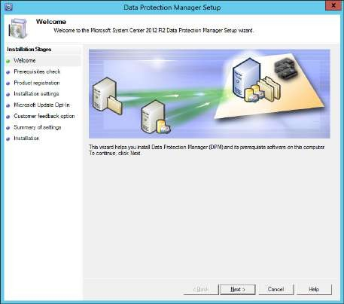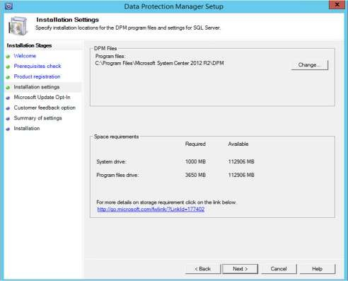

Click on **“Install”**. After installation click on **“Close”**

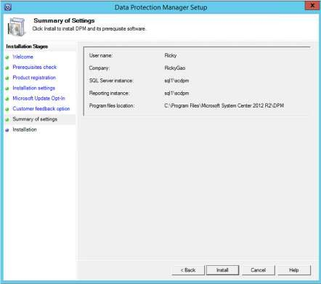 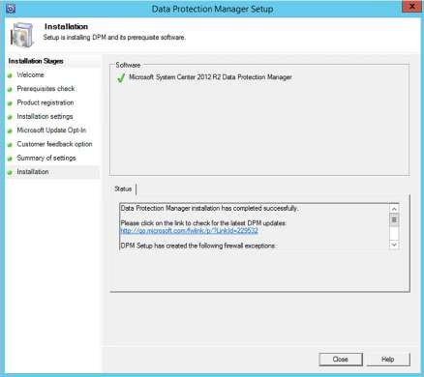

Launch the DPM UI.

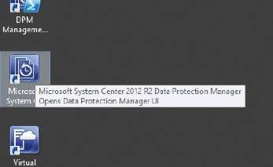

At the **DPM UI** go to Management in the left bottom pane, then click on **“Add”** option in the toolbar.

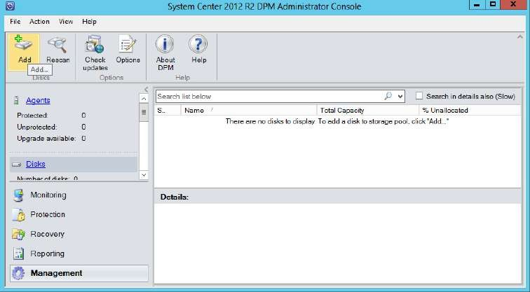

At the **Add Disks** window select the available disk from left and click on **“Add”**. It will then be listed in the right pane. Click on **“OK”**

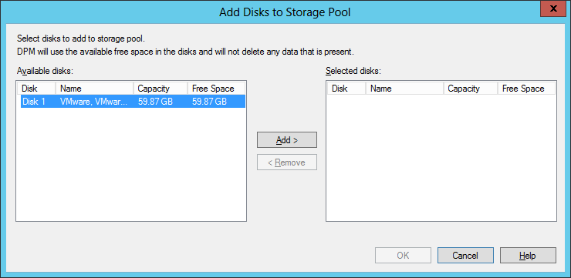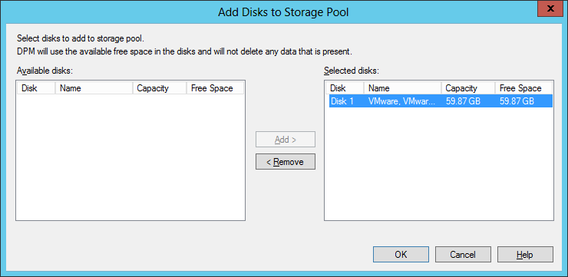

At the warning window just click on **“Yes”**

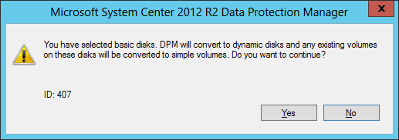

At the DPM main window, click on **Disks** in the left pane, the added disk is listed in the right pane

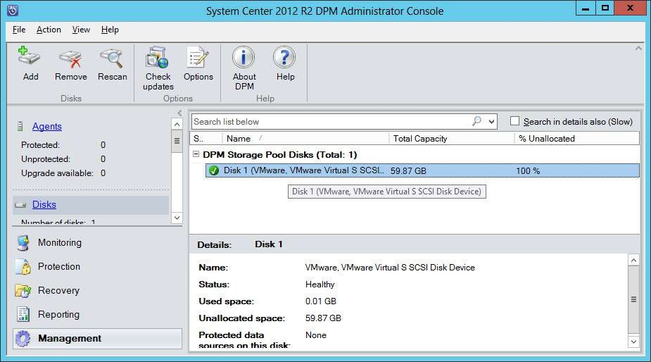

In the Left pane go to **Agents**. Select **“Install Agents”** and click on **“Next”**

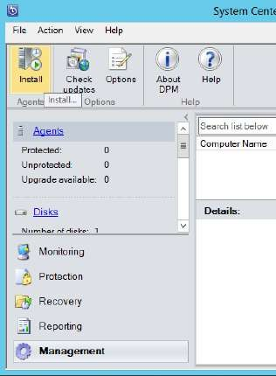 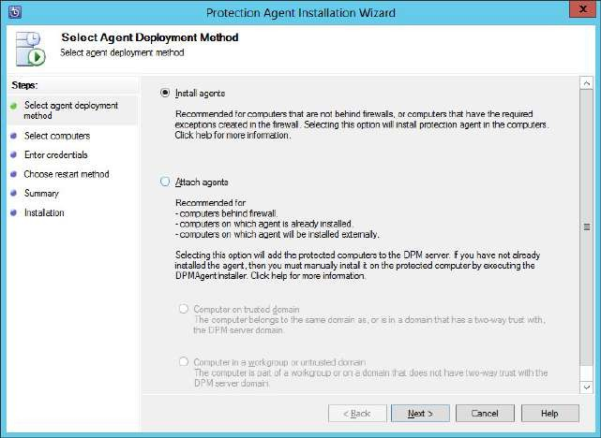

Launch SQL Server Management Studio.

# In the Object Explorer under Security→Logins right click on “NT AUTHORITY\SYSTEM”

and select **“Properties”** option.

At the first screen of **Login Properties** window just click on **“Next”**

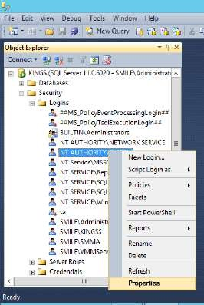 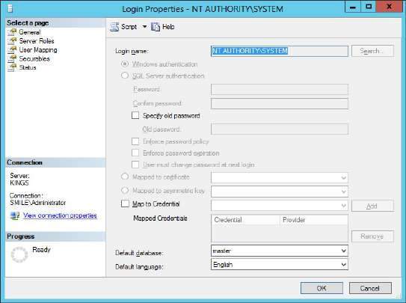

In the next step select the **“sysadmin”** server role and click on **“OK”**

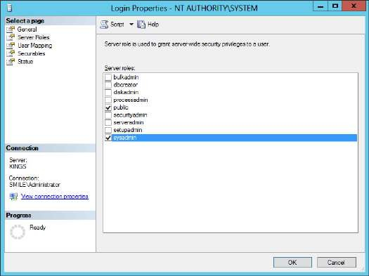

Now open the properties of **Administrator login** (here **SMILE\Administrator**) In the second step select the **“sysadmin”** server role and click on **“OK”**

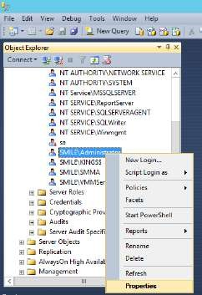 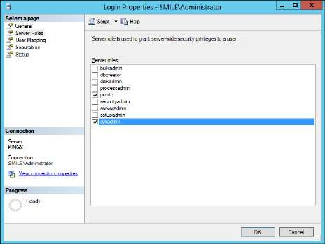

Go to **Protection** in the left bottom pane, in the toolbar click on **“New”**

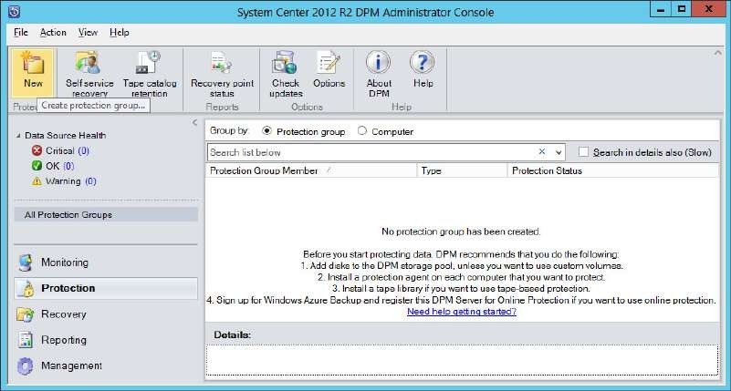

Click on **“Next”** at the Welcome screen.

Expand your domain, select your database, and click on “Next”

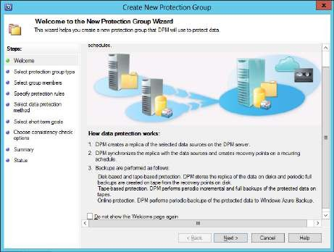 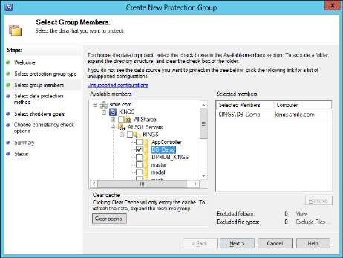

For the next step give a name to the protection group. Click on **“Next”**

# Change the Retention value to 5 days, synchronization frequency as every 15 minutes.

Click on **“Next”**

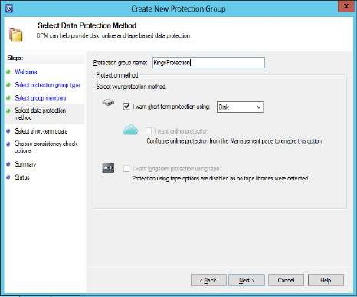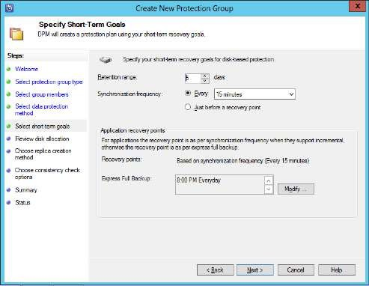

In the next step click con **“Next”**

In the next step select options as in the screenshot and click on **“Next”**

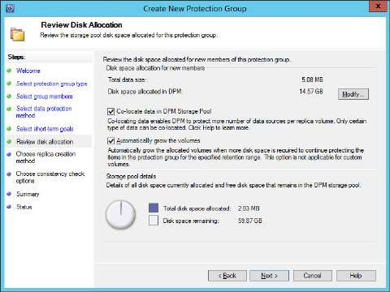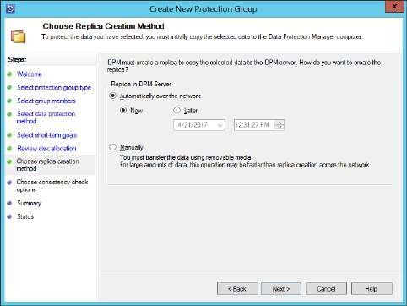

Select first option and click on **“Next”**. At the **Summary** screen click on **“Create Group”**

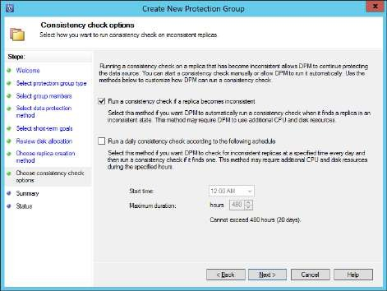 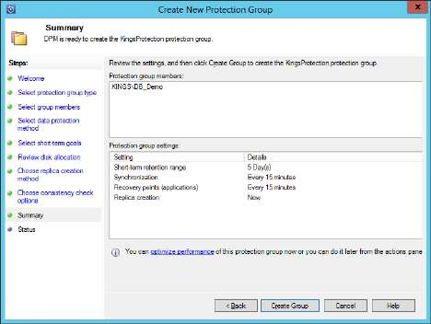

The group creation is successful

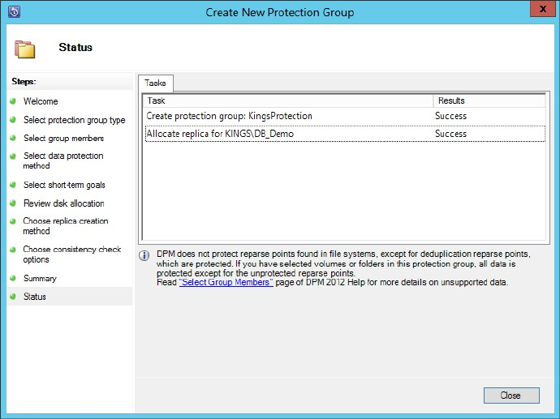

At the main window the created group can be seen.

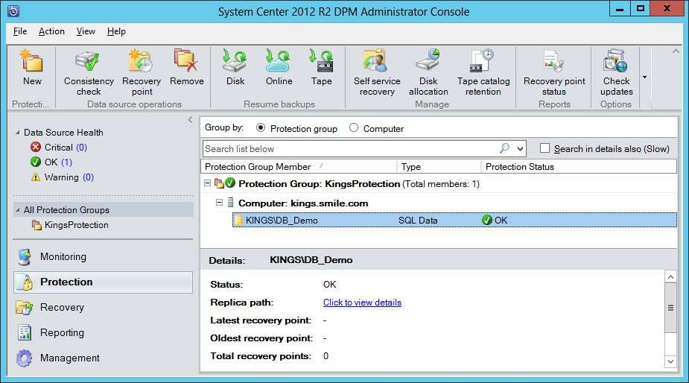

At the **SQL Management Studio**, **execute few queries** on the database that is synchronized with DPM.

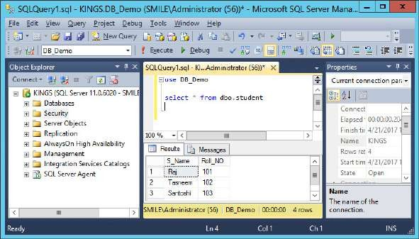

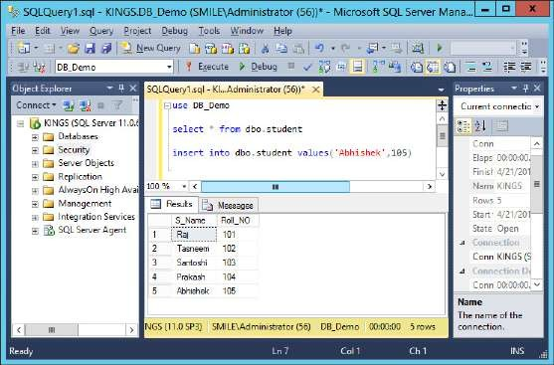

Go to **Recovery** in the left bottom pane. In the right pane it shows different recovery points.

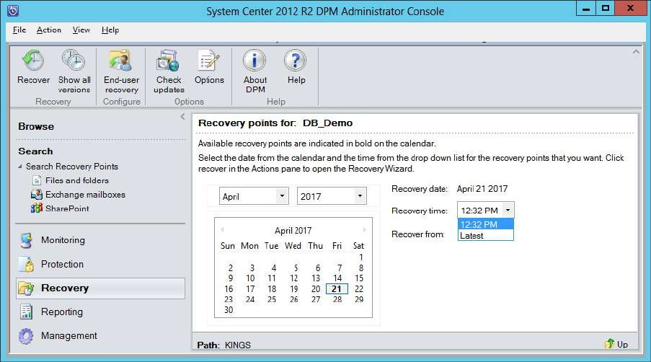

Click on **Recover** in the toolbar.

At the first screen of **Recovery Wizard** click on **“Next”**

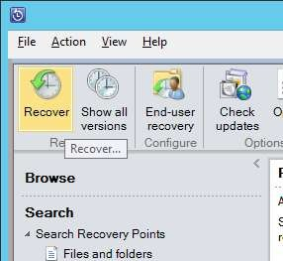 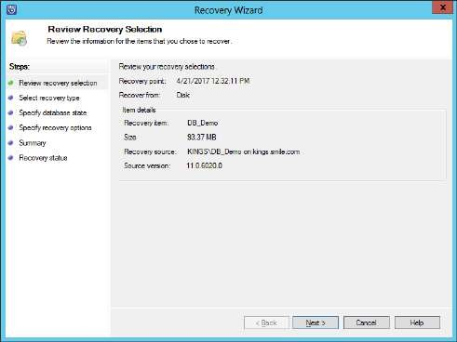

In the next step select first option and click on **“Next”**. Do the same for next step.

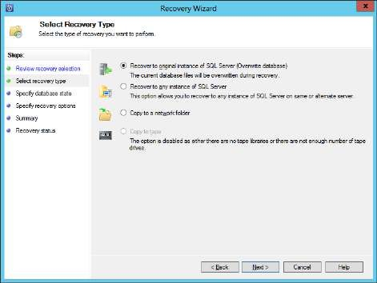 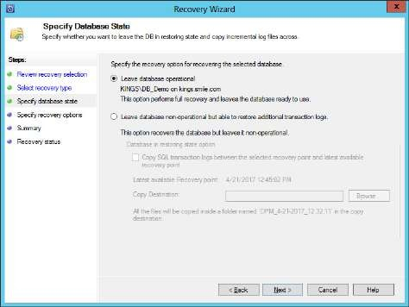

In next step click on **“Next”**. At summary step click on **“Recover”**

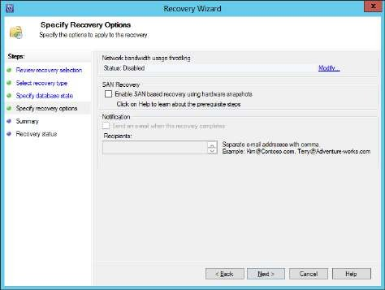 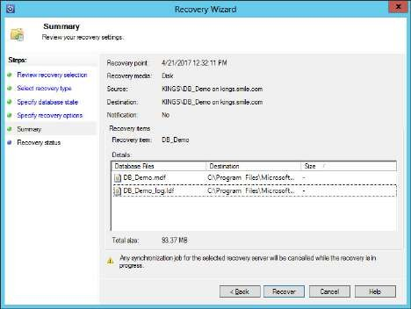

Recovery Status window..

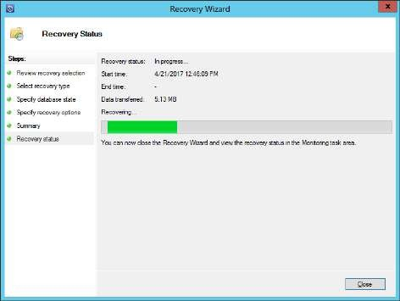 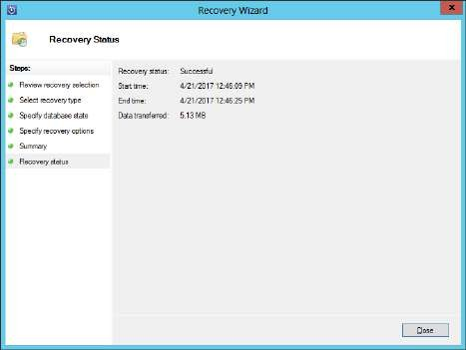

After the data recovery it will show the data before the modification in the database in sql manager and will show only the rows present before entering the row with **"name='Abhishek'"**

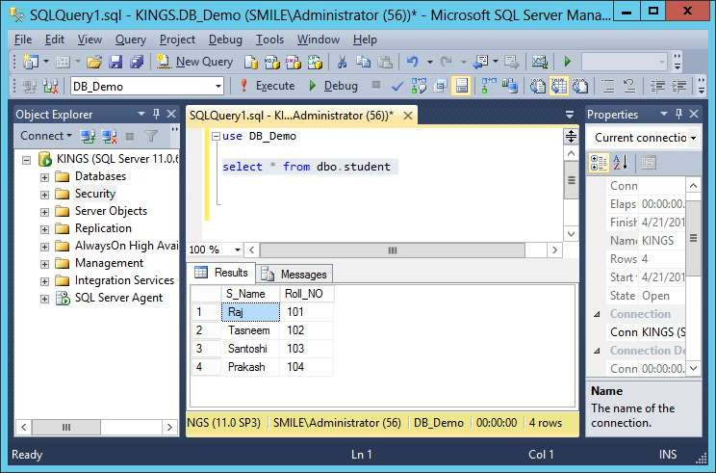

Due to the changes done in the database the replica of the database is **inconsistence** in the

**Protection Manager Group**. For consistency verification click on **Consistency check** for data

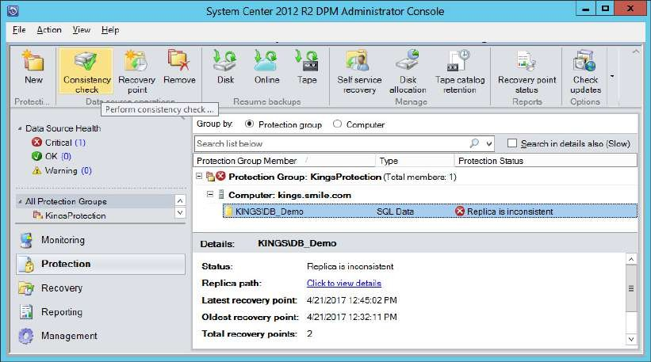

At the warning window click on “Yes”

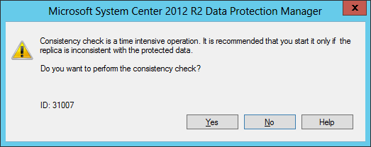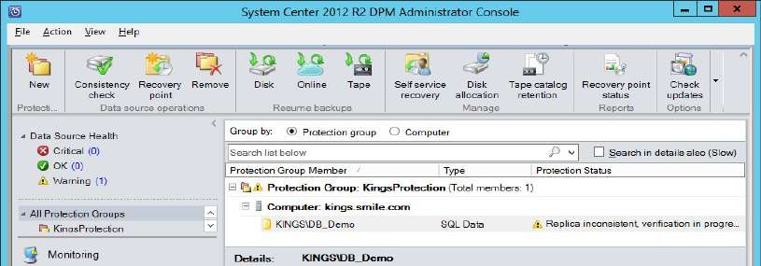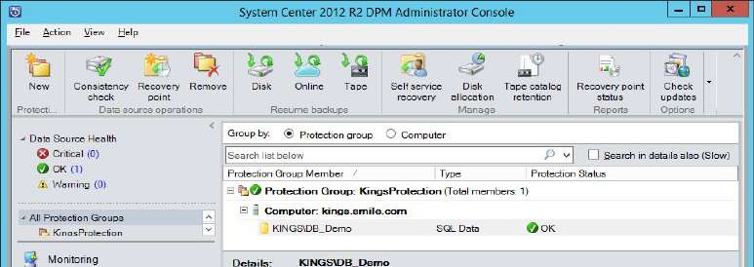

**PRACTICAL NUMBER** ➔ **5**

**USING OPERATING MANAGER FOR REAL-TIME MONITORING**

Installation of SCOM:

# Prerequisities

* **SQL Server 2012 instance:** SCOM

**Collation:** SQL_Latin1_General_CP1_CI_AS

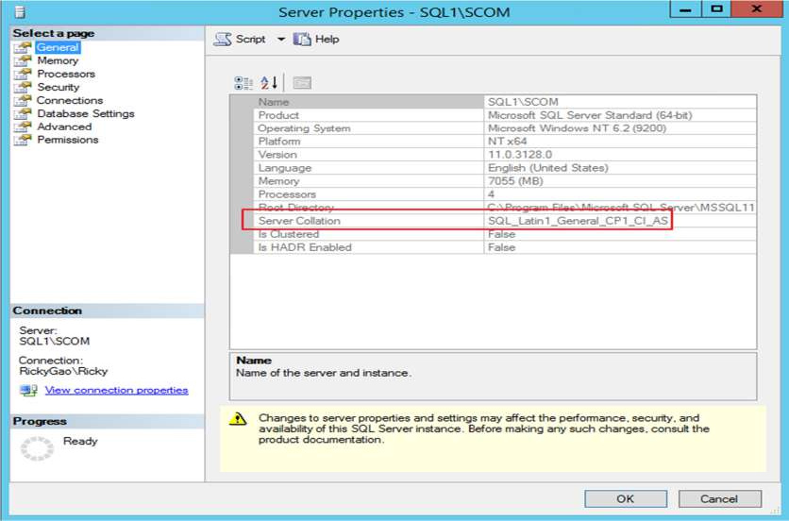

**SQL Server role:** Database Engine Services, Full-Text Search and Reporting Services

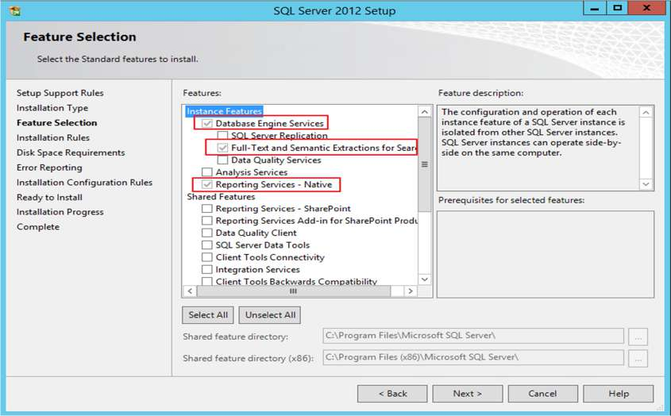

Select **“Use Mixed Authentication (Forms Authentication)”** and click on **“Next”**

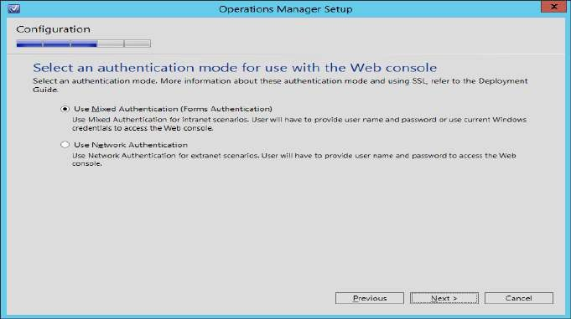

Here add all the users to their respective fields that were created as prerequisites, click on **“Next”**

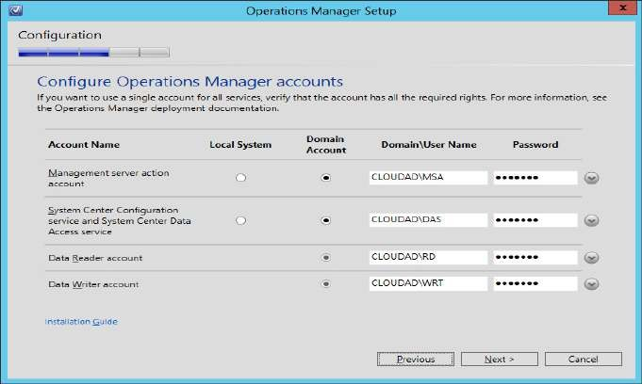

Select NO for both the offers of Microsoft

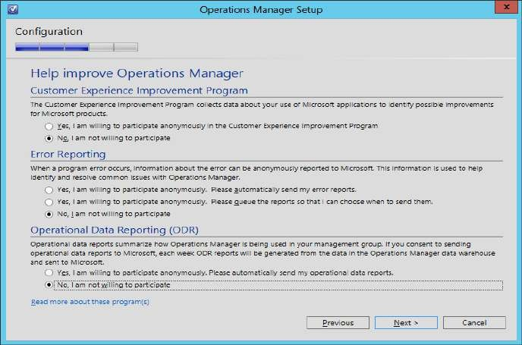

Click on **“Install”**

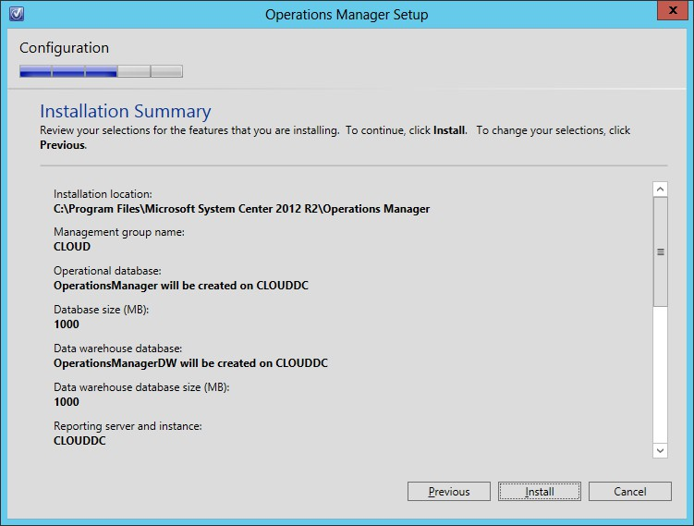

Setup is complete. Click on **“Close”**

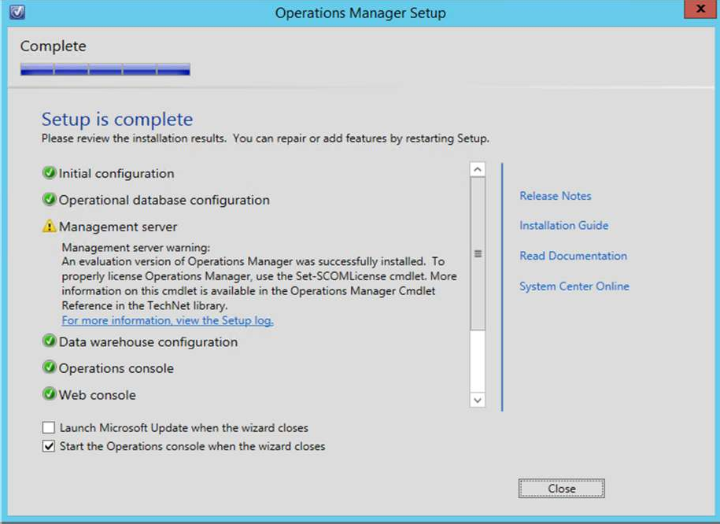

# Then Open Opeartions Manager Console.

1. **Adding new network devices to the Operations Manager console.**

Open **XIAN** on a machine on the network and click **Add**. Select **CISCO 2621**

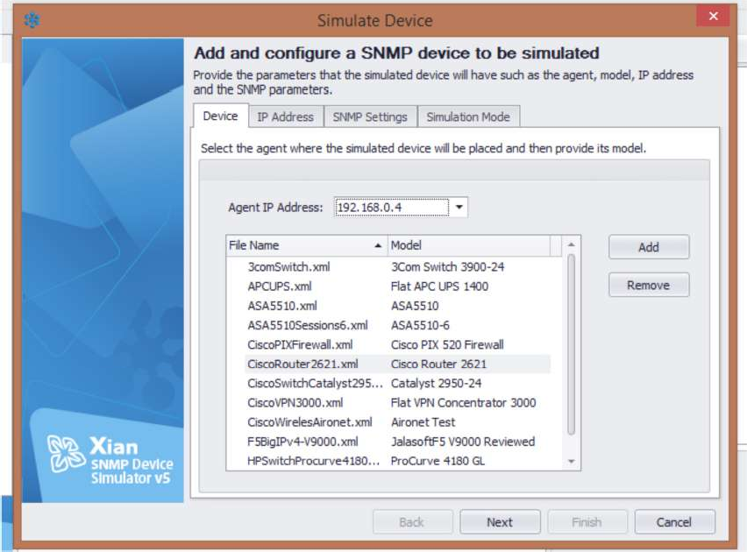

Click **Next** and Map it to an IP Address [Eg 10.0.0.170]

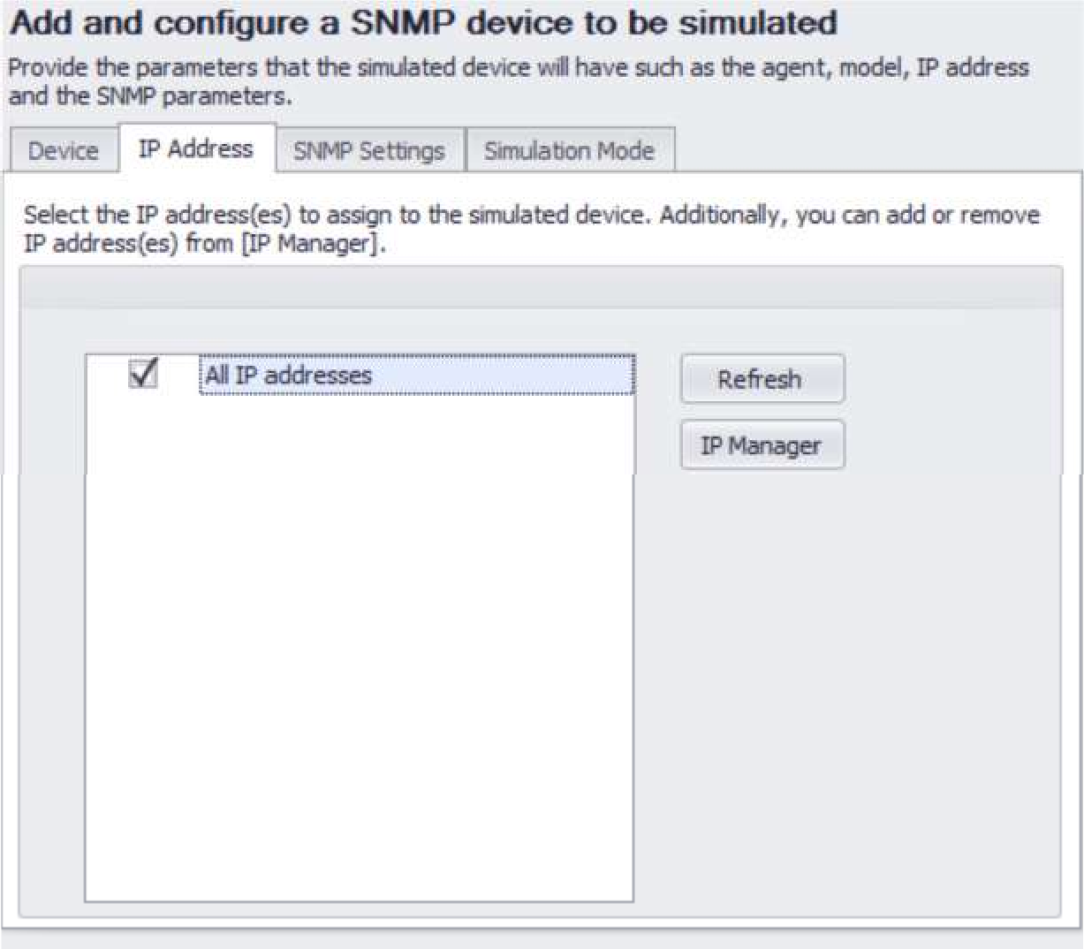

Select the community string **[v1 or v2]**

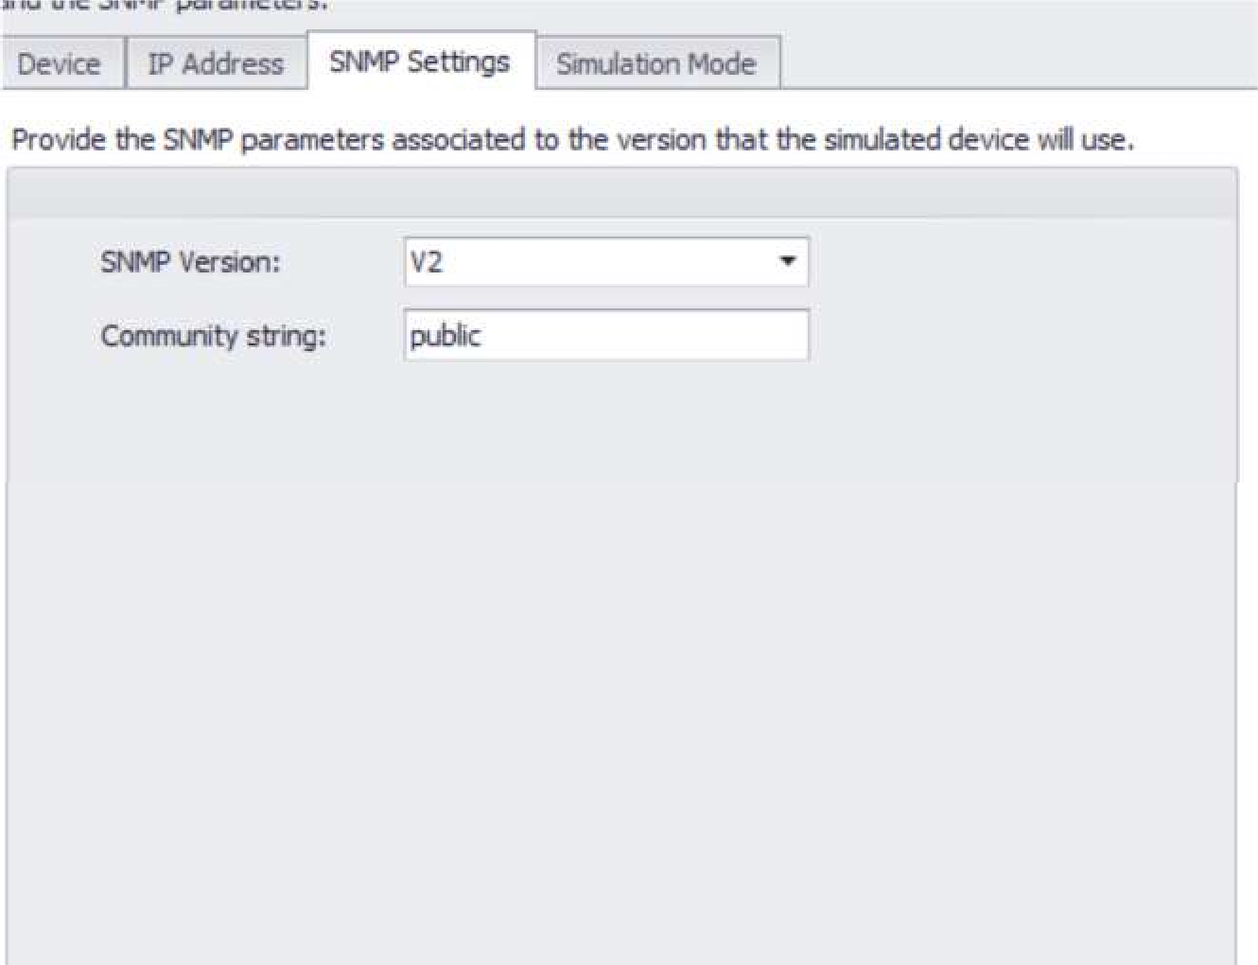

In SCOM, Select Network Devices in the Discovery Wizard

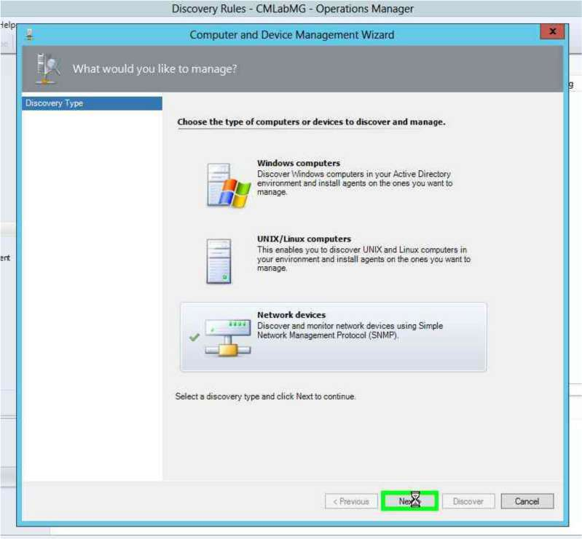

Enter a **name for the discovery rule**, select the **management server**

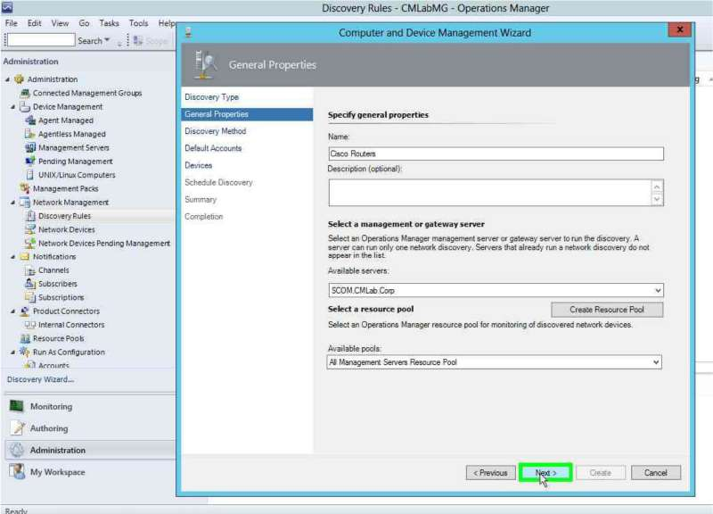

Explicit discovery will allow you to manually specify the network devices to monitor, while Recursive will perform a discovery of devices connected to the device you specify

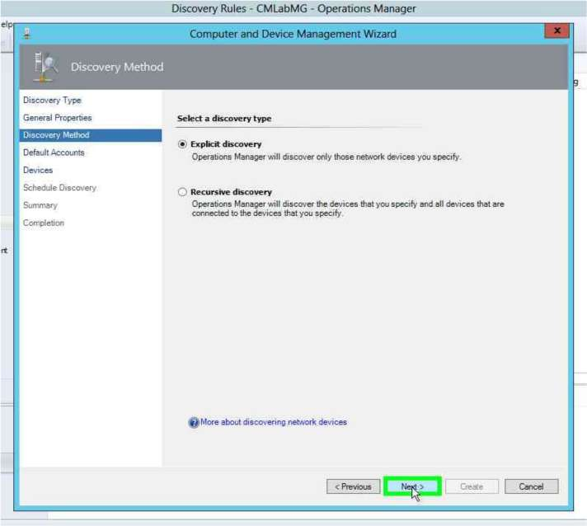

Create a **run as account** and specify the **SNMP** community string [Mostly ‘public’]

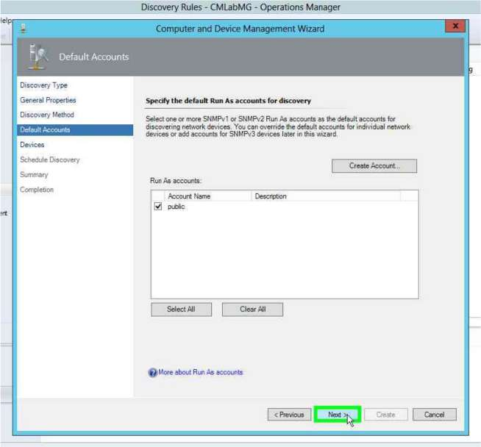

Click on Add and specify the details of the network device – IP Address, SNMP version, Port Number.

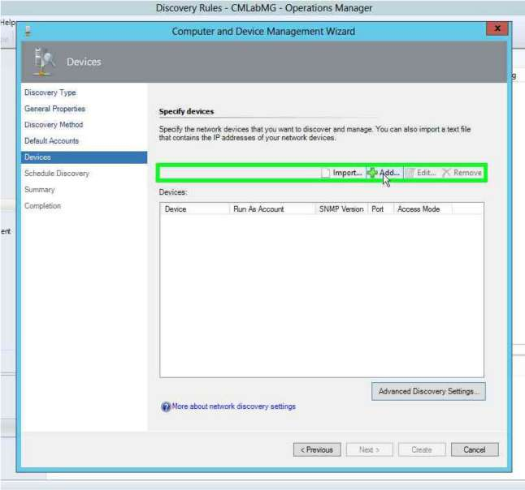

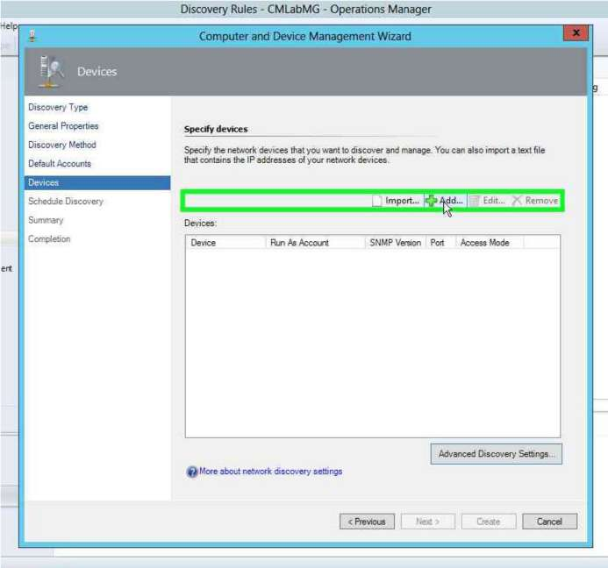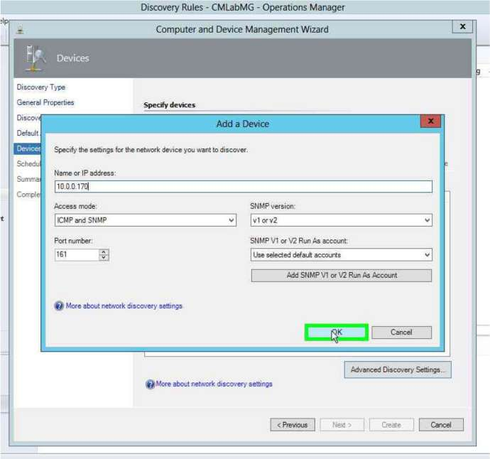

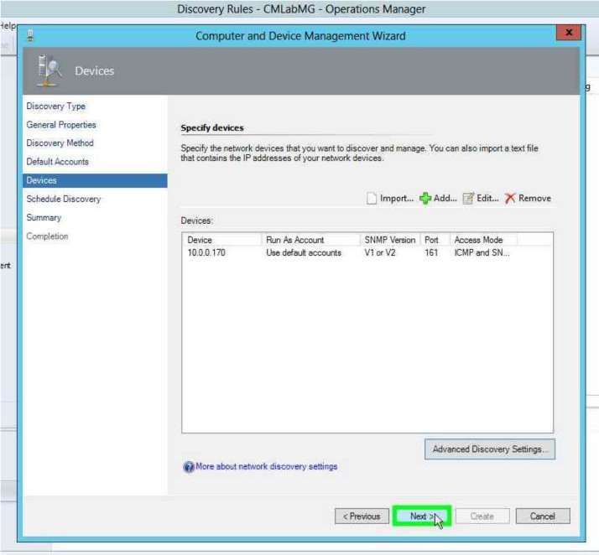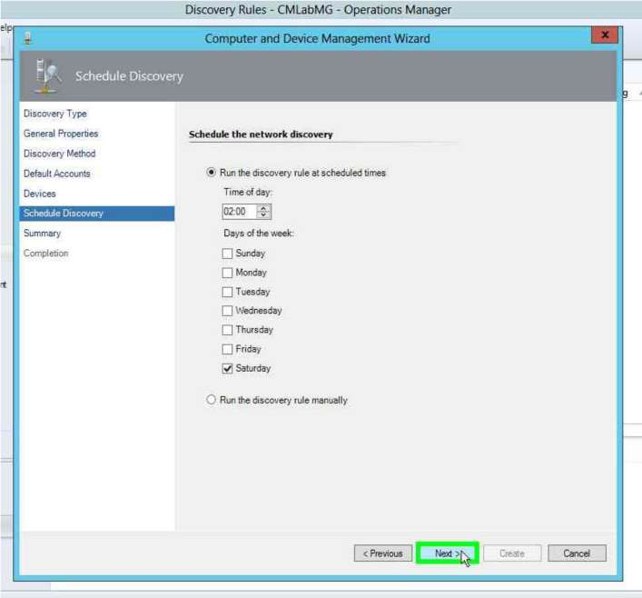

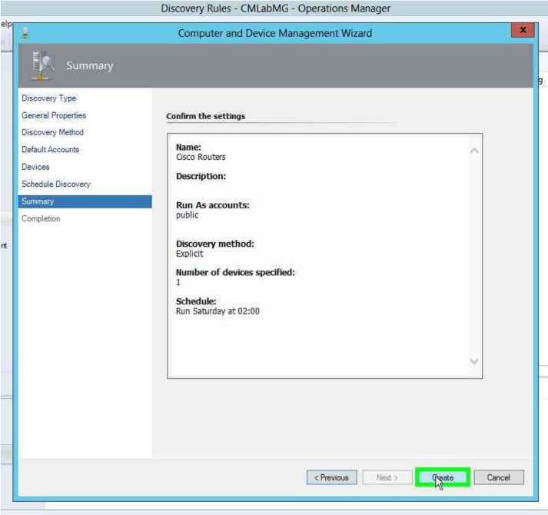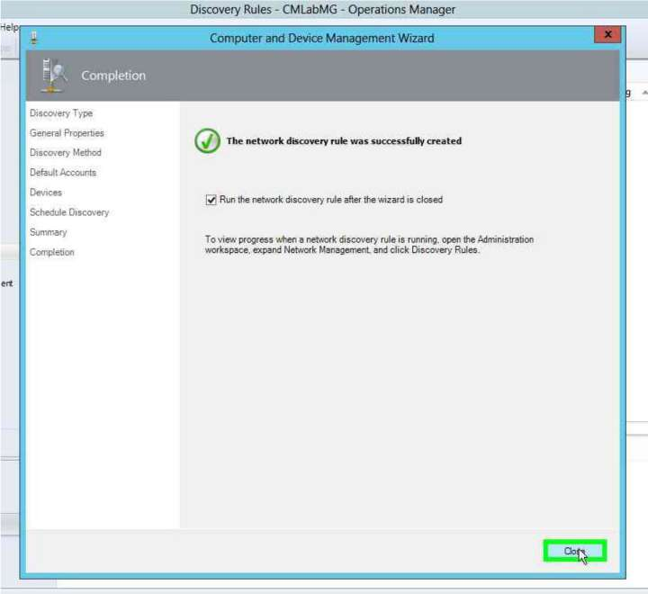

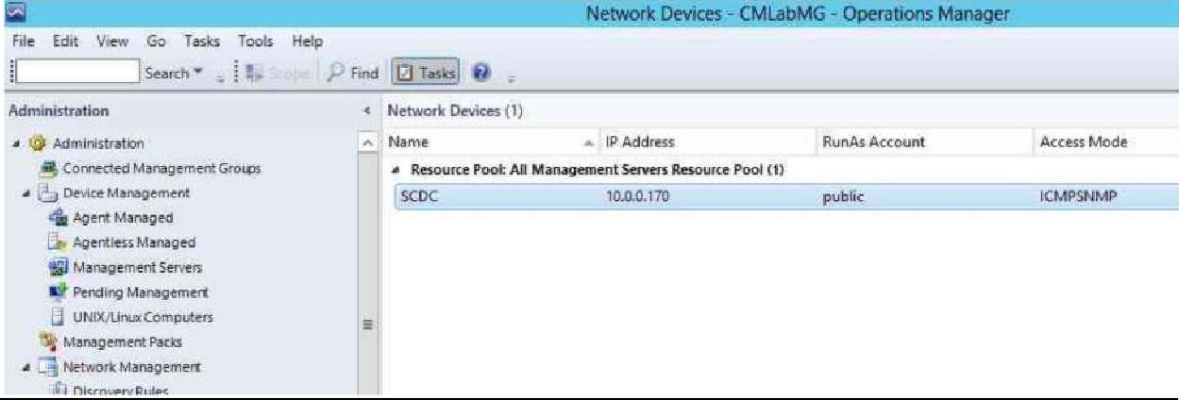

# Configuring and Monitoring hardware, servers, virtual machines, etc.

To perform the discovery of servers, start the discovery wizard from Administration

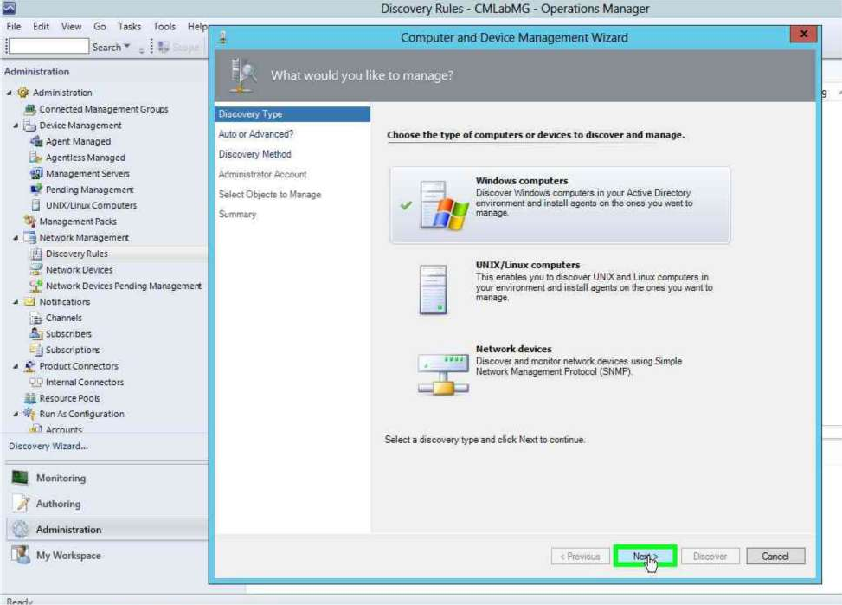

Specify advanced discovery.

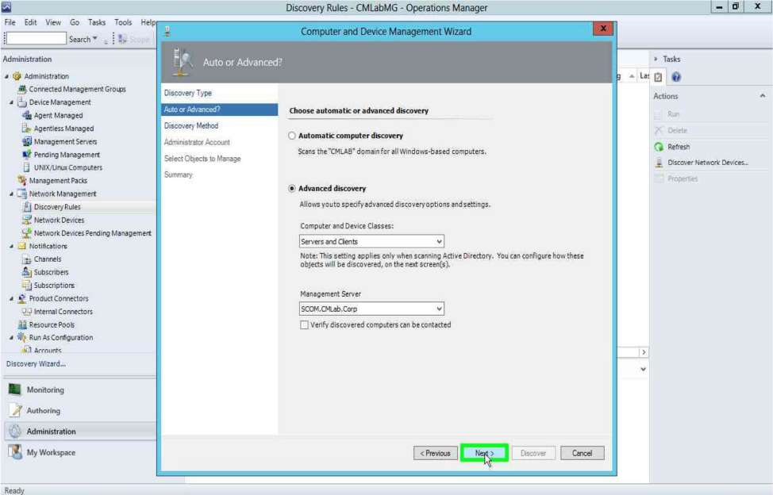

Click on configure and give the computer name to perform the discovery on

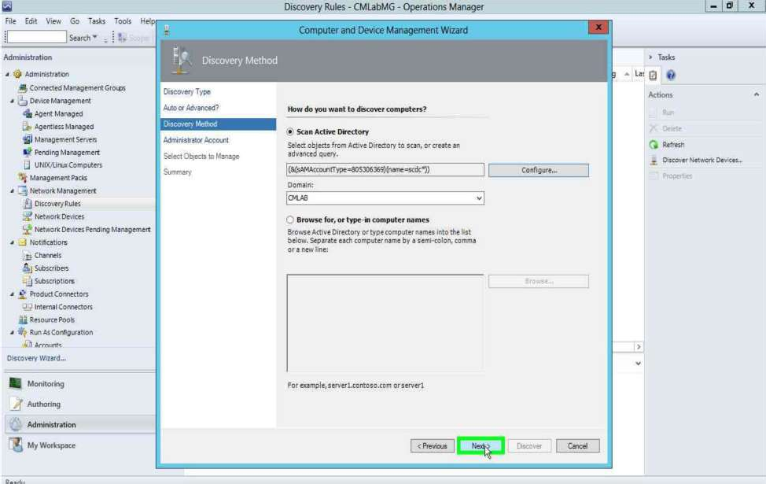

Give the domain admin credentials

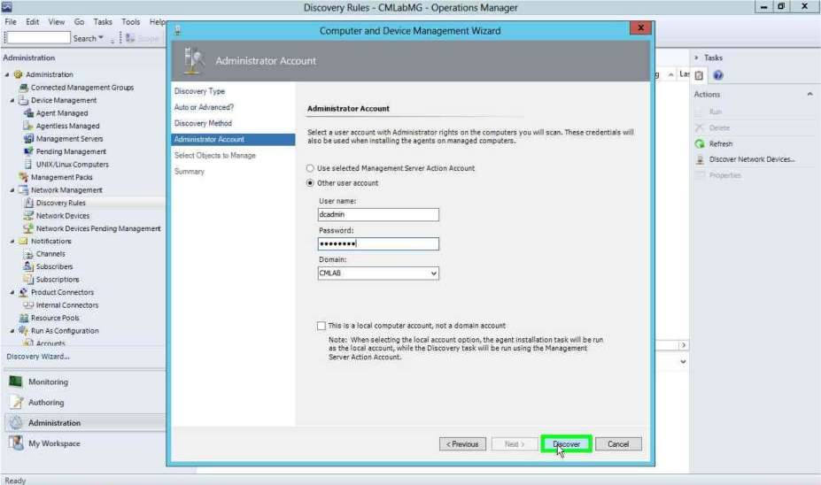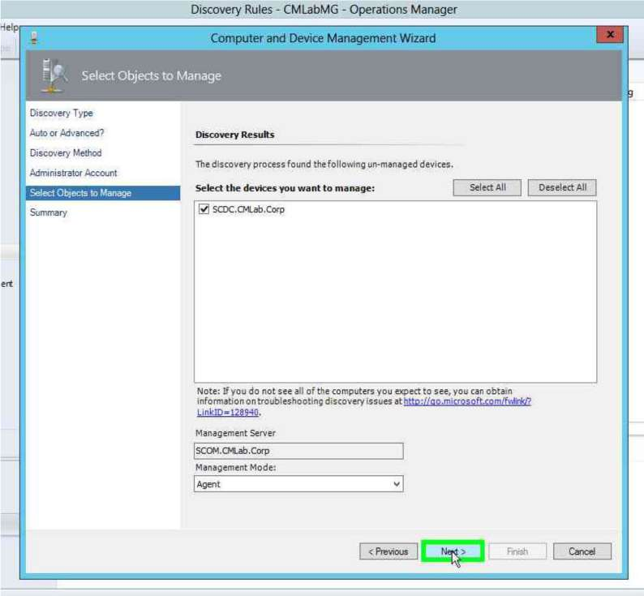

Select the Agent to be used – Agents or Agentless

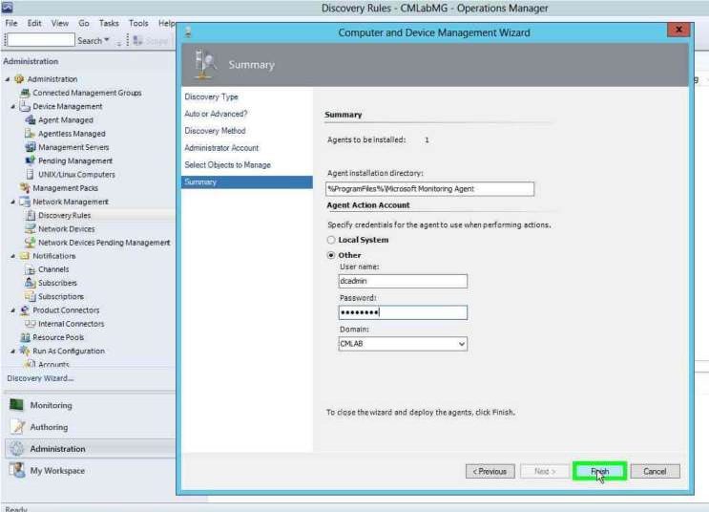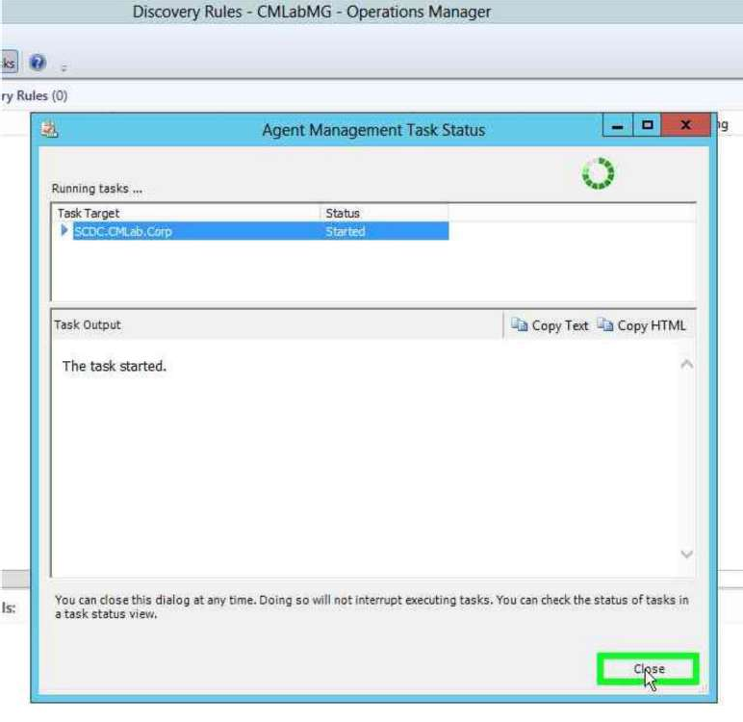

The server should show up as Healthy in the device managed screen.

# Implementing Microsoft System Center 2012 R2 Operations Manager Agents

The agent heartbeat interval can be configured from the settings screen

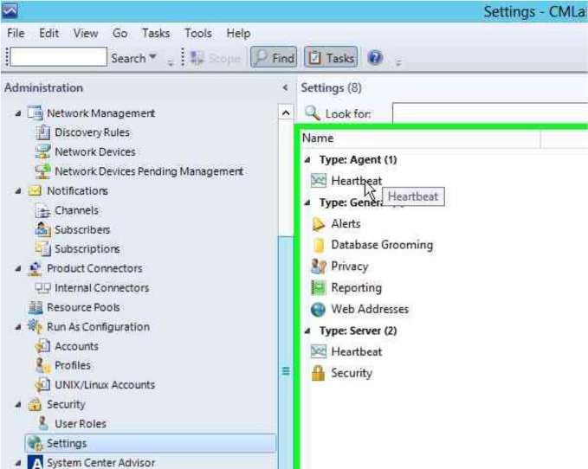

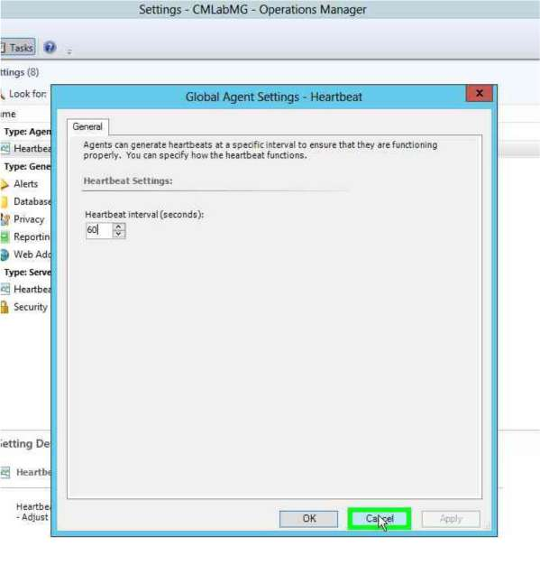

Go to **C:\Program Files \ System Center 2012\ Operations Manager\ Server\ Agent Management\** and copy the AMD64 folder to the machine on which you will be doing Performance Monitoring and run the setup from the folder over there.

That device will show up under Pending Device Management

# Configuring Operations Manager Monitoring Components

Go to Administration - > Device Managed and right click on a device name. Open will have various options

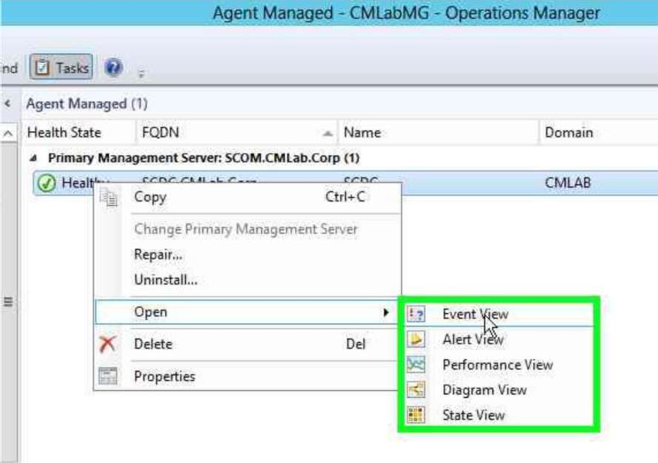

# Event View

This shows us the various events generated in the event log of the monitored machine.

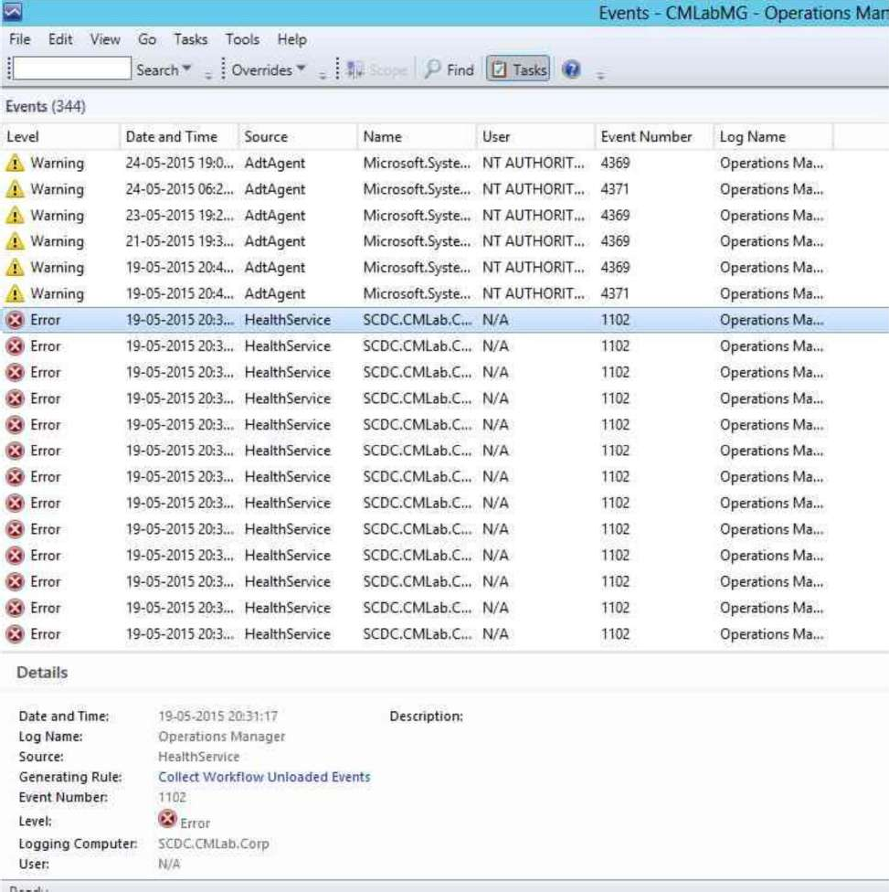

# State View

Shows us the state and state changes of the agent

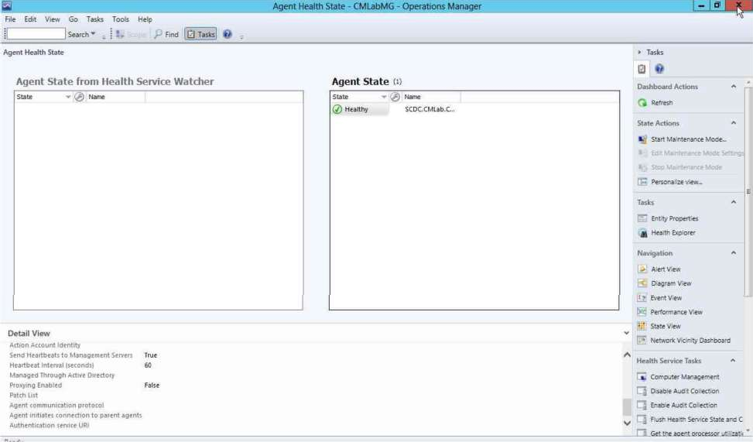

# Performance View

Allows us to plot various performance based metrics [CPU Utilization, Port Usage, etc] across the graph

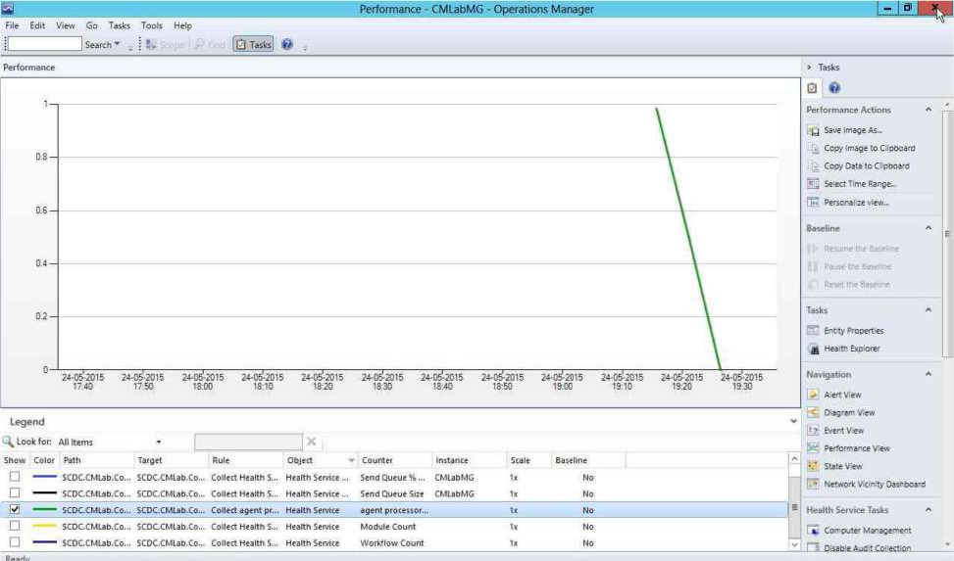

# Diagram View

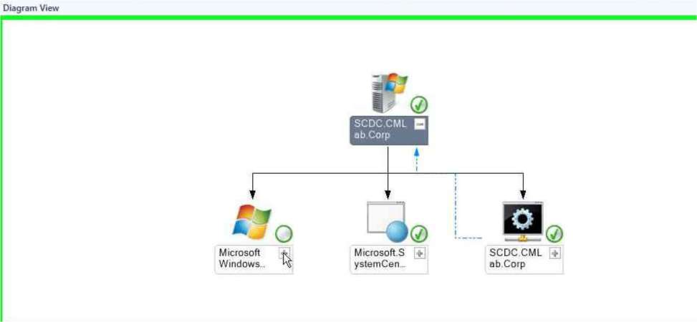

**Health Explorer**

Let’s us view issues with the health of the machine. It also specifies the cause and how to solve the issue

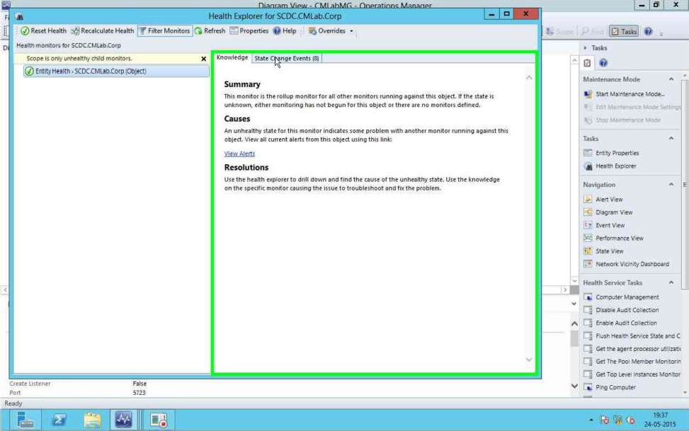

**The Windows Server and Network Monitoring sections are being explored**

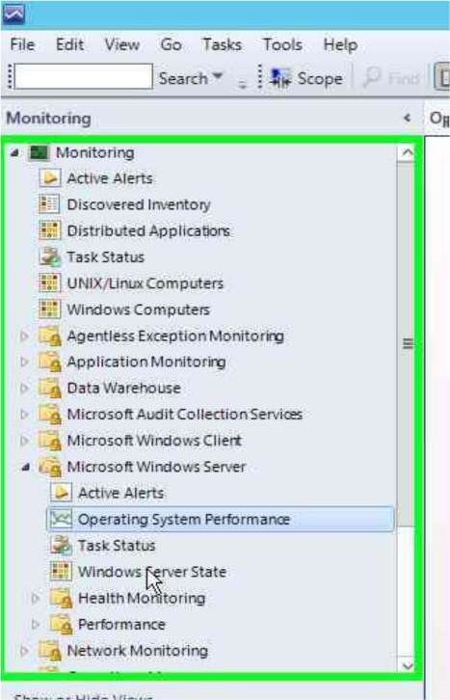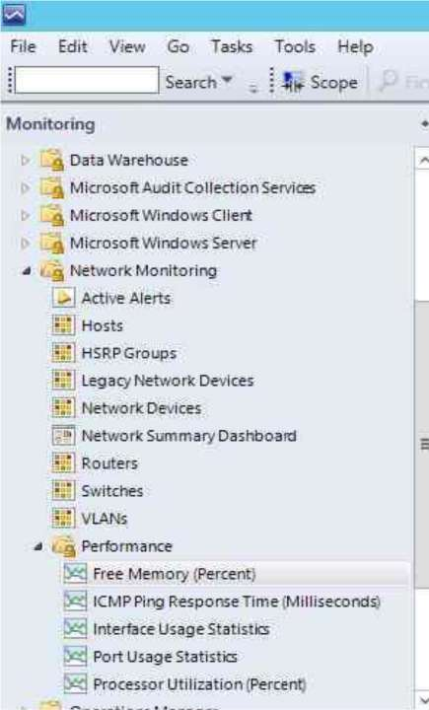

**For Network Devices**

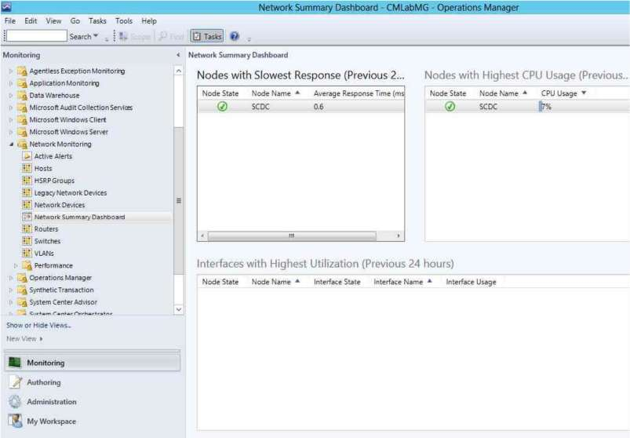

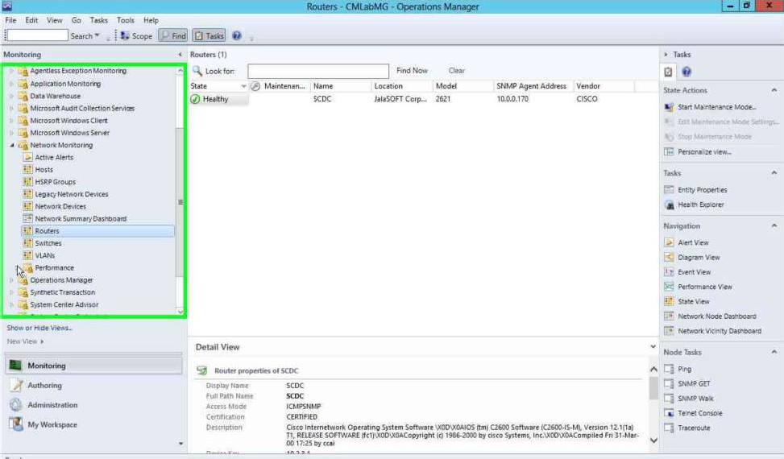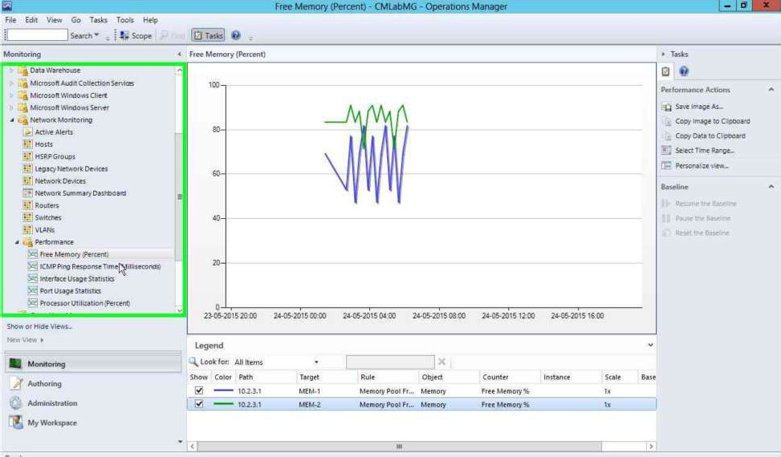

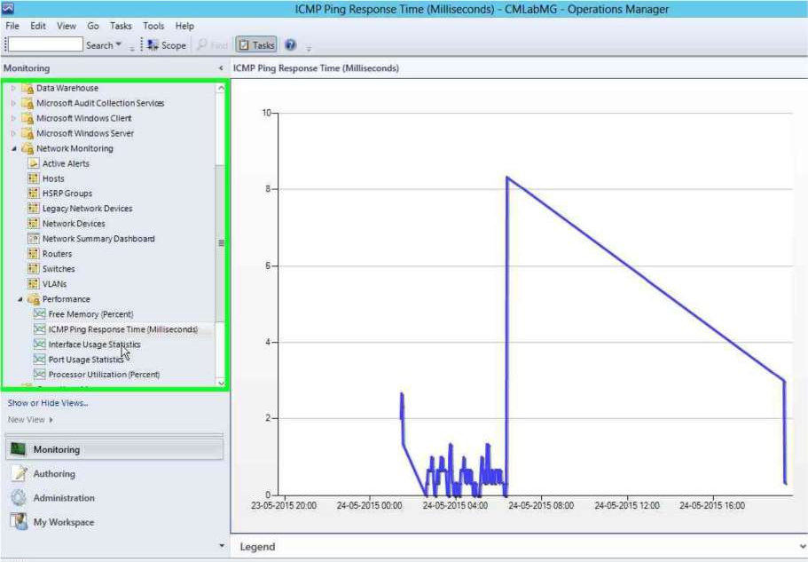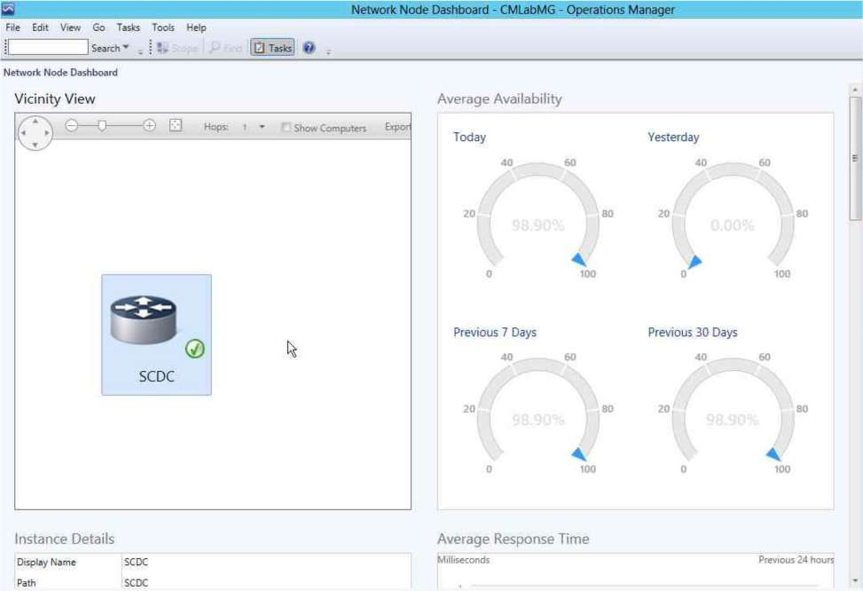

1. **Configuring Operations Manager Integration with System Center 2012 R2 Virtual Machine Manager (VMM)**

In VMM go to **Settings -> System Center Settings -> Operations Manager**

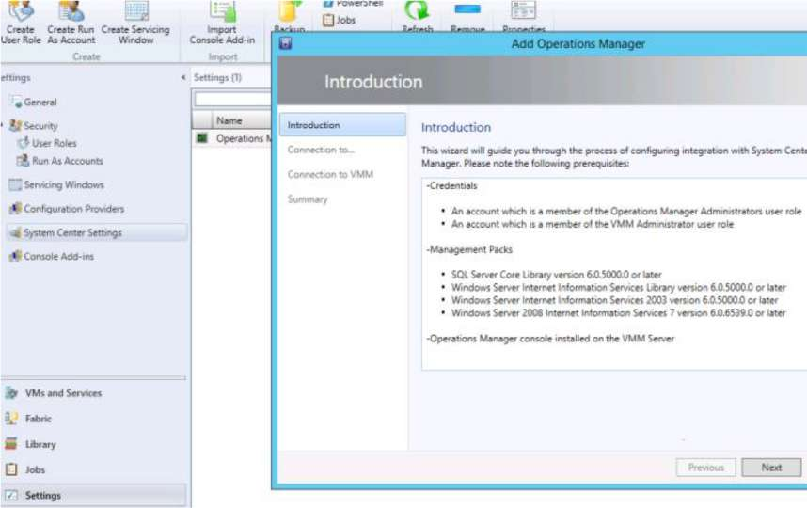

Specify the server and domain credentials to use [You can use the previously created VMM Admin **Run As Account**]

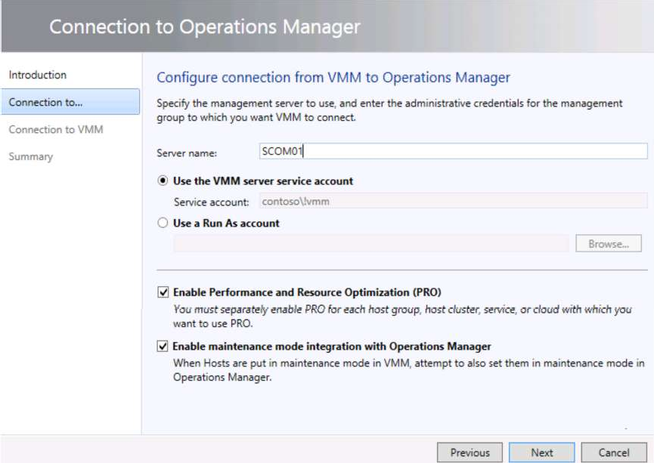

Specify the **Operation Manager Admin credentials**

Click **Finish**

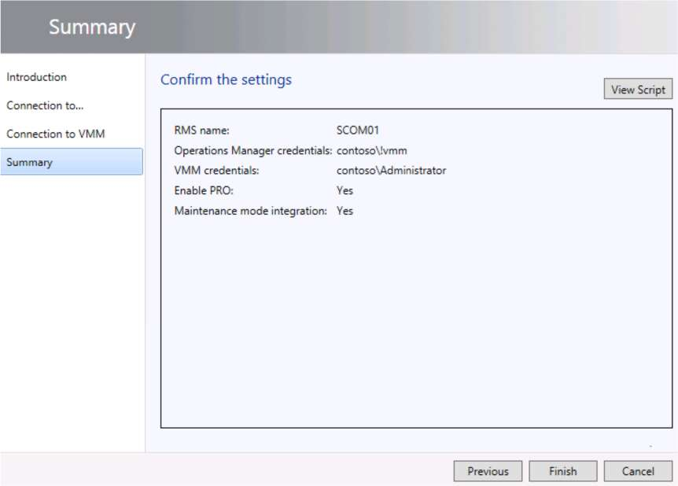

**PRACTICAL NUMBER** ➔ **6**

**USING ADVISOR FOR PROACTIVE MONITORING**

Open **Operations Manager** Console

# Reviewing a critical alert for a Virtual Machine Manager server and assigning an alert.

Go into **Authoring** and expand **Management Pack Objects**. Click on **Scope** and type **Logical Disk** and tick mark on **Windows Server 2012 Logical Disk**

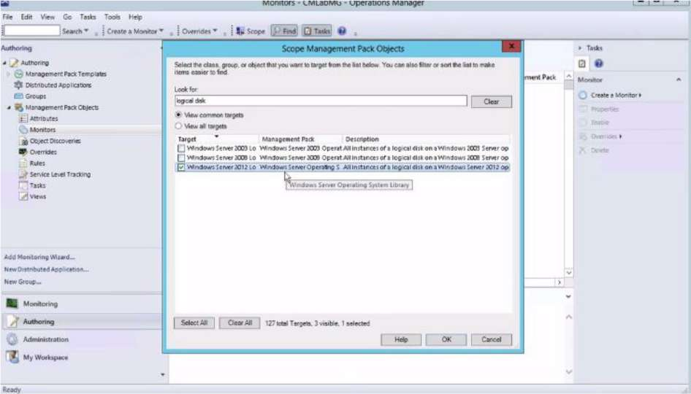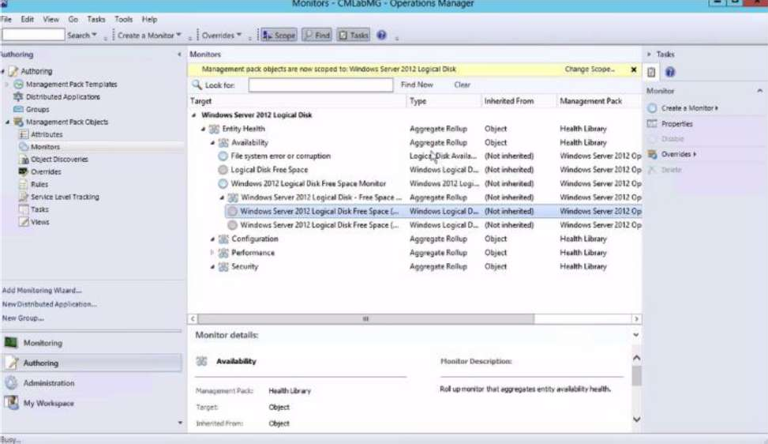

# Expand Entity Health→Availability→Windows Server 2012 Logical Disk Free Space. Right click on Server 2012 and choose Overrides→Override the Monitor→For all objects of class Windows Server 2012 Logical Disk

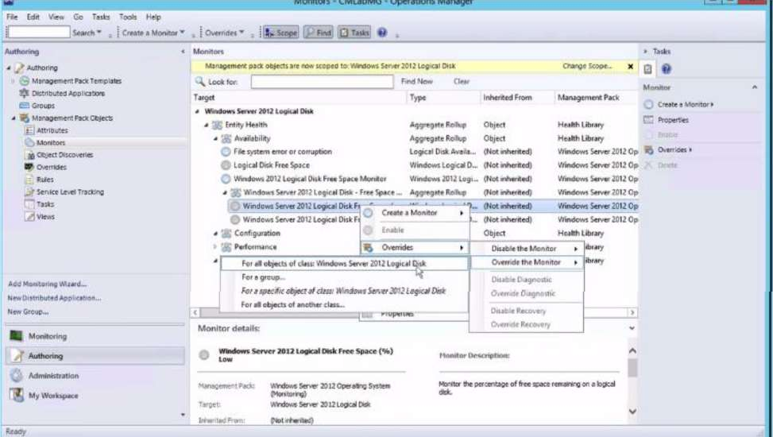

Tick mark the options in the override properties. Change the threshold values for Critical and warning values.

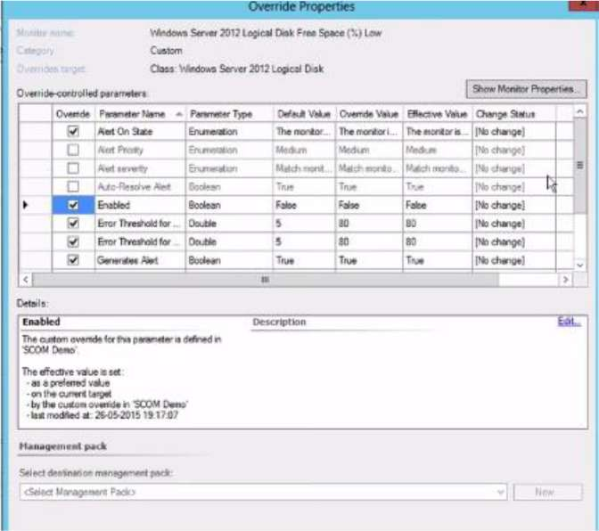

# Integrating Advisor with Operations Manager

Go to **Administration**→**System Center Advisor** and click on **Register to Advisor Service**

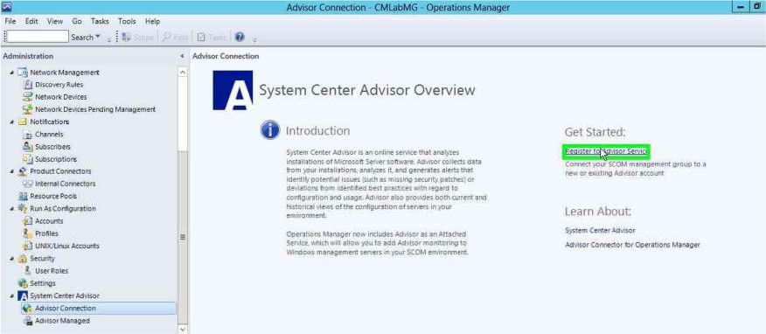

Select Microsoft Account

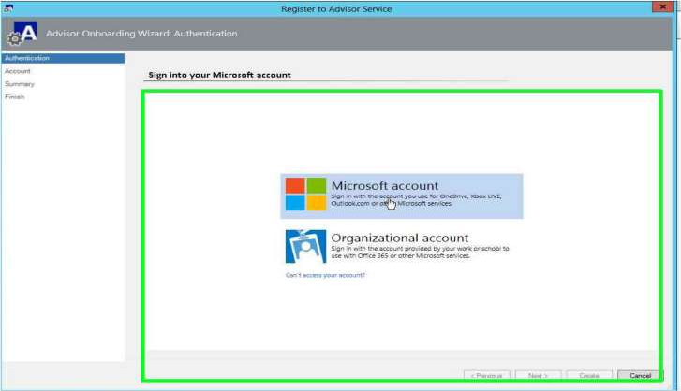

Enter your Microsoft details

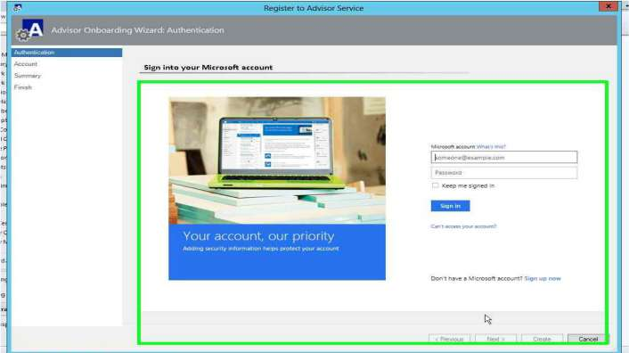

Give a name for the Advisor account

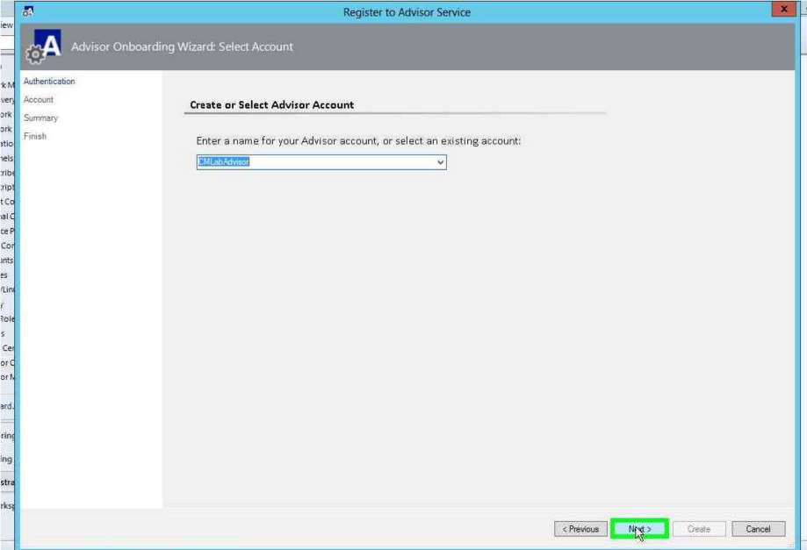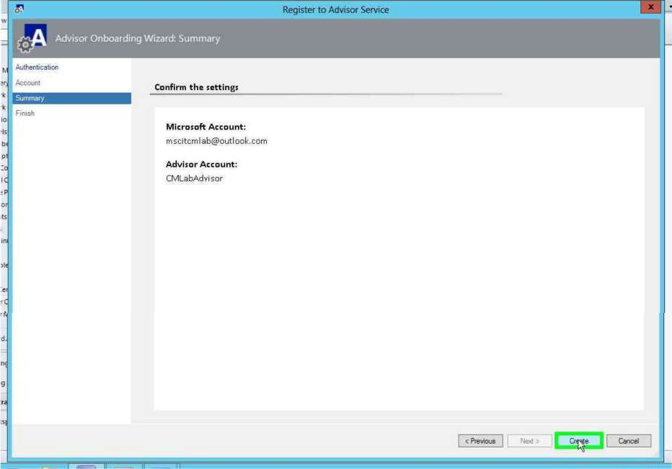

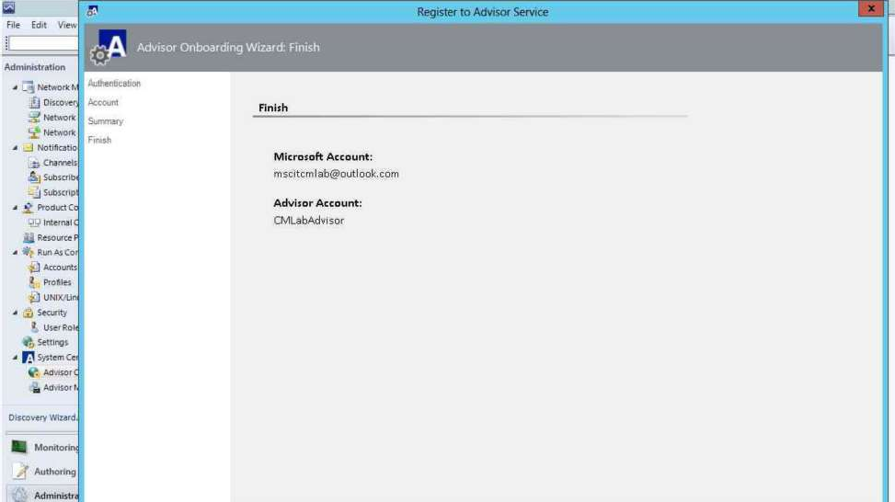

Computers need to be added to be monitored to SA by using the **Add Computer Group** option

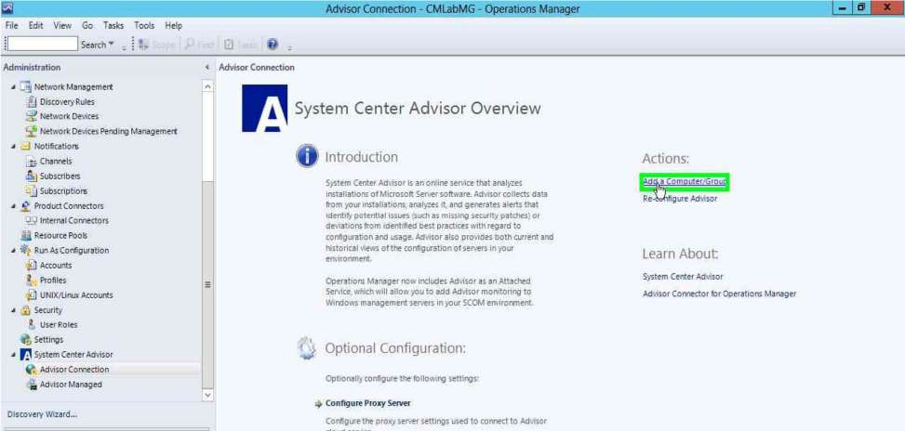

Click on **Search**, Choose the **Computers** and click **Add**

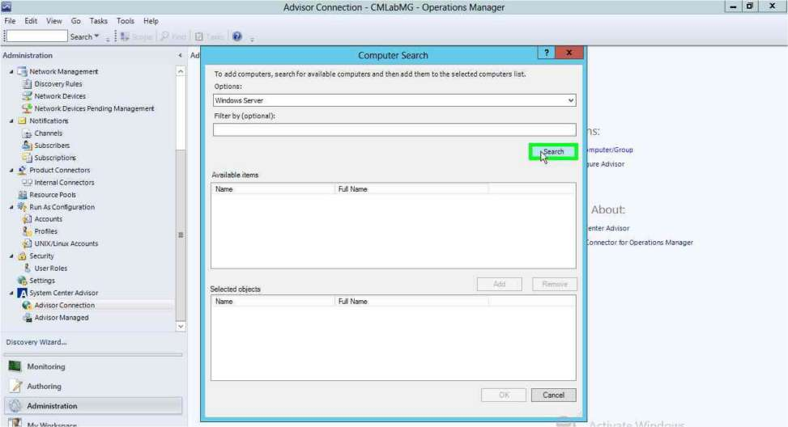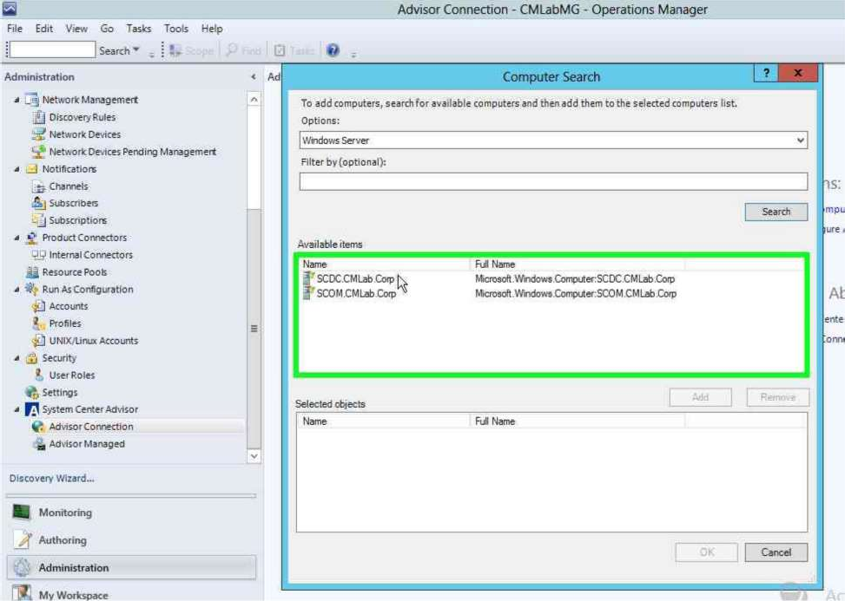

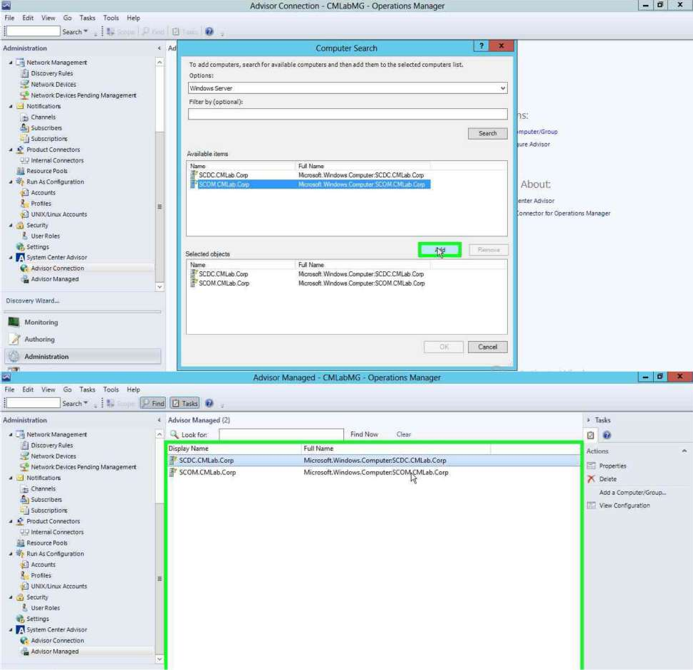

Computers will be visible under the **Advisor Managed** section

**PRACTICAL NUMBER** ➔ **7**

**USING SERVICE MANAGER TO STANDARDIZE**

Create a user group. In server manager go to **“Active Directory Users and Computers”**

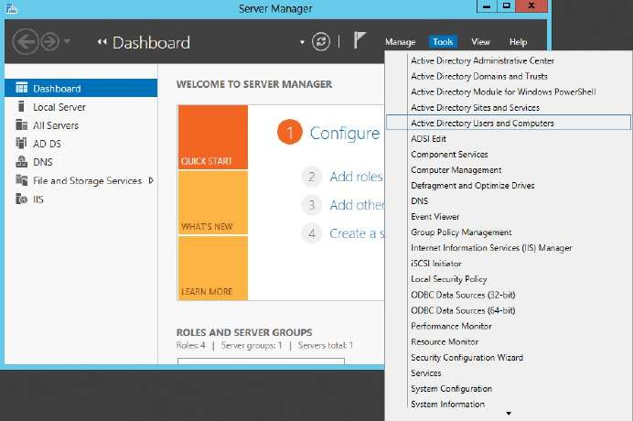

At the **Active Directory Users and Computers** window right click on **Managed Services Account**→**New**→**Group**.

At the New object window enter a **name** for the group, select **group scope as Global, group type as Security** and click on **“OK”**

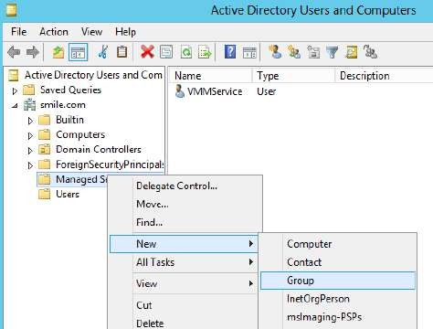 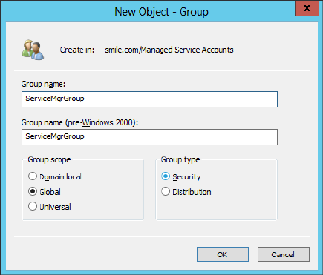

The group is created.

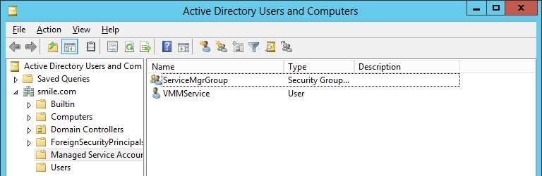

Create 3 users. Right click on **Managed Services Account**→**New**→**User**. At the New Object window enter a name (here, **SMA**) and click on **“Next”**

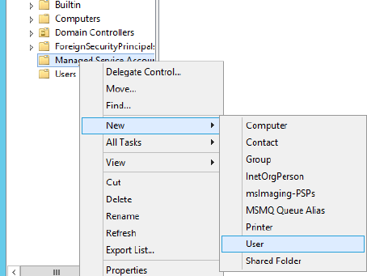 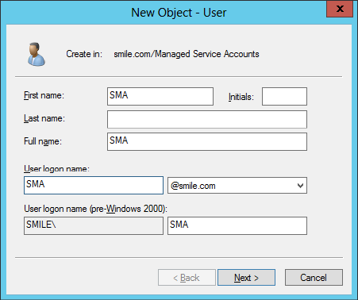

In next step enter a **password** and select **“Password never expires”** option. Click on **“Next”**. Click on **“Finish”**

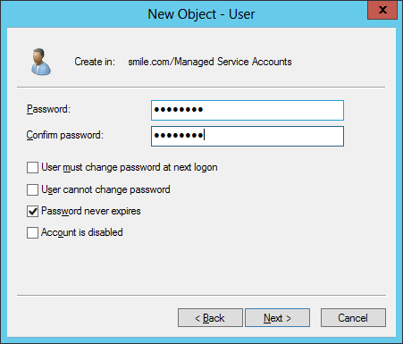 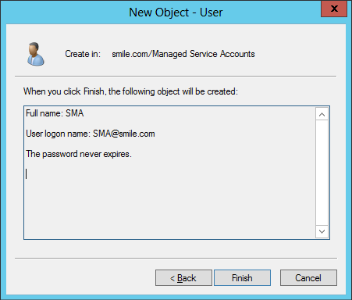

Follow the same steps to create two more users **WFA** and **SMMA** as the above steps. All the three created users are now listed. Add them to Administrator group.

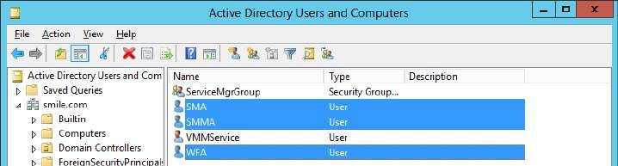

Right click on a user select **“Add to a group…”** option.

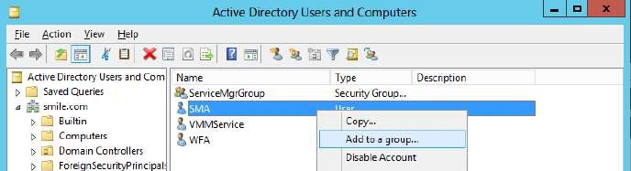

In the **Select Groups** window type initial letters of administrator user name and click on **“Check Names”**. It lists the **Administrators** account. Click on **“OK”**

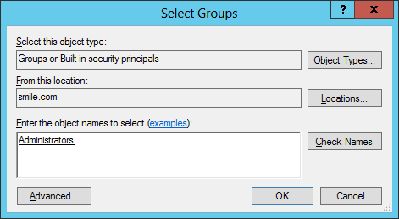

Follow the above steps to add the remaining users to the **Administrators** group. Also add your **ServiceMgrGroup** to the Administrators group.

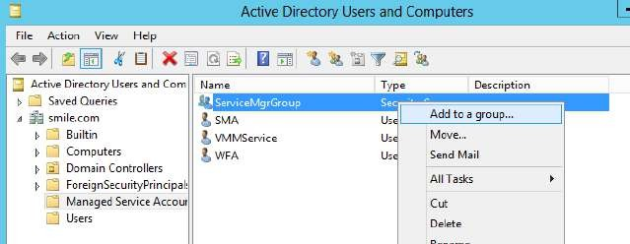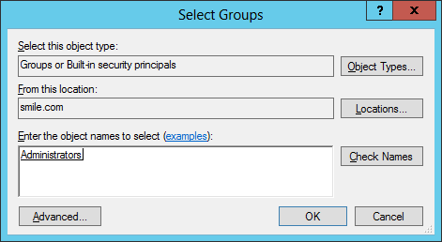

Run the **SQL Server setup** file.

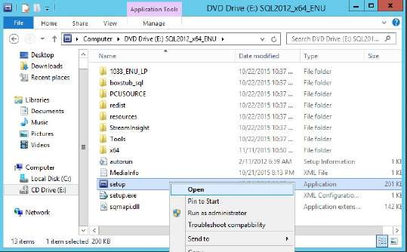

Continue with the installation steps as shown in previous practical (refer practical 1). At the

**Feature selection** step select **Instance Features**→**Analysis Services** and click on **“Next”**

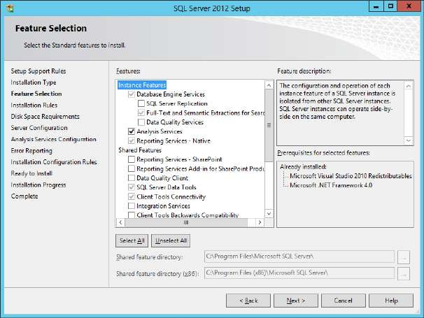

A the **Server Configuration** step, in **Service Accounts** tab, enter account name. This will open the **Select user** window, type the user name SMA and click on **“Check Names”**. Then click on **“OK”**

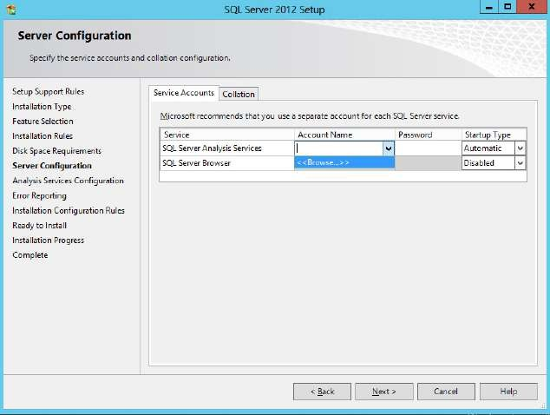

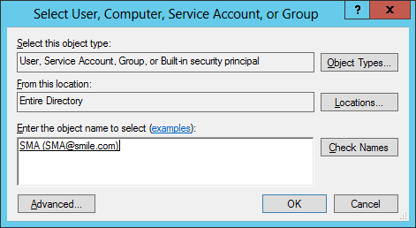

Enter the password for the user then click on **“Next”**

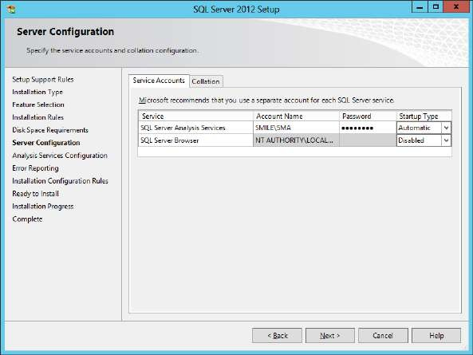

In next step click on **“Add Current User”**, Administrators user is added, click on **“Next”**

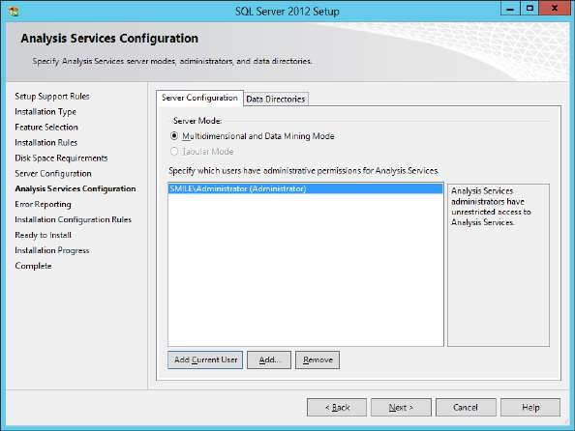

Click on **“Next”** in the next two steps.

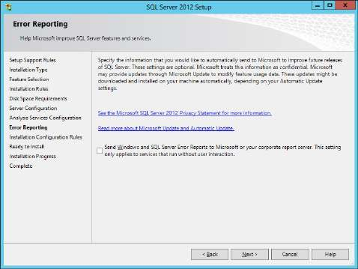 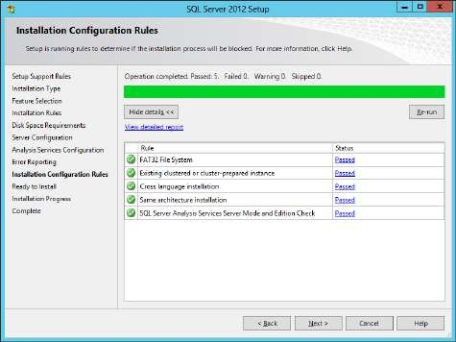

Click on **“Install”**. Click on **“Close”**

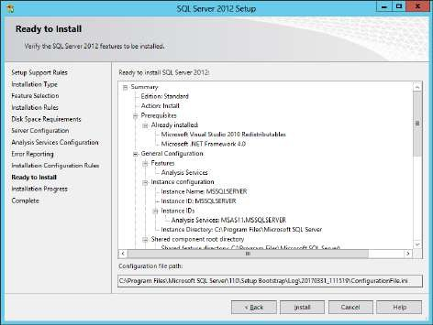 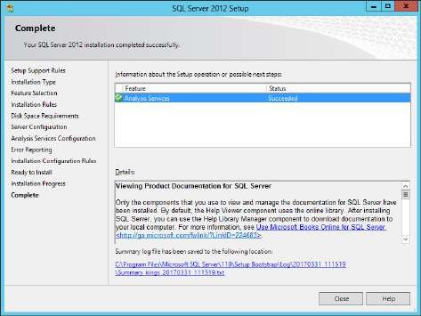

Mount the Service Manager iso file. Open **amd64** folder (since Windows Server 2012 is a 64 bit system) and run the setup file. Right click on the setup file and select **“Run as administrator”**

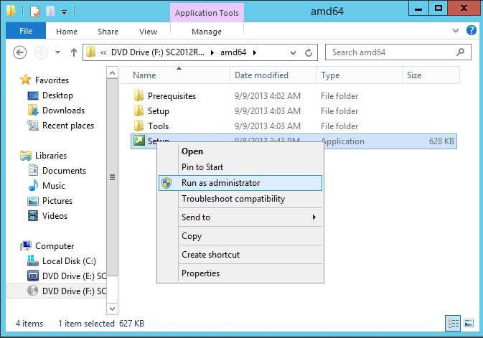

Click on **“Install”**. No product key is available, accept the license agreement click on **“Next”**

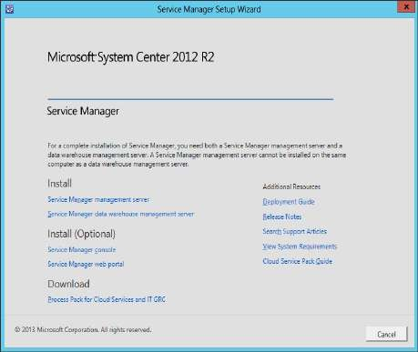 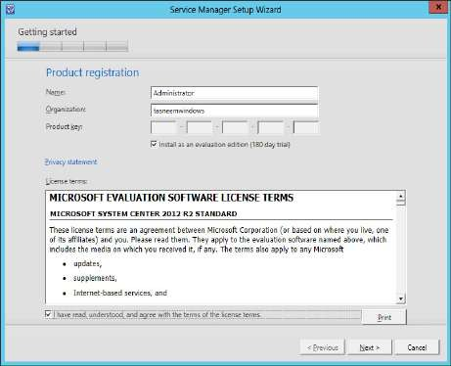

At Installation location step click on **“Next”**. In the next step it checks for prerequisites.

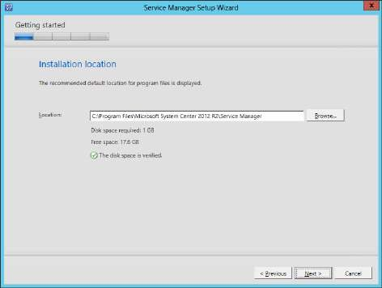 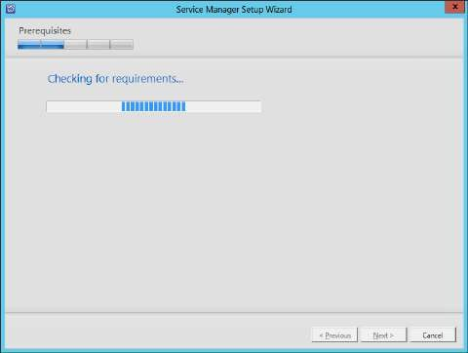

It is showing a prerequisite is not installed.

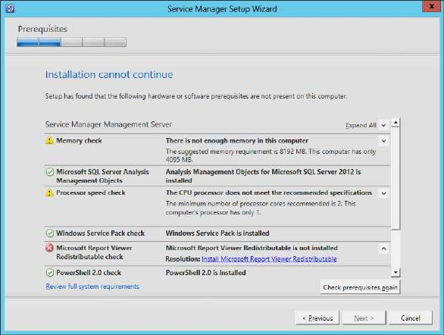

Install the **Report Viewer** redistribution

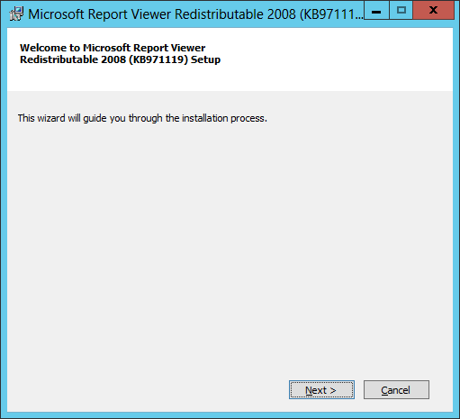 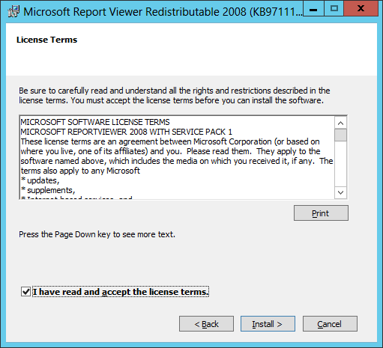

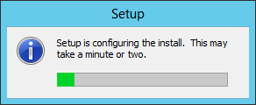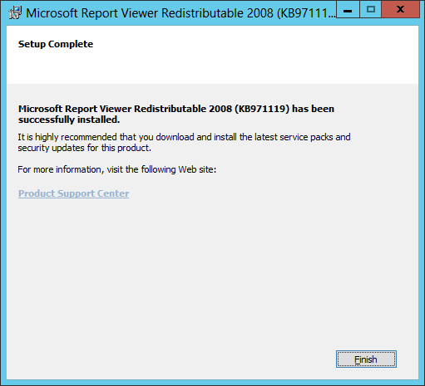

Again at the **Service Manager Setup Wizard** go to **previous** step and click on **“Next”**. It will again check for prerequisites and this time it will be successful. Click on **“Next”**

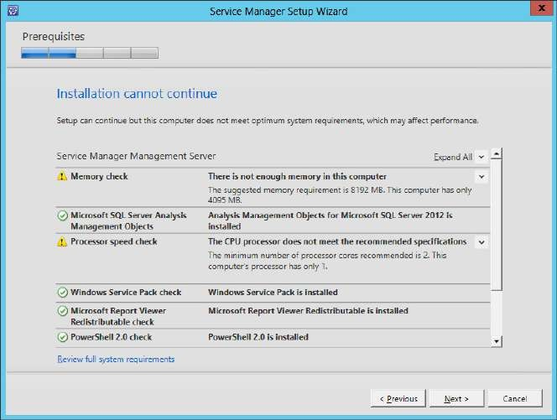

At the **Database Configuration** step, check the following screenshots.

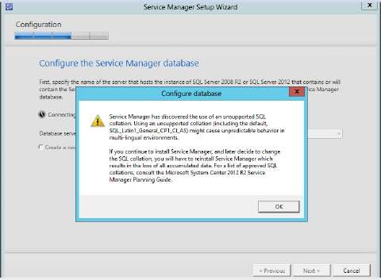 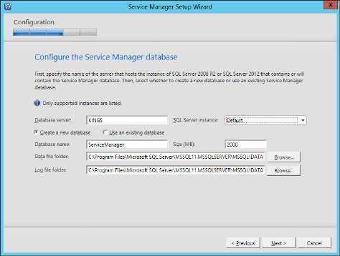

Enter the Management group name as **“ServiceMgrGroup”** click on **“Next”**

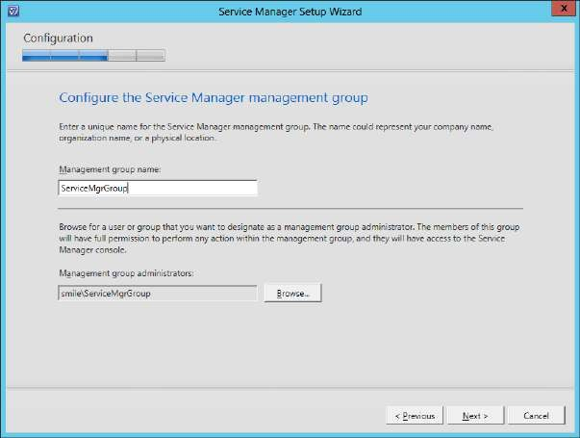

In the next steps configure the created user accounts respective to the services.

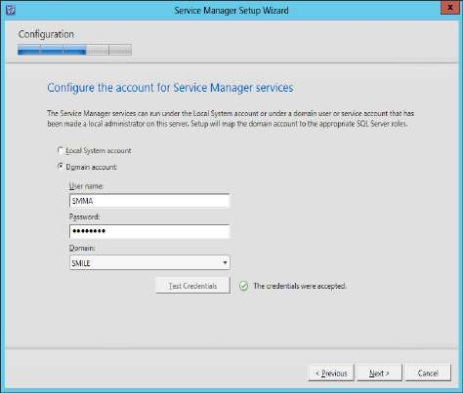 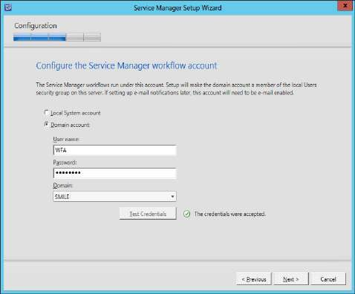

At the Microsoft offers select **“No…”** and click on **“Next”**. Click on **“Install”**

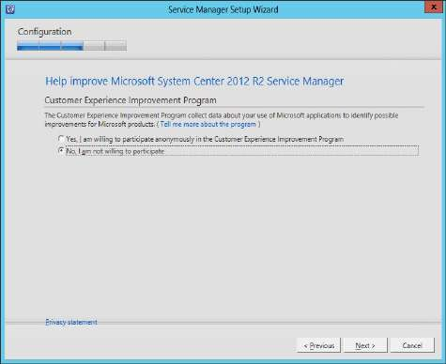 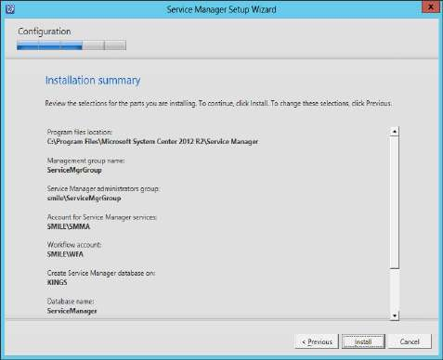

After the completion of installation click on **“Close”**

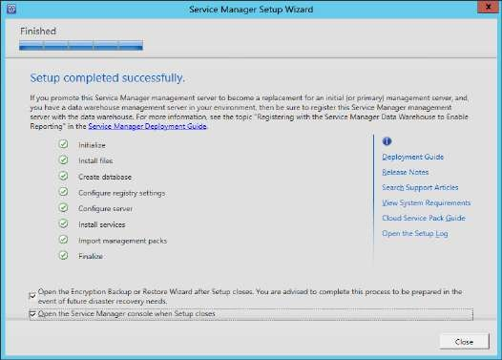

# Open Service Manager Console.

In the left pane go to **Administration**→**Settings**. In the Middle pane **Incident Settings** can be seen

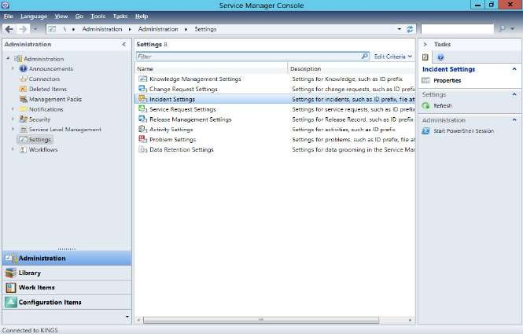

Go to **Work Items** in the left bottom pane. In the right top corner click on **Create Incident**.

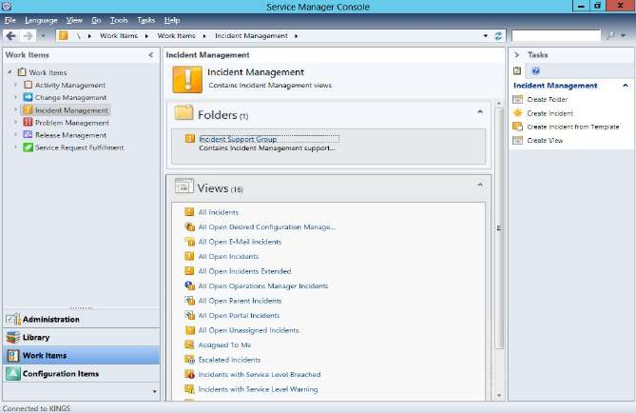 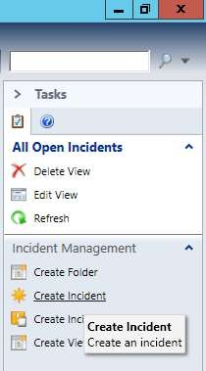

For **Affected User** field browse and select the **SMMA** user.

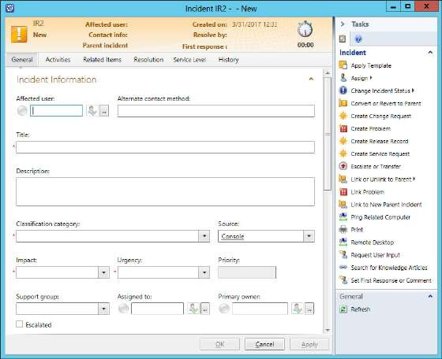 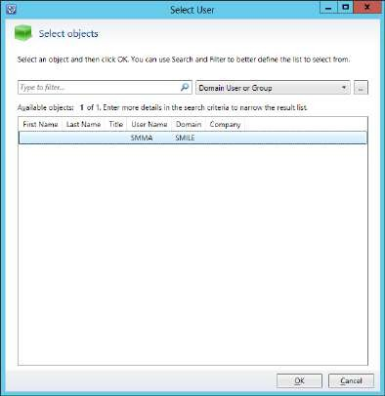

Enter other required details and click on **“Apply”** then **“OK”**

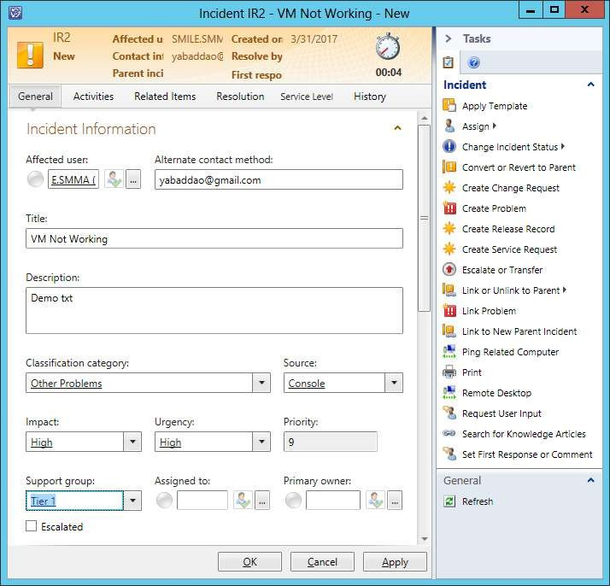

At the main window of **Service Manager Console** the new incident is listed and its details are displayed.

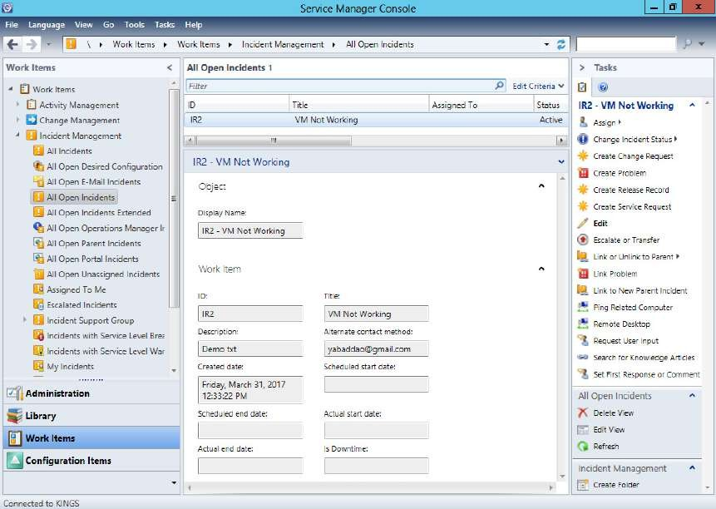

In the left bottom pane click on **Library**. Then I the top right corner click on **Create Request Offering**

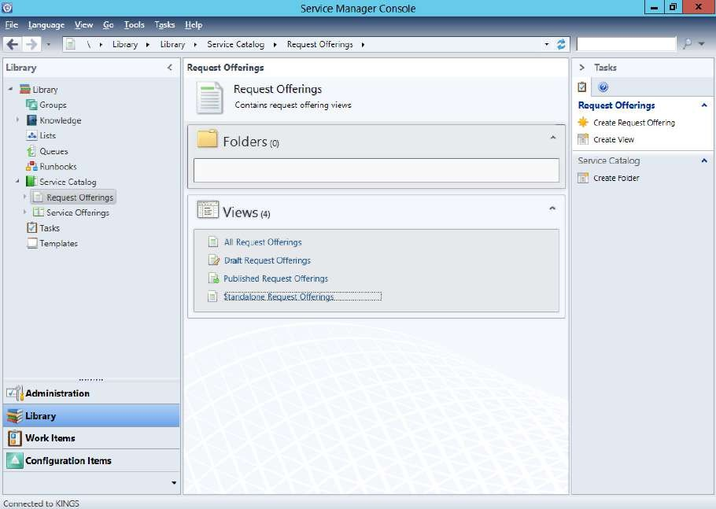

At the Create Request Offering window click on **“Next”**

In the next step enter a **name** and click on **“Select template”**

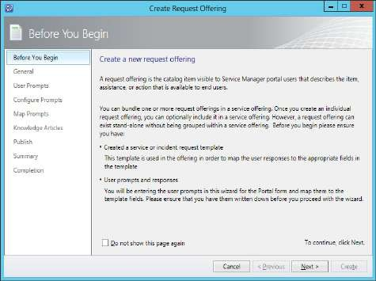 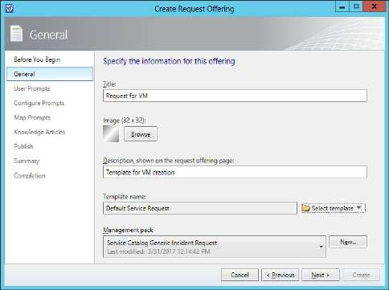

Select the **Default Service Request** and click on **“OK”**

In the next step just click on **“Next”**

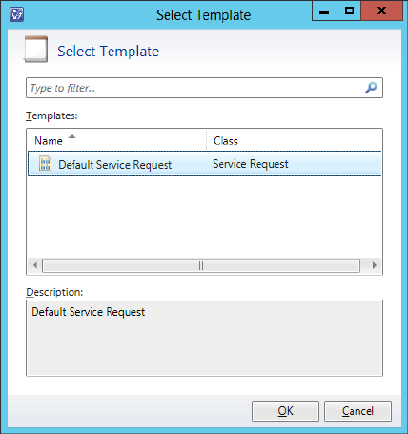 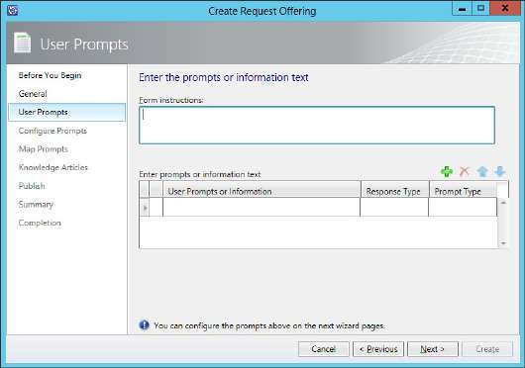

Click on **“Next”**. Select **Display common properties** and…

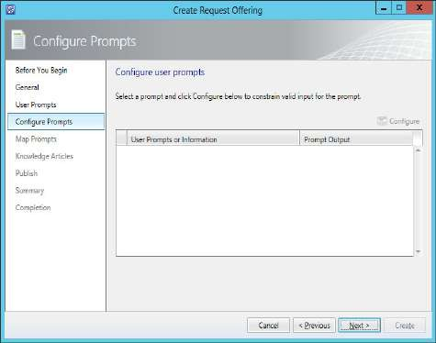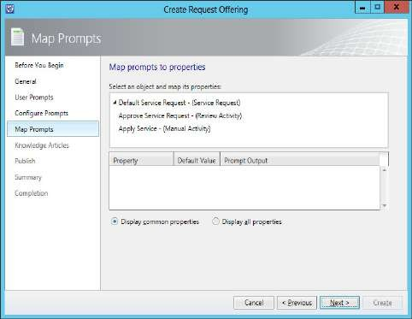

Select **Default Service Request** and click on **“Next”**

In the next step click on **“Next”**

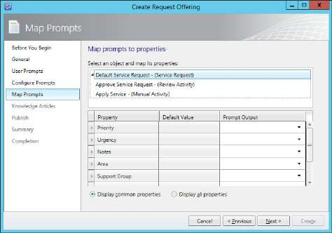 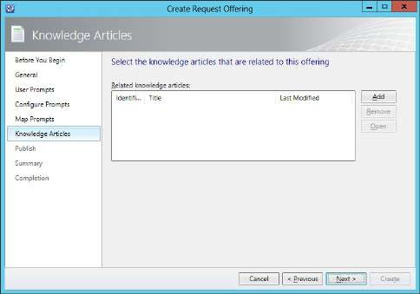

In the next step the **Offering status** should be **Published** and click on **“Next”**

In the Summary step it will take some time to process and then install the request offering.

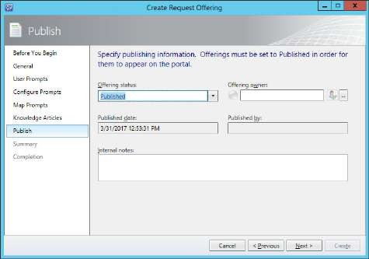 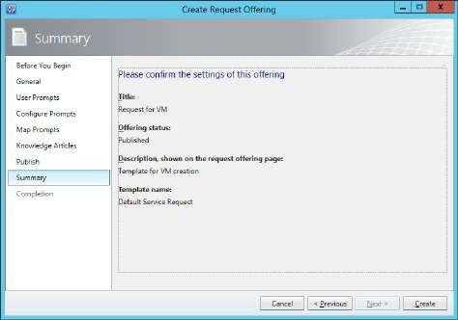

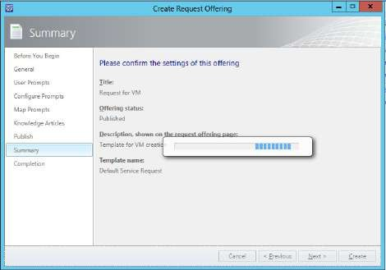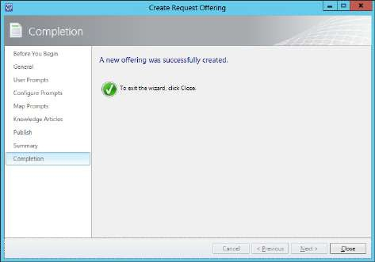

At the main window of Service Manager Console.

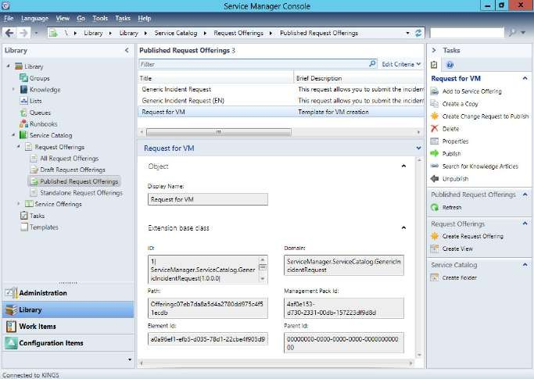

Click on Work Items in the left bottom pane. In the right top corner click on Create Service Request

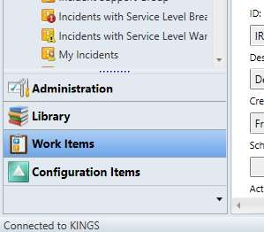 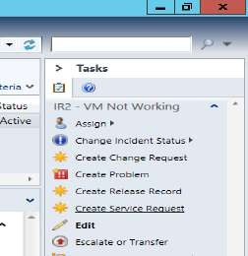

At the **Request Offering** window select **Request for VM** and click on **“OK”**

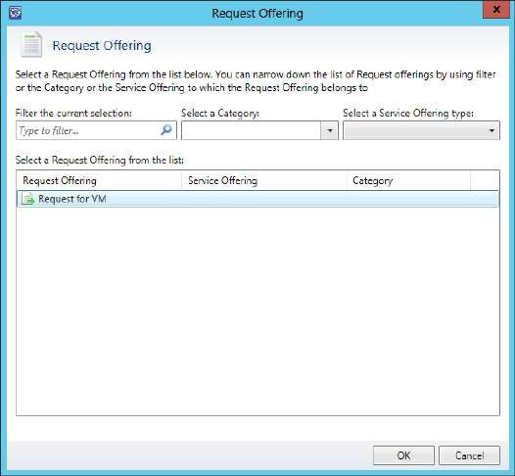

At the **VM Not Working** window enter the required details and click on **“Next”**

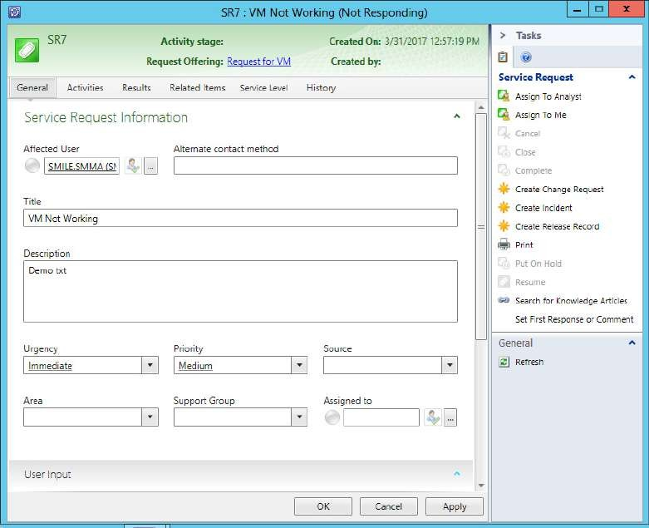

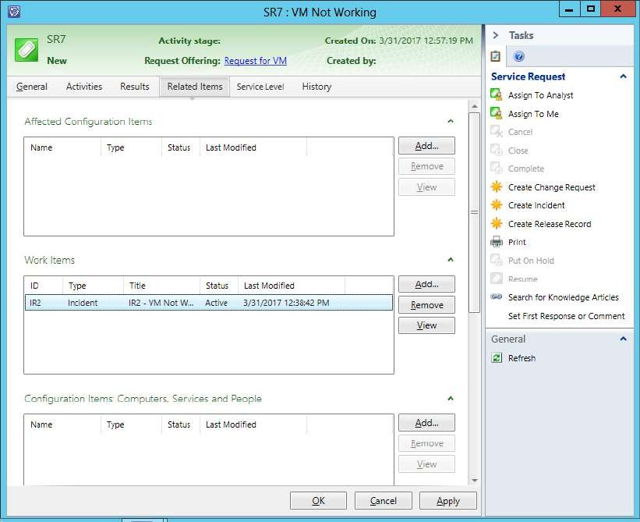

Now go to all incidents and click on change incident status

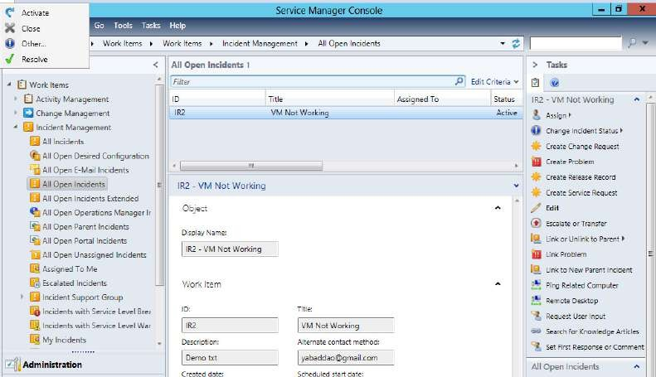

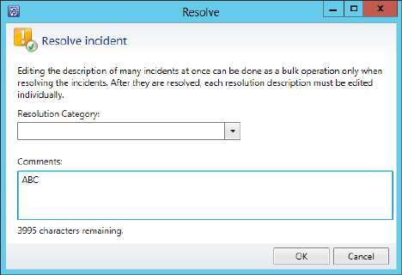

Click on **Refresh**

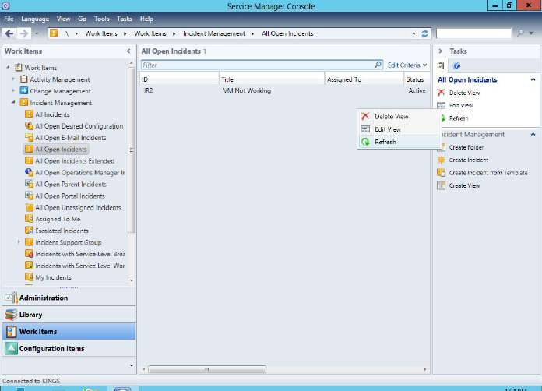

Click on **Close**

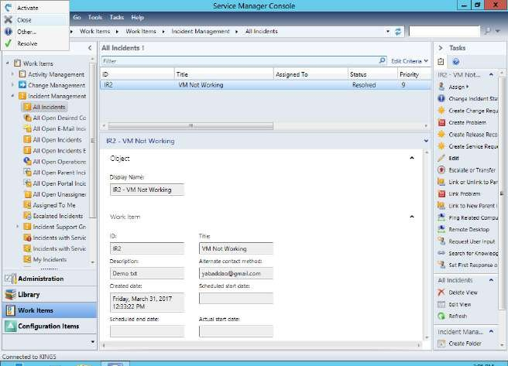

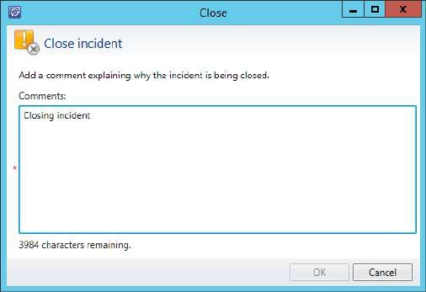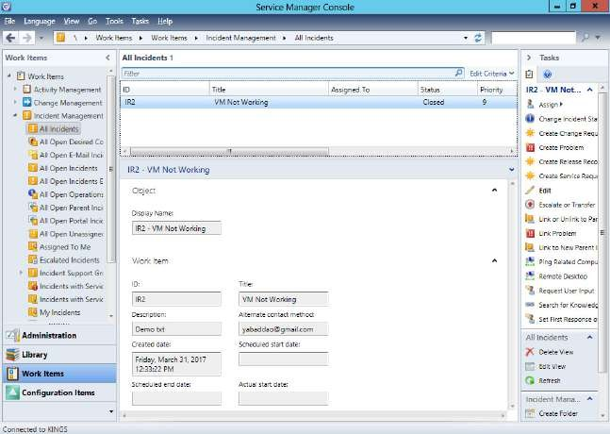

**PRACTICAL NUMBER** ➔ **8**

**USING ORCHESTRATOR FOR AUTOMATION**

# Prerequisites:

1. VMware ESXi Server
2. SQL Server 2012, with Database Engine feature
3. Add roles and features: windows authentication
4. vSphere Client to connect to the remote system ESXi server

**Step 1: VMware ESXi Server. Installed as a remote server (note down its IP address, (here it is, 192.168.206.133) username and password)**

**Step 2: SQL Server 2012 with Database Engine feature. It is already installed in my system. If in your system it is not installed then install it (refer practical 1).**

**Step 3: Add roles and features: Windows Authentication. Already installed (Refer practical 5)**

**Step 4: vSphere Client is already installed and is tested whether it is connecting to the ESXi server.**

**Step 5: Orchestrator setup**

**Copy paste the ISO file** of orchestrator from **host to VM** system. **Mount the ISO** file of Orchestrator in VM, then **run the setup** file.

At the **Orchestrator setup** window click on **“Install”**

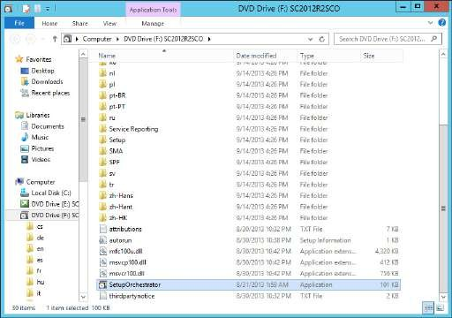 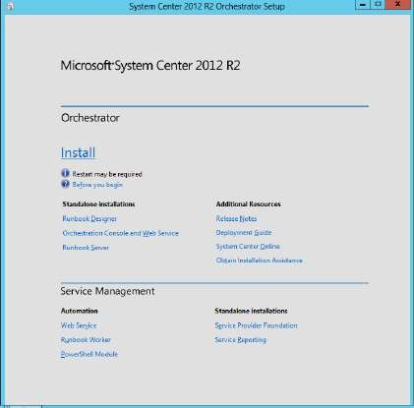

Skip the **Product Registration** step and click on **“Next”**

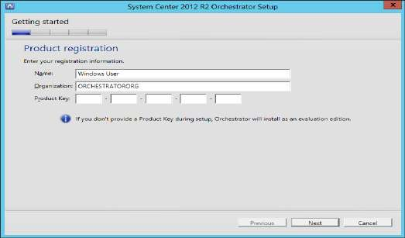

Accept the **License Agreement** and click on **“Next”**

In next step select all the features to install, click on **“Next”**

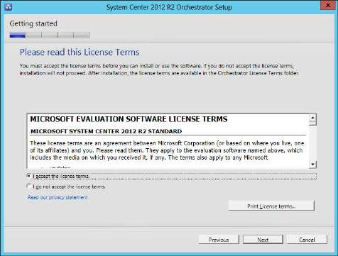 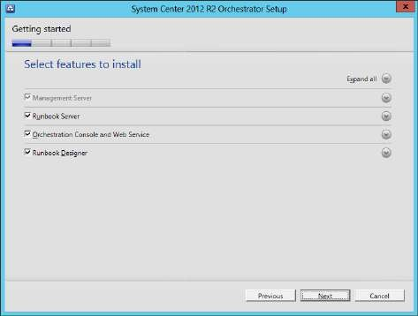

It checks for prerequisites, if all are available it will proceed to next step.

At the **Configure the service account** step enter username as **domainname\administrator**

(here it is, **WINCMDOMAIN1\Administrator**) and password. Click on **“Test”**

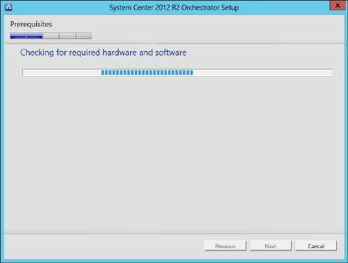 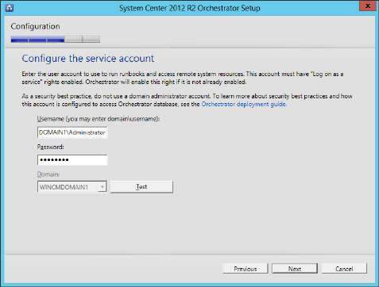

If the credentials are tested and are accepted then click on **“Next”**

At the **Configure the database server** step enter the **SQL Server Instance** (with system server name) that was created during the SQL Server installation (here it is, **WINSERVER2012\MSSQLSERVER**) and click on **“Test Database Connection”**

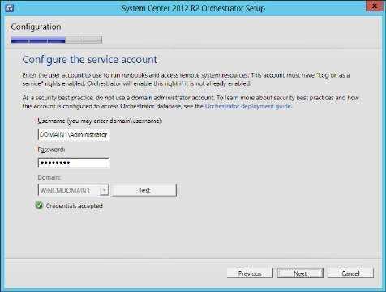 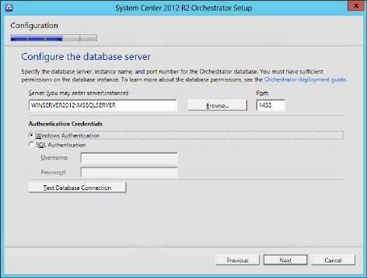

When the database is successfully tested, click on **“Next”** button.

At this step select **“New Database”** and give a name to it. Click on **“Next”**

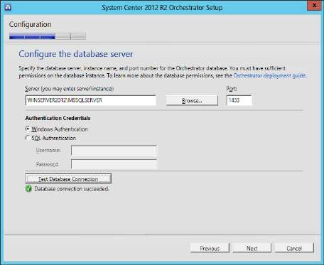 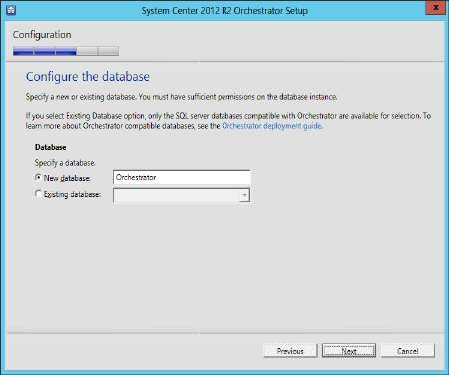

In the next step keep the **default** settings and click on **“Next”**

For port settings keep the **default** values and click on **“Next”**

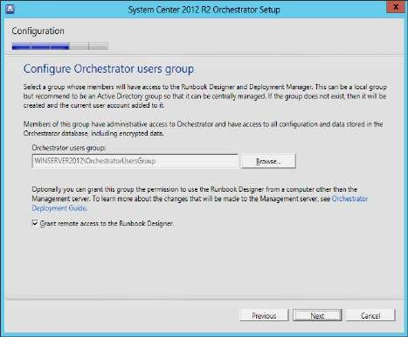 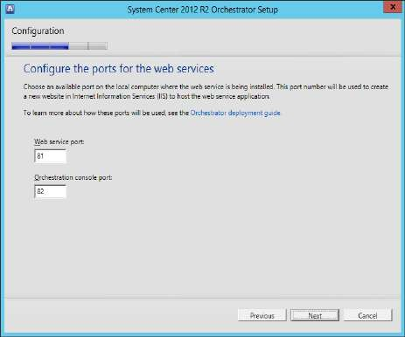

Leave the default installation location as it is and click on **“Next”**

Next step select **“No…”** for both the offers of Microsoft and click on **“Next”**

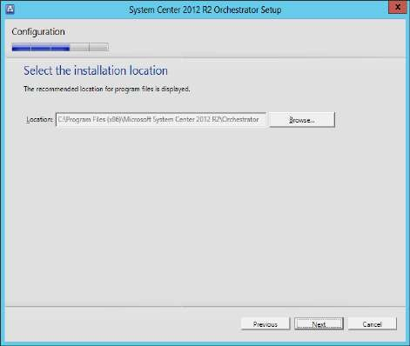 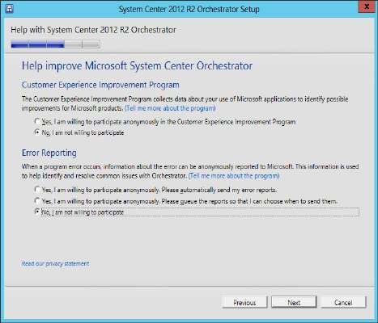

At the **summary** screen click on **“Install”**

After the completion o finstallation click on **“Close”**

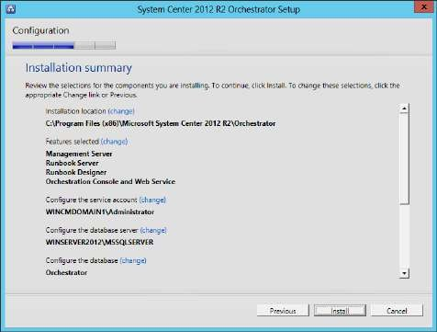 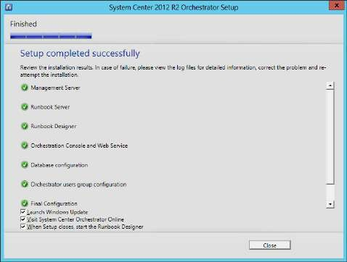

# Step 6: Integration Packs

Copy and paste the Integration packs from host to VM. Mount it, Extract it.

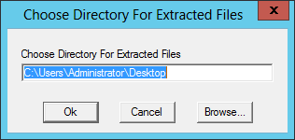 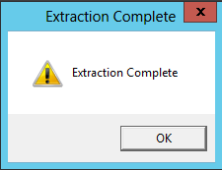

After extraction three files are to seen at the destination location of extracted files.

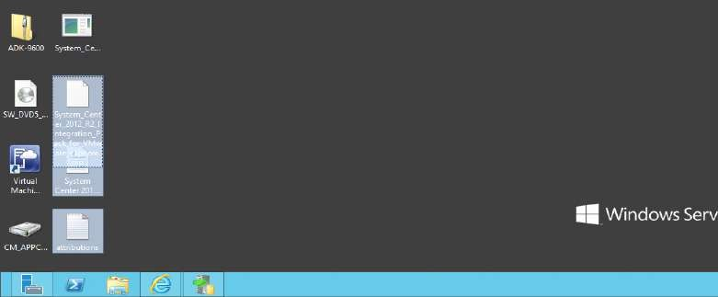

# Step 7: Deployment Manager

Open orchestrator **Deployment Manager**

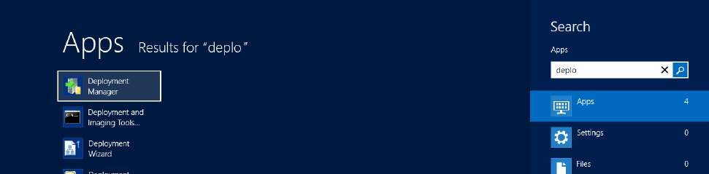

In the left pane **Integration Packs** can be seen. Right click on it and select **“Register IP with the Orchestrator Management Server...”**

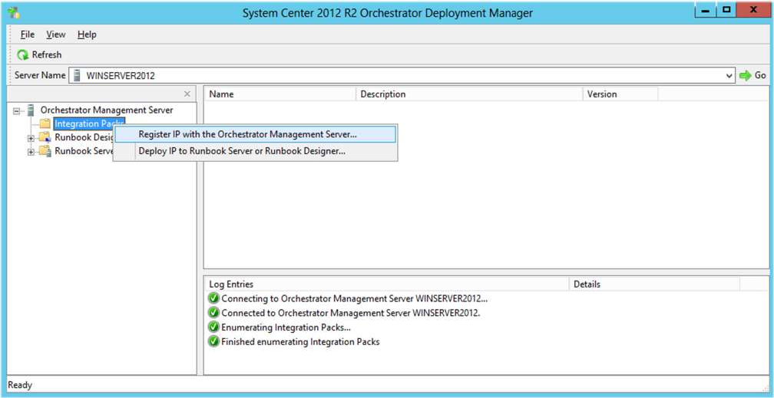

At the **Integration Pack Registration Wizard** click on **“Next”**

In next step click on **“Add”**

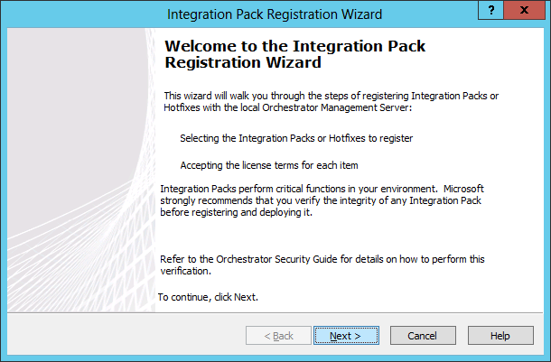 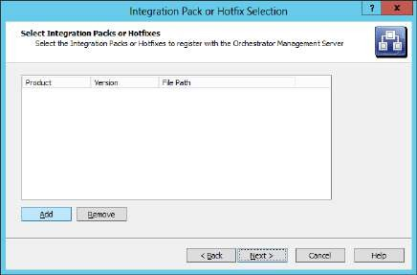

Select **.oip** file from the extracted files and click on **“Open”**, Click on **“Next”**

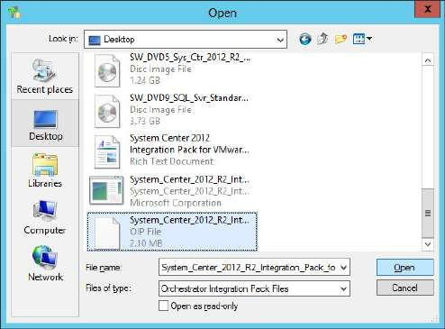 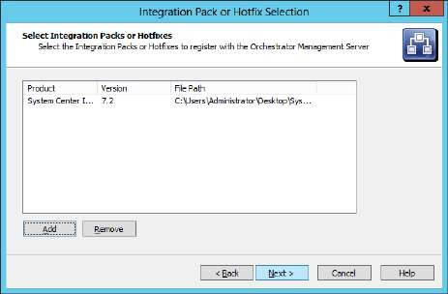

At the completion screen click on **“Finish”**. **“Accept”** the **License Terms**.

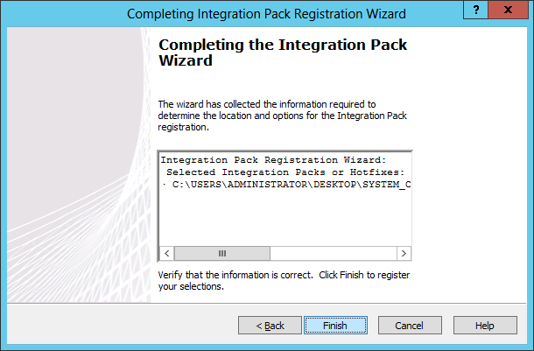 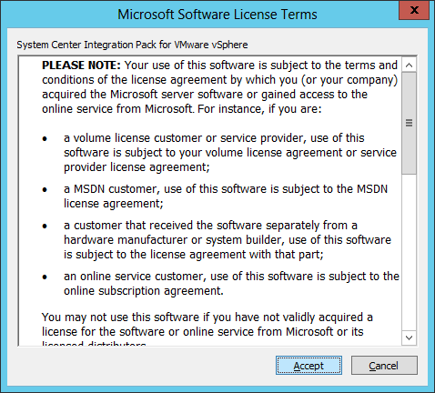

The result of registration can be seen at the bottom pane of the screen

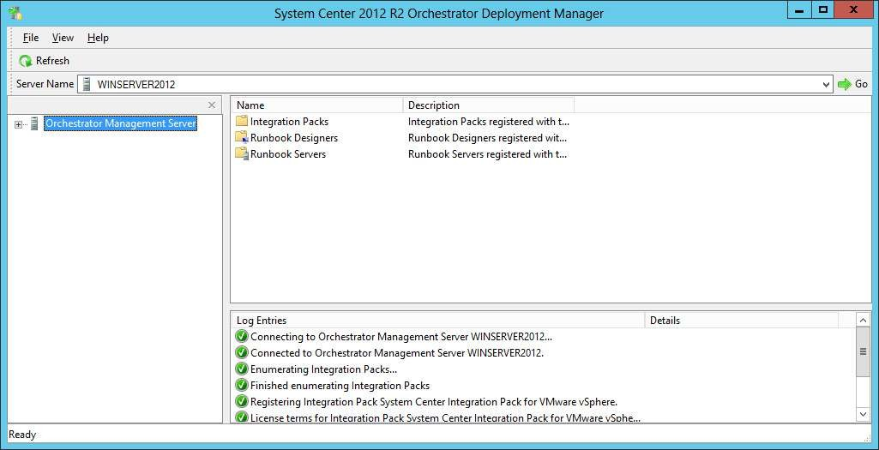

At **Orchestrator Deployment Manager** right click on **Integration Packs** and select **“Deploy IP to Runbook Server or Runbook Designer…”**

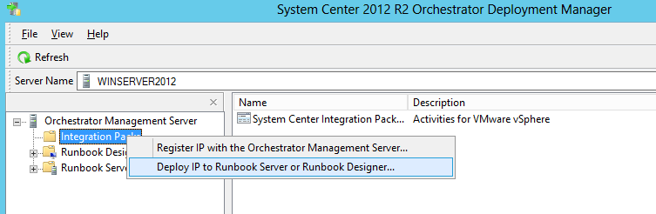

At the **Integration Pack Deployment wizard** click on **“Next”**

In the next step select the **“System Center Integration Pack for VMware vSphere”** option and click on **“Next”**

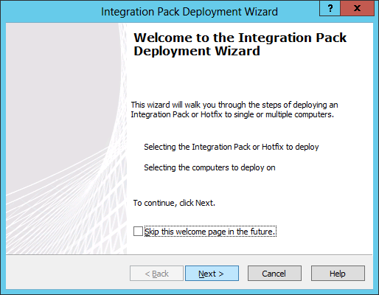 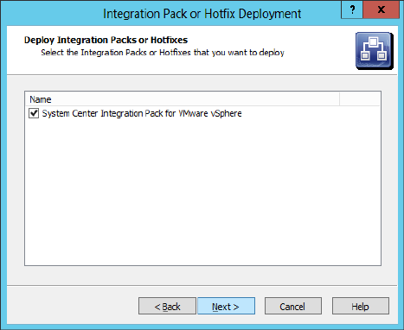

In the **Computer Selectio**n step type **your server’s name** and click on **“Add”** button. Then click on **“Next”** button.

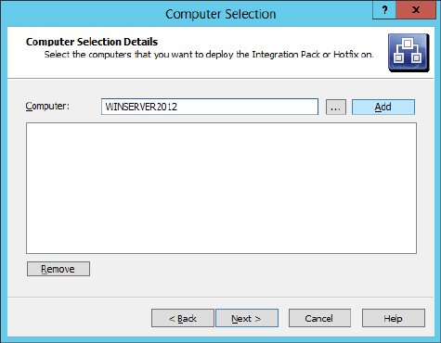 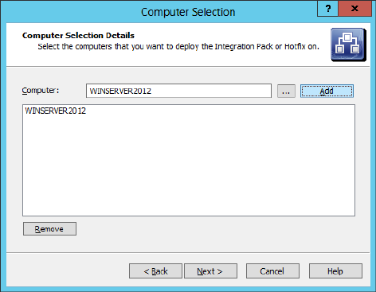

At the **Installation Configuration** step select **“Stop all running Runbooks before installing the Integration packs or Hotfixes”** and click on **“Next”** button.

At the Completion step click on **“Finish”** button.

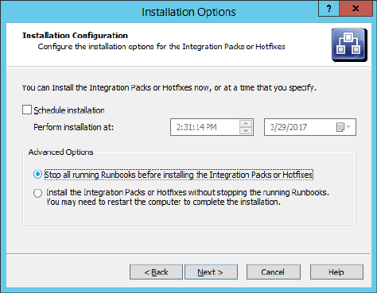 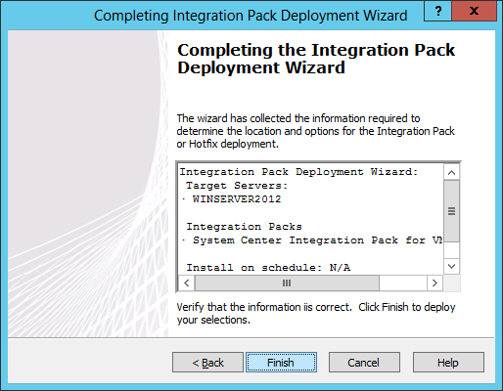

The result of deployment can be seen at the bottom pane of the screen

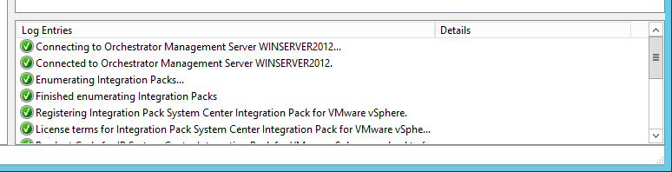

# Step 8: Runbook Designer

Open **Runbook Designer**

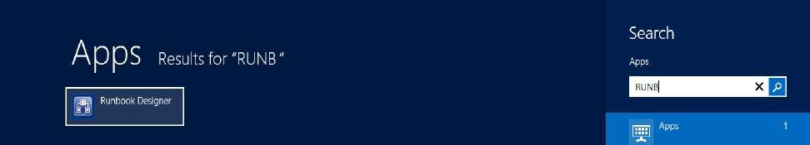

The Runbook Designer looks like…

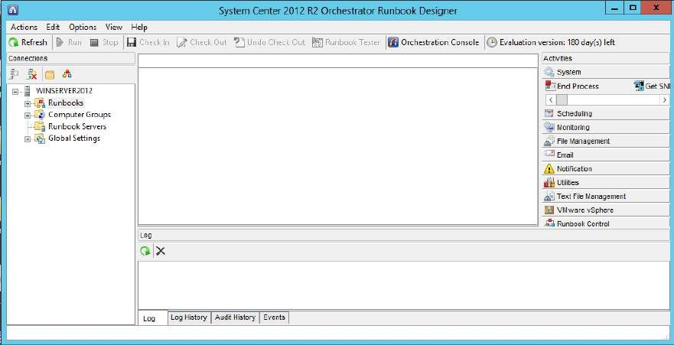

In **Runbook Designer** go to **Options**→**VMware vSphere**

At the **VMware vSphere** window click on **“Add”** button.

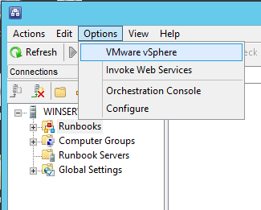 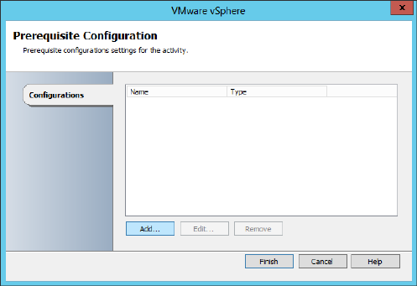

At **Add Configuration** window give a name to the vSphere (here it is, **VSPHEREORCH**), click on **“…”** to select type.

In the **Item Selection** window one item **“vSphere Settings”** is listed. Select it and click on **“OK”**

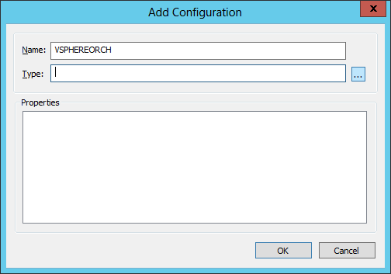 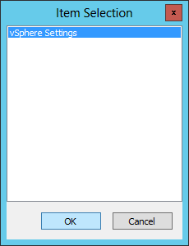

*(Both my ESXi server and Windows Server [client using vSphere Client] are put in same network through the static IP addresses, the ESXi is installed on host hypervisor and not on Windows server 2012)*

Enter the IP address of ESXi server, its root username and password. Click on **“OK”**

At the **VMware vSphere** window click on **“Finish”**

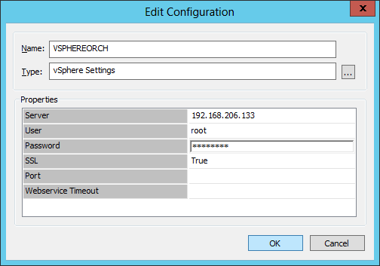 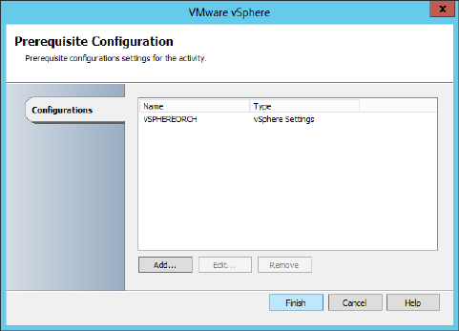

At **RunBook Designer**, in the left pane right click on **Runbboks**, select **New**→**Runbook**

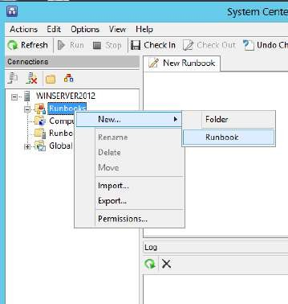

A new tab opens with the title **New Runbook**. Drag and drop **“Create VM”** from right pane **Activities**→**VMware vSphere** (under Activities click on VMware vSphere, a list of items is displayed in horizontally in a row, use the horizontal scroll bar to see all the items of VMware vSphere in Activities pane)

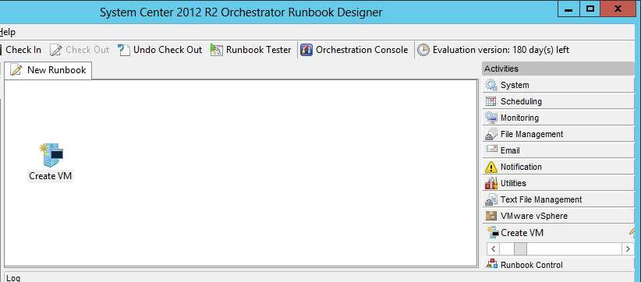

Then drag and drop **“Get VM List”** from same location, (scroll towards right in VMware vSphere to see this option).

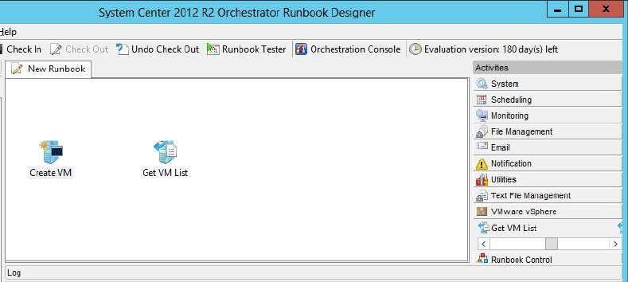

Drag and drop **“Get VM Status”** from same location, (scroll towards right in VMware vSphere to see this option).

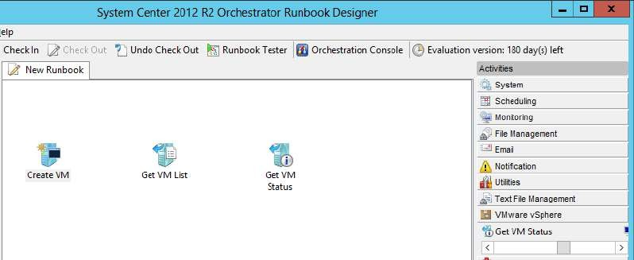

Drag and drop **“Start VM”** from the same location, (scroll towards right in VMware vSphere to see this option).

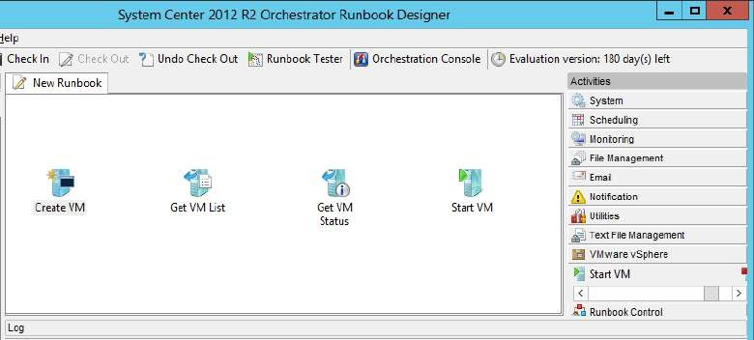

For Links (right arrows) between two items in the workflow: Click and drag from the right arrow pointer of the **“Create VM”** to the left arrow pointer of the **“Get VM List”**. The resultant workflow looks like...

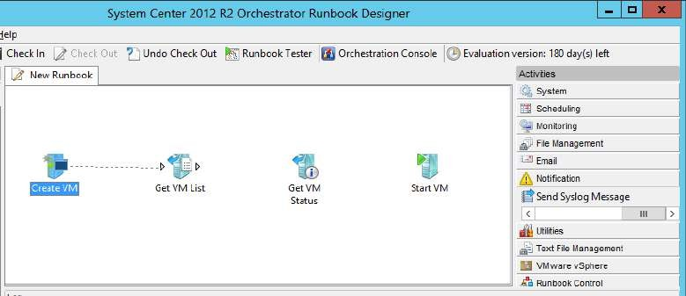

Do the same for all the connections in the workflow. The **final workflow** looks like…

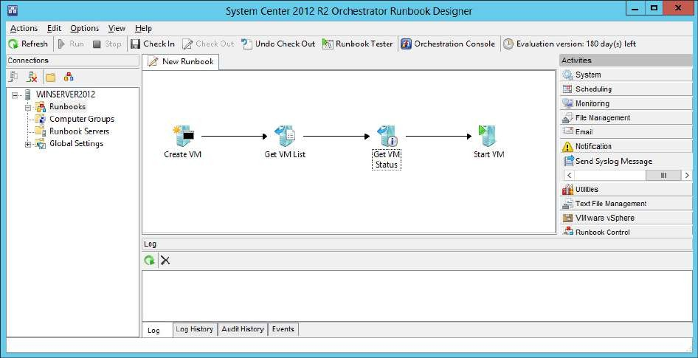

Right click on **Get VM List** and select **“Properties”** option

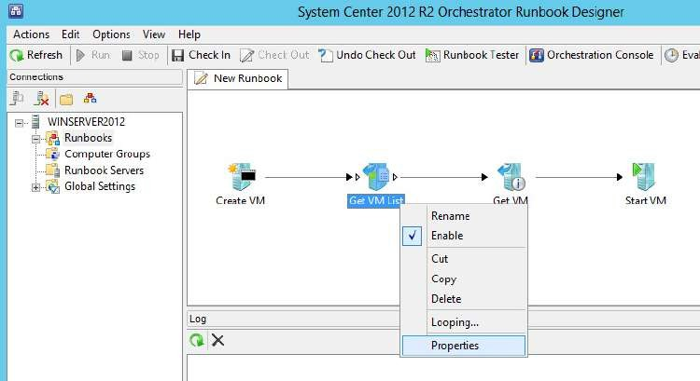

At the **Get VM List Properties** window click on **“…”** button.

At the **Item Selection** window select the VMware vSphere item listed (here **VSPHEREORCH**) and click on **“OK”**

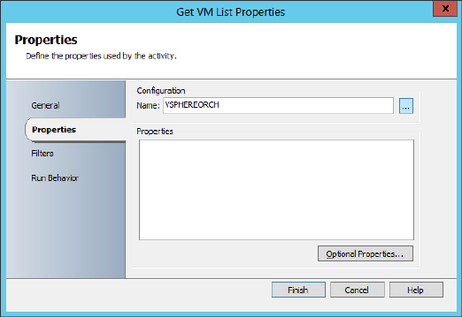 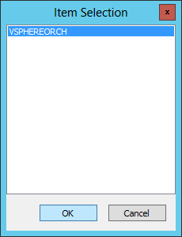

Then at the **Get VM List Properties** window go to Filters and click on **“Add”**

At **Filter Settings** window enter the details as shown in the screenshot. (The filter **name is VM Name, relation is Contains and values is “DEMO”**, i.e. towards the end of the practical a VM will be created such that its name should contain the DEMO word in it.) Click on **“OK”**

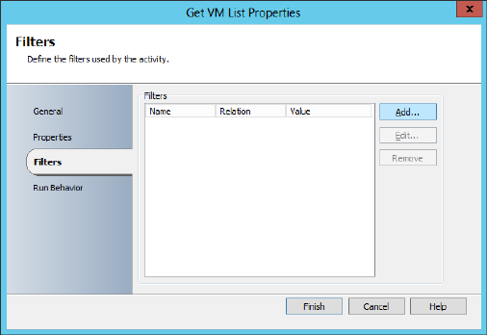 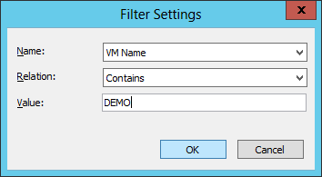

At the **Get VM List Properties** window click on **“Finish”**

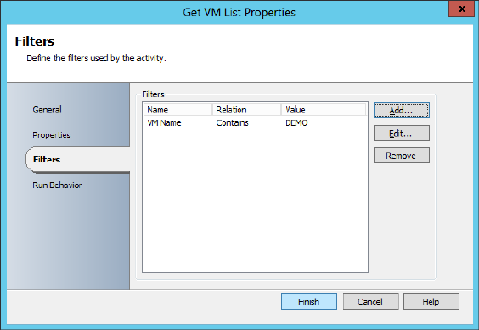

Now right click on **Get VM Status** and select **“Properties”** option.

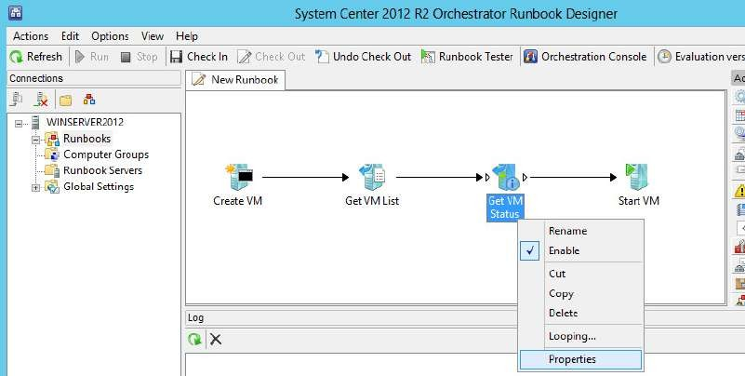

At the **Get VM Status Properties** window click on **“…”**

At the **Item Selection** window select the VMware vSphere item listed (here **VSPHEREORCH**) and click on **“OK”**

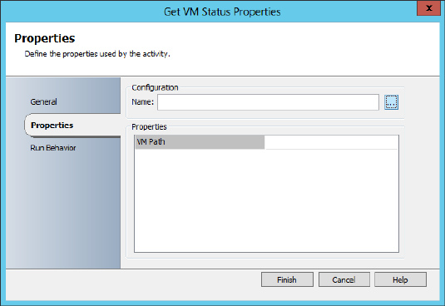 

At the **Get VM Status Properties** right click on the blank field given besides the **VM Path** label and select **Subscribe**→**Published Data**

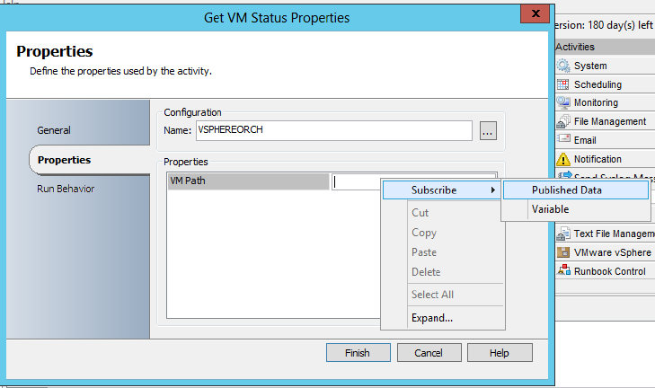

At the **Published Data** window select **VM Path** from the list and click on **“OK”**

At the **Get VM Status Properties** window click on **“Finish”**

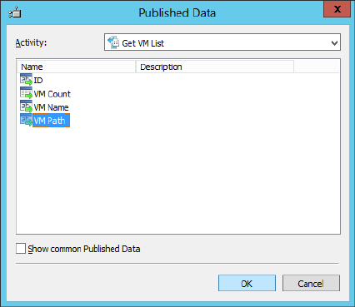 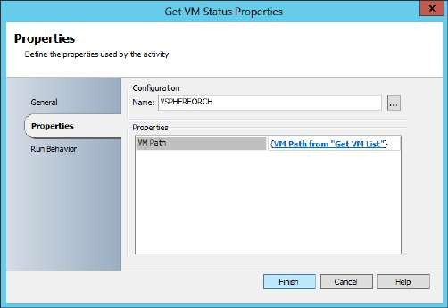

Right click on **Start VM** and select **“Properties”** option.

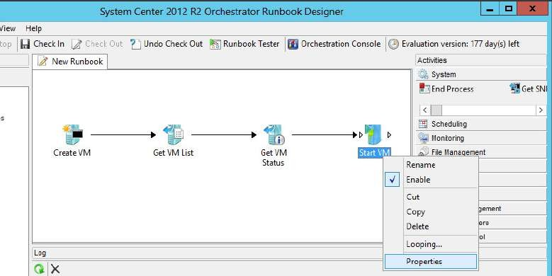

At the **Start VM Properties** window click on **“…”**

At the **Item Selection** window select the VMware vSphere item listed (here **VSPHEREORCH**) and click on **“OK”**

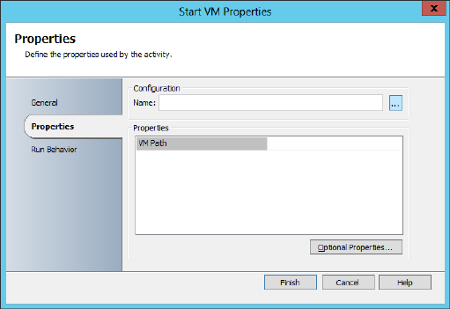 

At the **Start VM Properties** right click on the blank field given besides the **VM Path** label and select **Subscribe**→**Published Data**

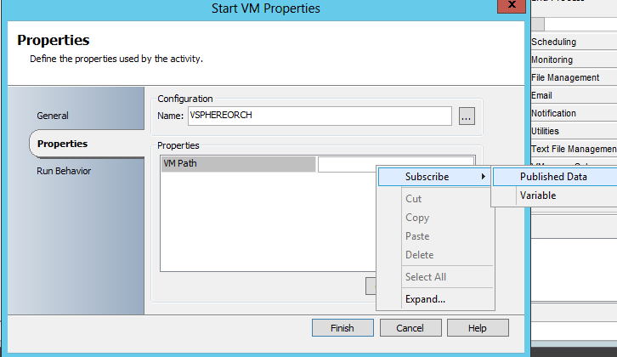

At the **Published Data** window select **VM Path** from the list and click on **“OK”**

At the **Start VM Properties** window click on **“Finish”**

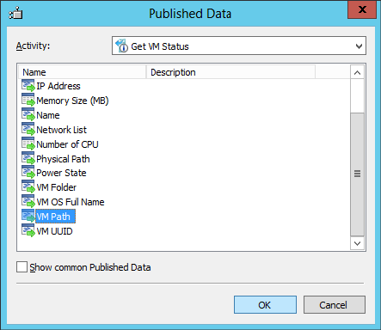 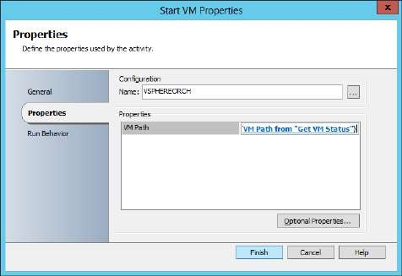

Right click on **Create VM** and select **“Properties”** option

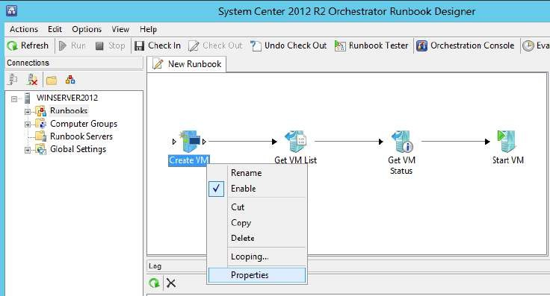

At the **Create VM Properties** window click on **“…”**

At the **Item Selection** window select the VMware vSphere item listed (here **VSPHEREORCH**) and click on **“OK”**

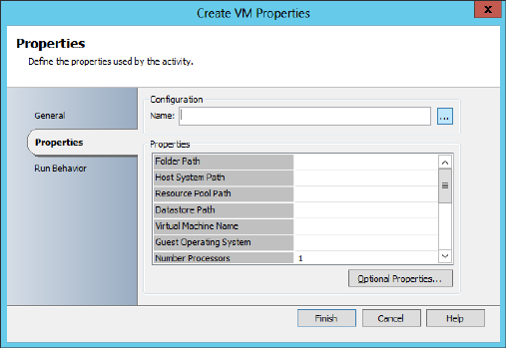 

Most fields are selected using the browse (**“…”**) button given for the corresponding field, except **VM name** has to be typed, check for the **memory size**, a string value has to be given for **NIC** value.

One by one all the fields are browsed and available items are added to the fields

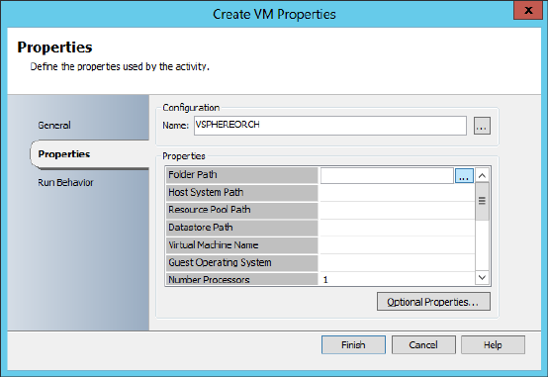 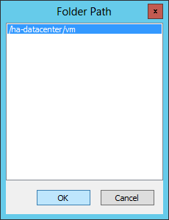

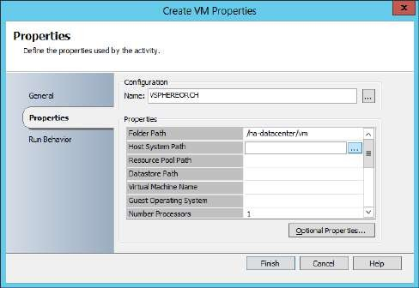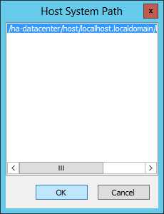

While giving a name to the virtual machine see to it that the name should contain the word **“DEMO”** (In this case as it was declared in the **Get VM List properties**). For **guest operating system** here I have selected **"otherGuest"** so that I can install any OS's iso for my VM. The input values for all the fields are shown in the below screenshots.

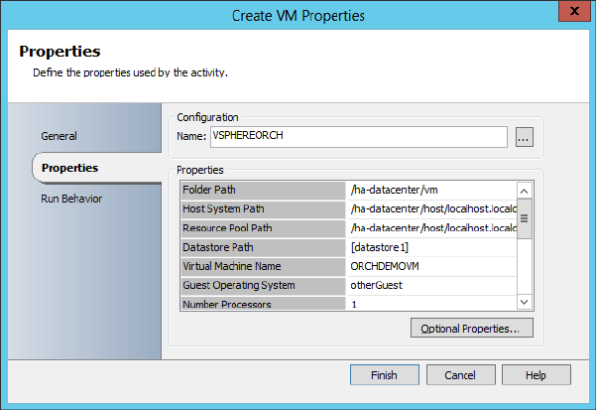

# Enter Memory size as 128 MB and NIC 1 value as “ABCD”

At the **Create VM Properties** window click on **“Finish”**

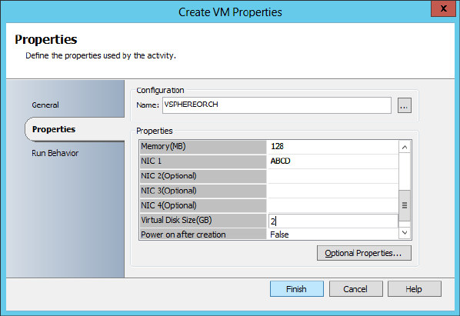

# Step 9: Runbook Tester

At the main window of Runbook Designer click on **“Runbook Tester”** in the toolbar

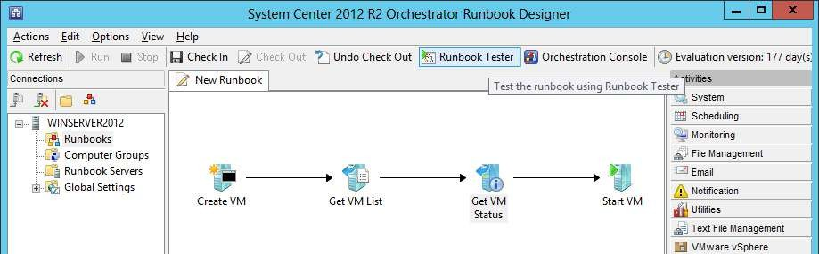

At the **Runbook Tester** window click on **“Run”** button in toolbar

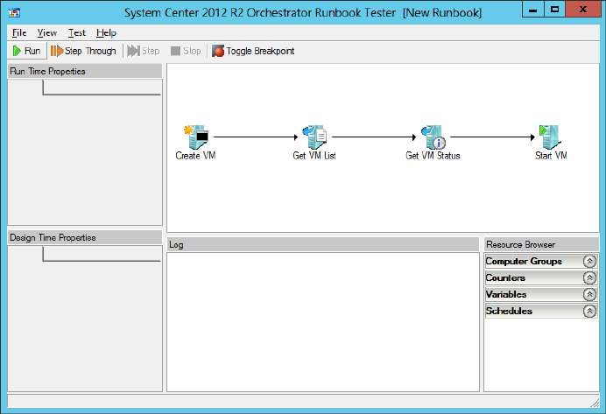

The test should run successfully as shown in the below screenshot

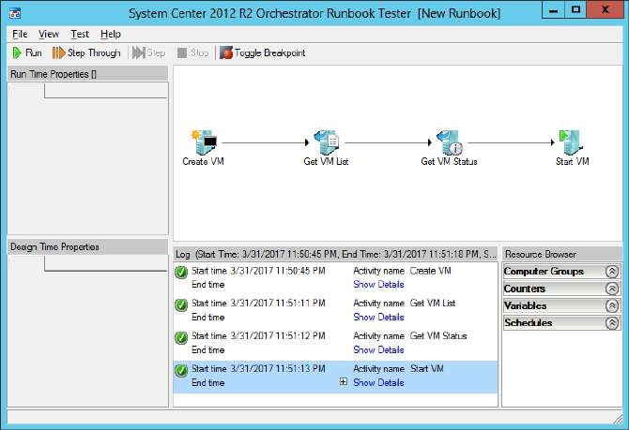

# Step 10: vSphere Client

Launch **vSphere Client** and login using the ESXi Server IP address (that was connected to the Runbook Designer, here **192.168.206.133**), **root username and password**. It shows a new VM created successfully by the name (here, **ORCHDEMO**) that was given in the **Create VM Properties** in Runbook Designer.

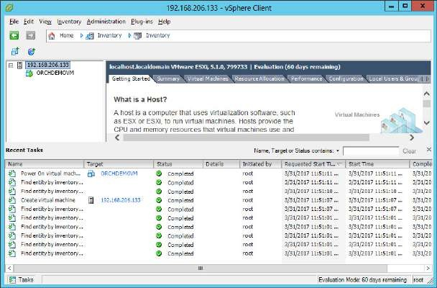

The VM is up and running. Check the **“Virtual Machines”** tab

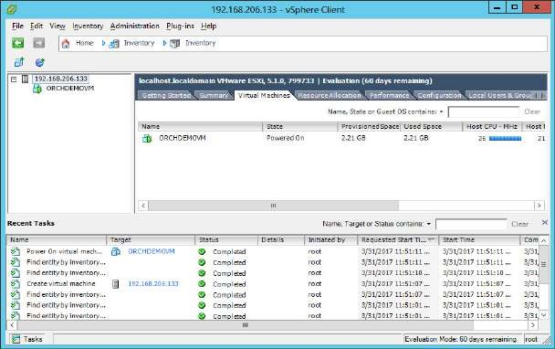

Check the **“Summary”** tab for all the details of the VM

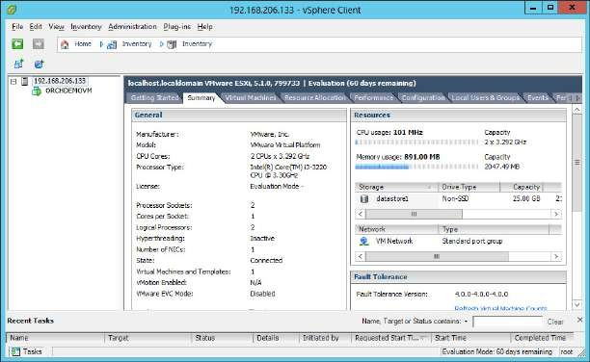

**PRACTICAL NUMBER** ➔ **9 IMPLEMENTING WINDOWS AZURE PACK**

Dashboard of Windows Azure:

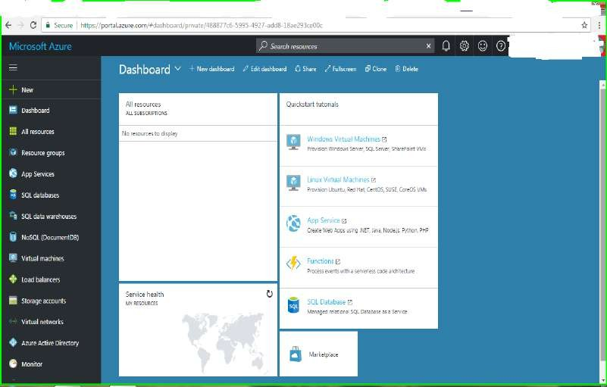

**Azure virtual machines** can be created through the **Azure portal**. This method provides a browser-based user interface for creating and configuring virtual machines and all related resources.

**Log in to Azure**

Log in to the Azure portal at **“**[**http://portal.azure.com**](http://portal.azure.com/)**”**. Components in Azure:

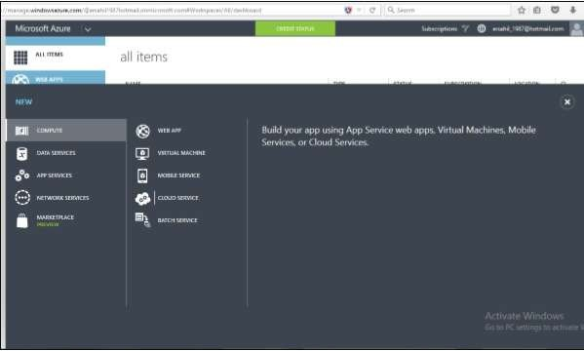

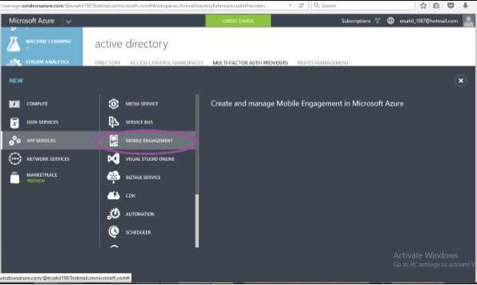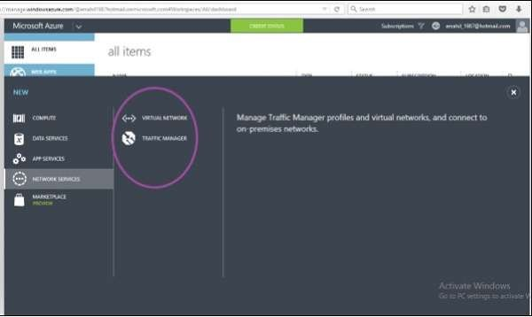

Create virtual machine

1. Click the **New** button found on the upper left-hand corner of the Azure portal.
2. Select **Compute** from the **New** blade, select **Windows Server 2016 Datacenter** from the **Compute** blade, and then click the **“Create”** button.
3. Fill out the virtual machine **Basics** form. The user name and password entered here is used to log in to the virtual machine. For **Resource group**, create a new one. A resource

group is a logical container into which Azure resources are created and collectively managed. When complete, click **“OK”**.

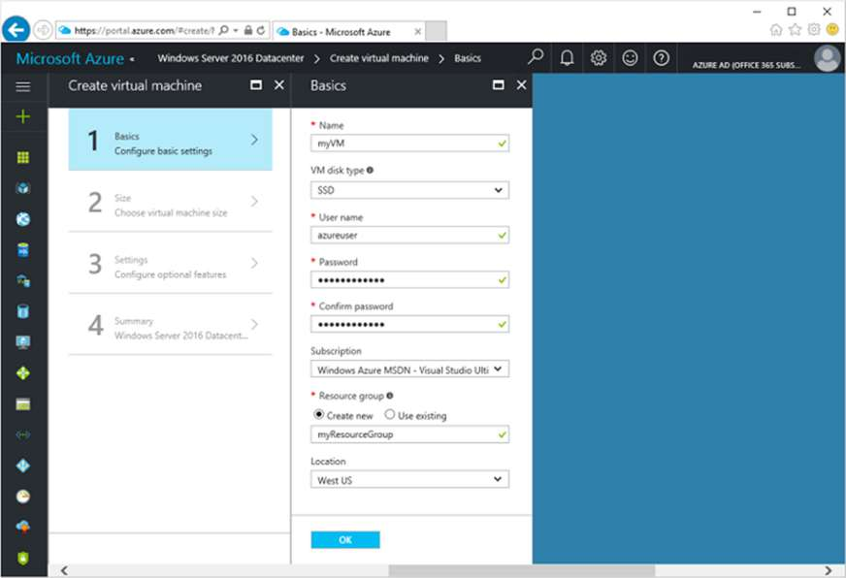

1. Choose a size for the VM. To see more sizes, select **View all** or change the **Supported disk type** filter.

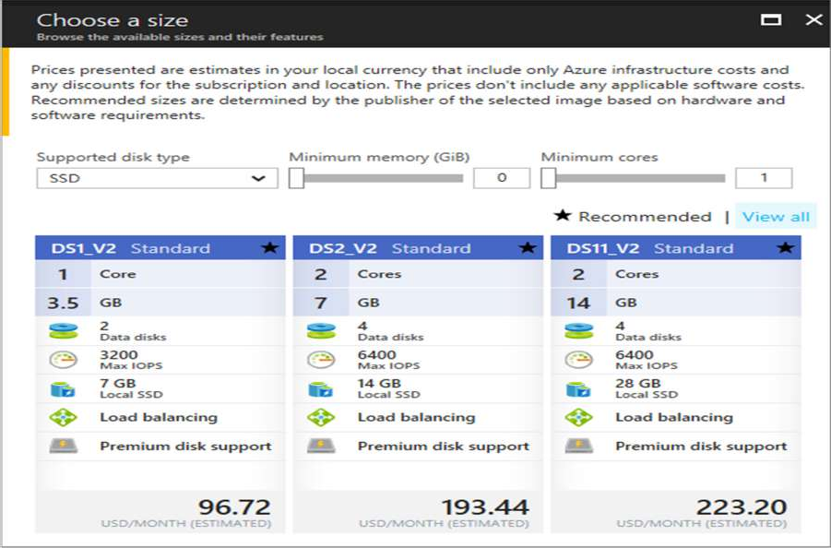

1. On the settings blade, select **Yes** under **Use managed disks**, keep the defaults for the rest of the settings, and click **OK**.
2. On the summary page, click **Ok** to start the virtual machine deployment.
3. To monitor deployment status, click the virtual machine. The VM can be found on the Azure portal dashboard, or by selecting **Virtual Machines** from the left-hand menu. When the VM has been created, the status changes from **Deploying** to **Running**.

**PRACTICAL NUMBER** ➔ **10**

**USING CONFIGURATION MANAGER 2012 FOR MANAGING AND MAINTAINING**

# Prerequisites:

Run SQL Server setup file. Follow the steps of installation according to the previous practicals (refer practical 1). *For this practical login as administrator in the server system.*

At the **Feature selection** window click on **Select All** button to choose all the features. Click on

# “Next”

In the next step browse Account Name for Database Engine

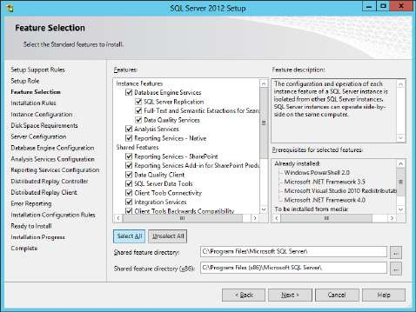 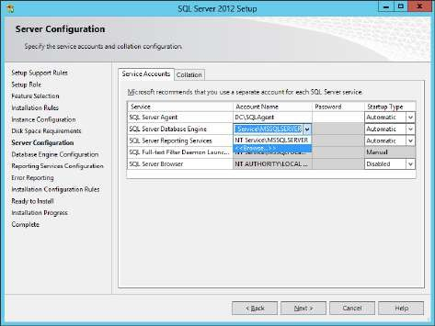

At the **Select user** window type **sql** and click on **Check Names**, the **SQLAgent** user appears, click on **“OK”**

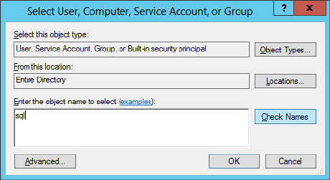 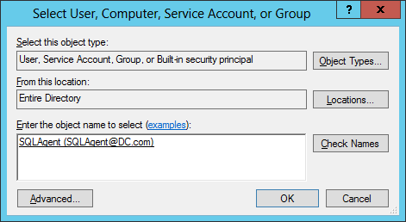

For all the services (except for those are given as manual and disabled in Startup Type column)

**add the same account and enter passwords** for all the services. In the next step click on **“Add Current User”**

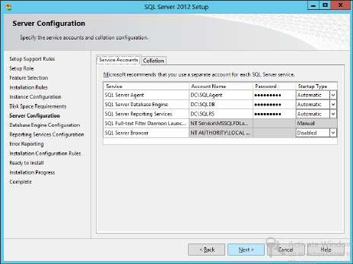 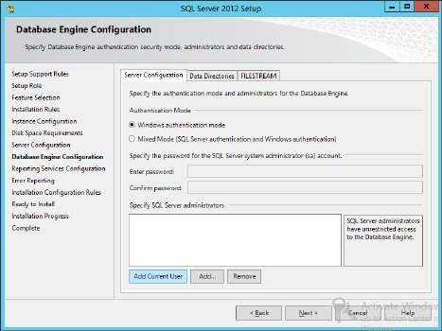

At the **Select User** window click on **“Advanced”**.

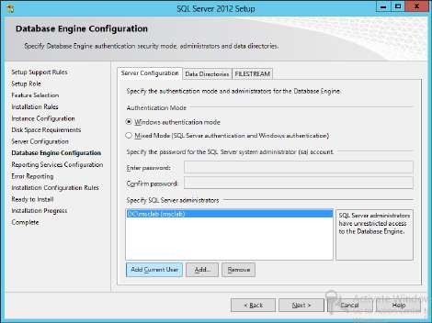 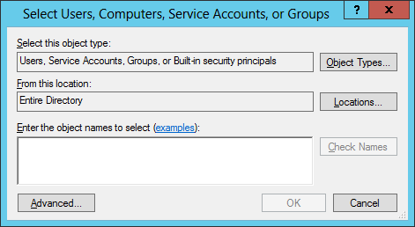

Click on **“Find Now”**. The search results are displayed in the below pane. Select the Administrator user and click on **“OK”**

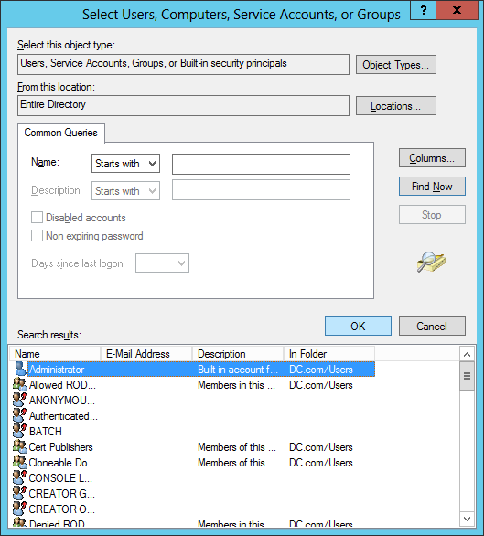

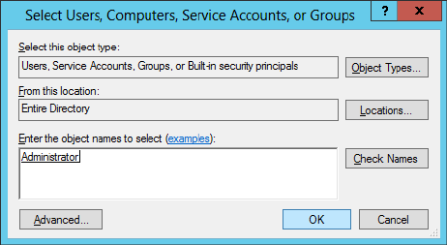Click on **“OK”**

Click on **“Next”**

Select **“Install & Configure”** for Native mode and **“Install only”** in SharePoint Integrated Mode

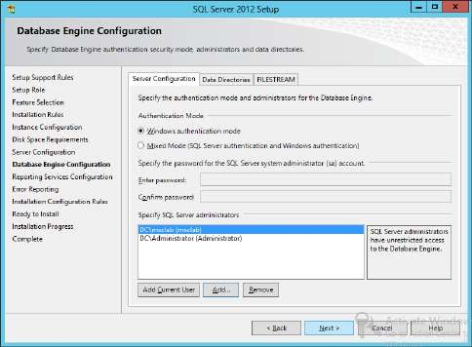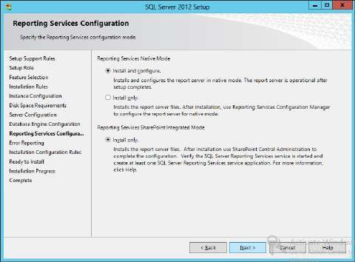

Then complete the installation.

Launch **SQL Server Management Studio**. In the **Object Explorer** right click on the **Server** and select **Properties** option. At the **Server Properties** window go to **Memory** in the left pane.

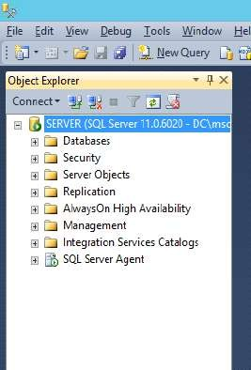 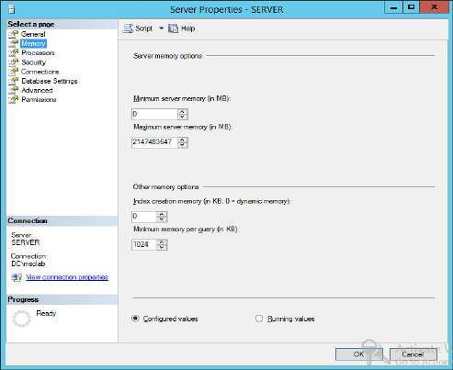

# Enter the Minimum and Maximum Server memory (in MB) as 4096¸clcik on “Next”

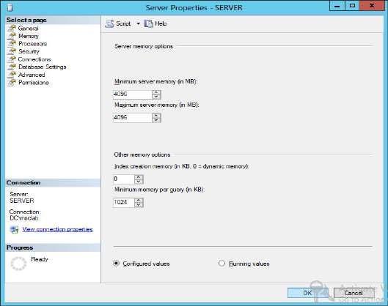

Open **Server Manager**, click on **Add roles and features**

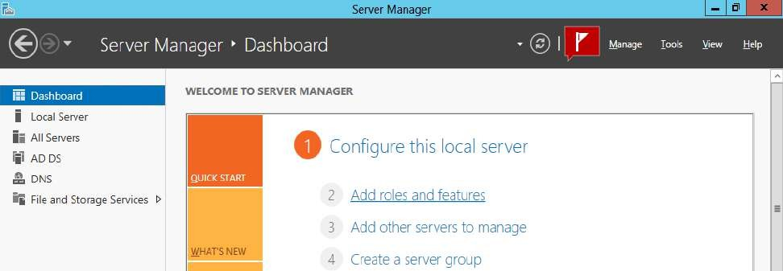

Follow the steps to add roles and features as given in previous practicals. Here install the **Web Server (IIS)** role and its features. Check the below screenshots and add roles and features accordingly

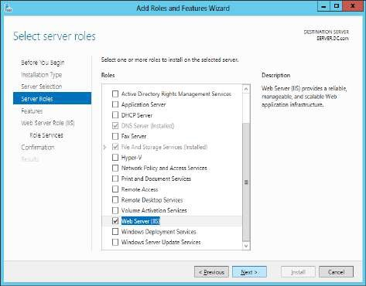 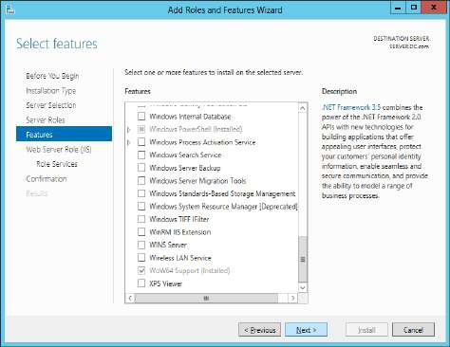

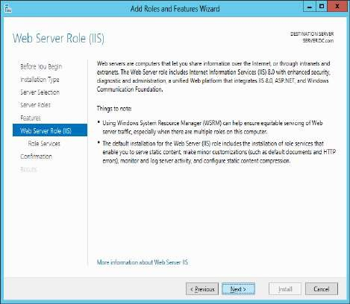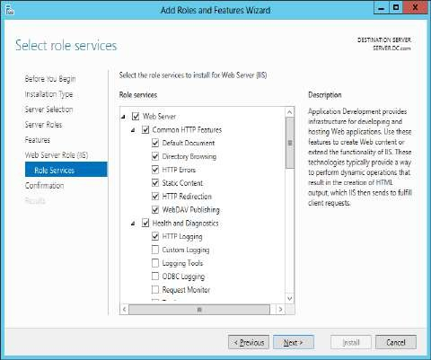

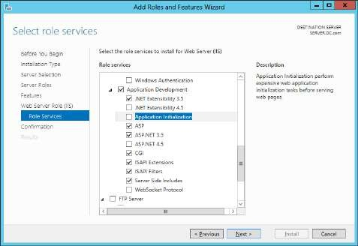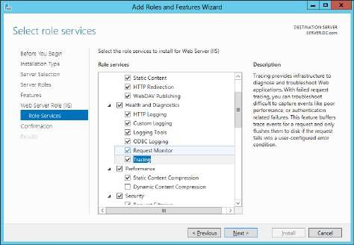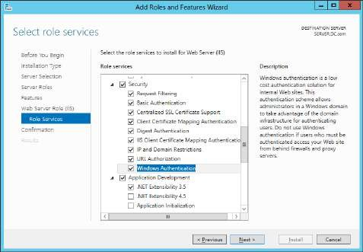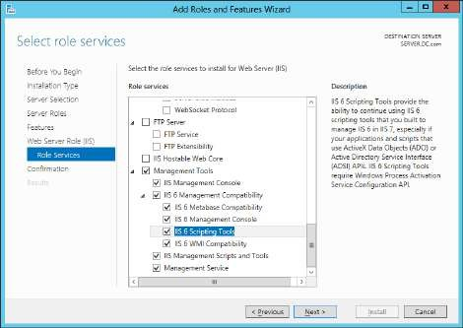

Again in **Server Manager** click on **Add roles and features**.

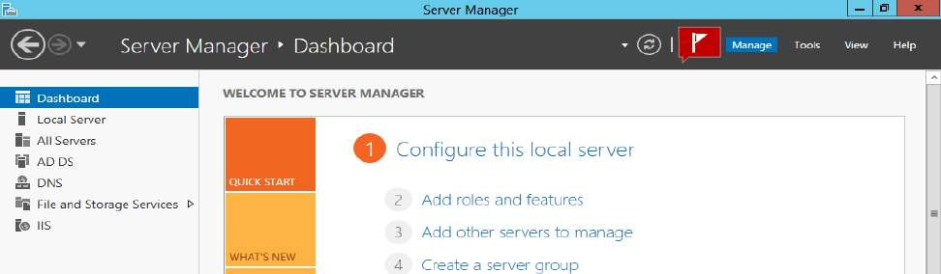

Add the following roles and features.

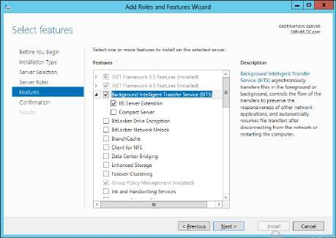 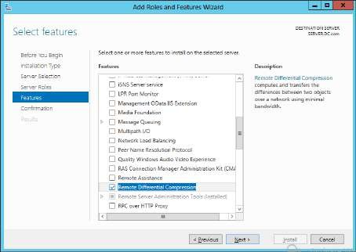

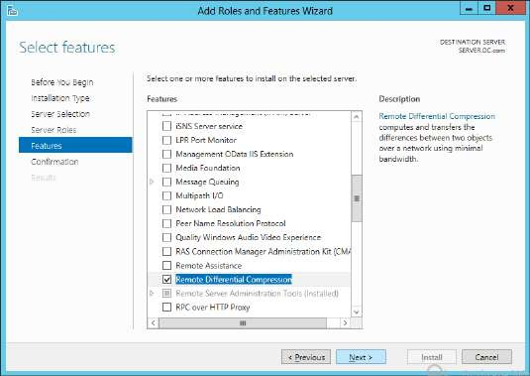

To add WSUS role: Click on Add roles and features

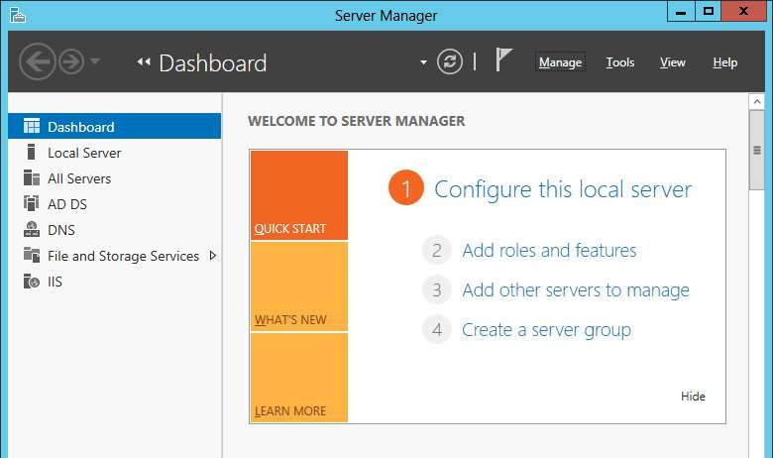

Add the following roles and features.

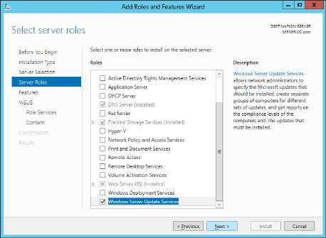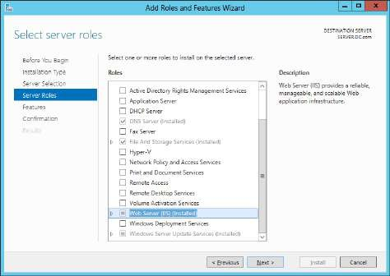

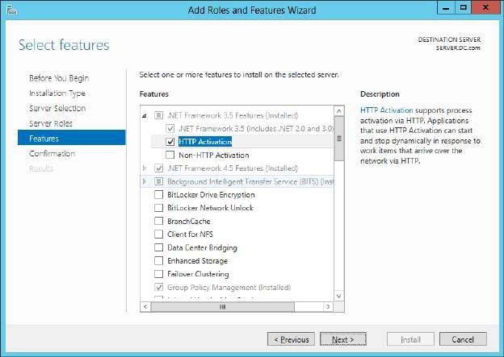

Select **WSUS Services** and **Database**. Click on **“Next”**. Click on **“Next”**

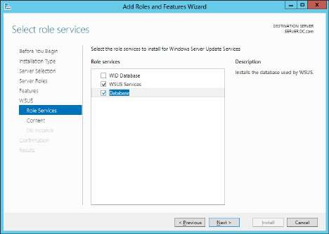 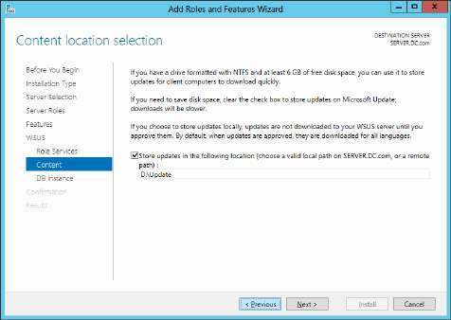

Click on C**heck connection**.

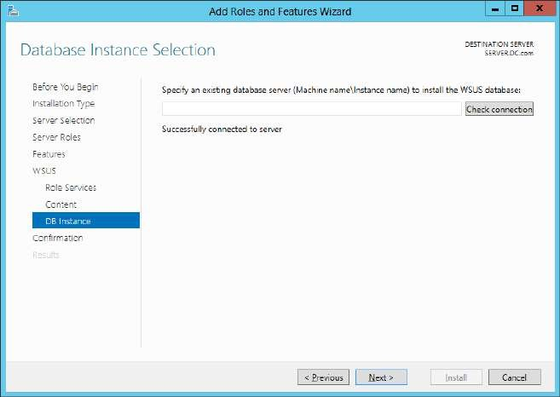

Go to Start and launch **Windows Server Update Service (WSUS) Interface**

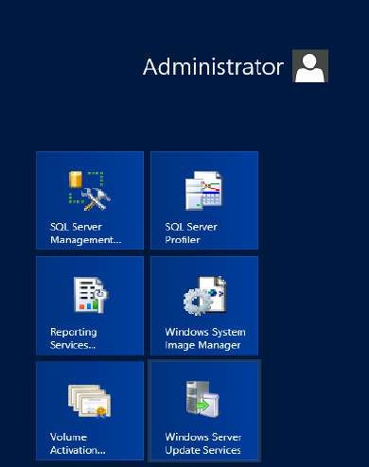

At the **WSUS** window click on **“Next”**

Click on **“Next”**

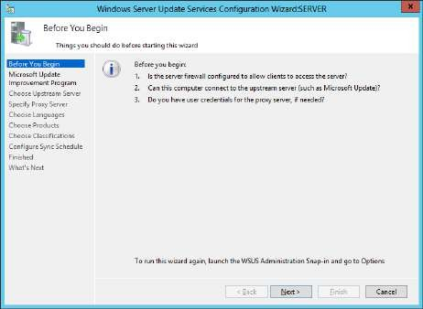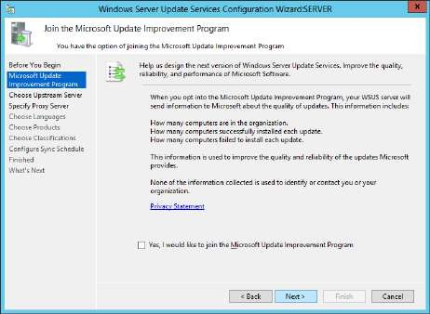

Select **Synchronize from another Windows Server Update Services server**, enter your server name and click on **“Next”**

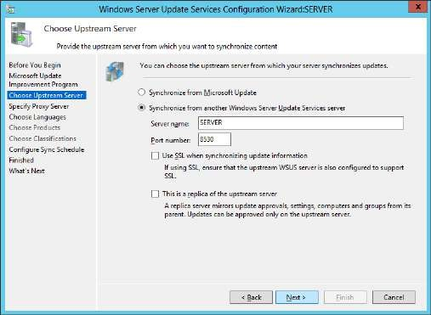

Click on **“Next”**. Click on **Start Connecting**

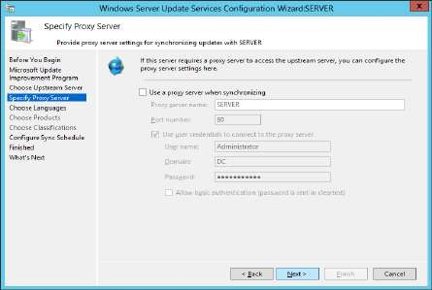 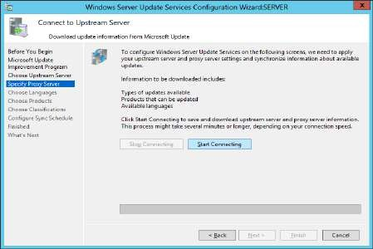

Click on **“Next”** in next two steps.

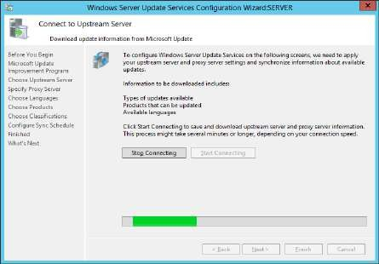 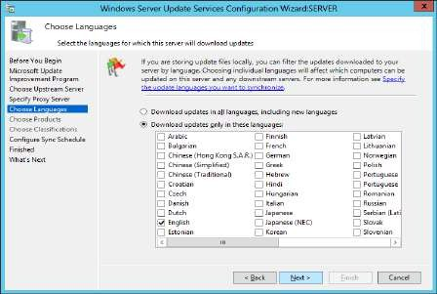

Select **Synchronize manually** and click on **“Next”**. Click on **“Next”**

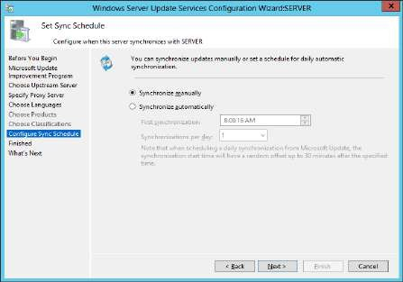 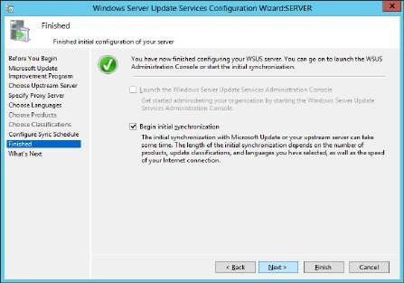

Click on **“Finish”**

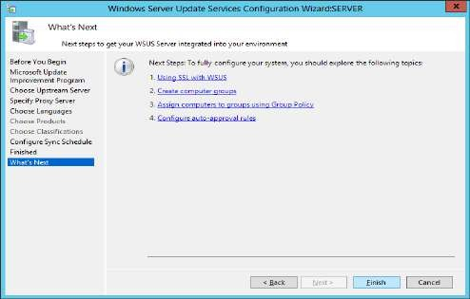

At **WSUS** window expand **SERVER** in the left pane and select **Synchronizations**

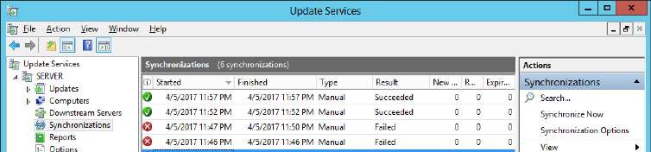

Go to **Options**. Click on **Computers**

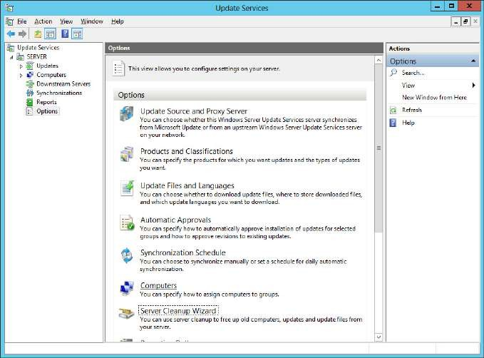

If we are using **server side targeting** then we need to select **first option**, else we need to use

**second option** if we are using **client side targeting**. And click on **“OK”**

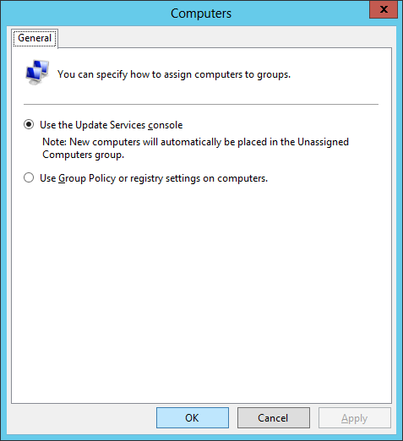

Click on **Server Cleanup Wizard**.

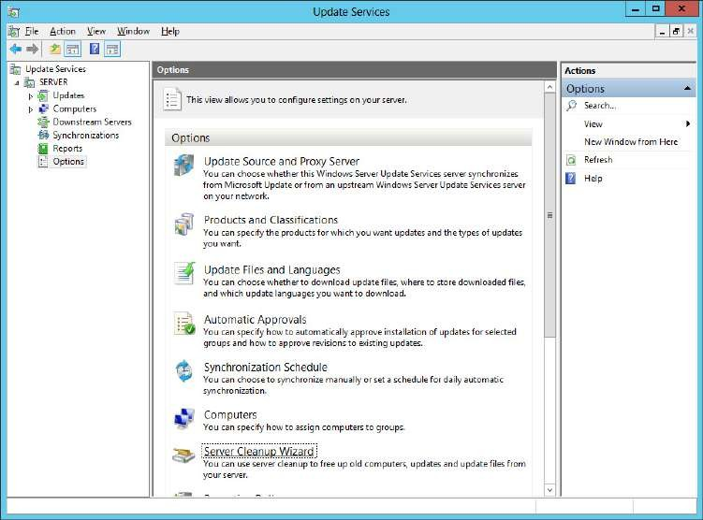

At the **Server Cleanup Wizard** select all the options and click on **“Next”**

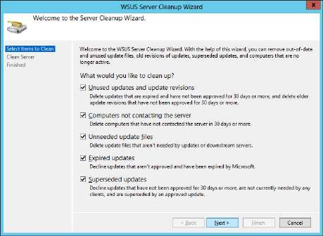 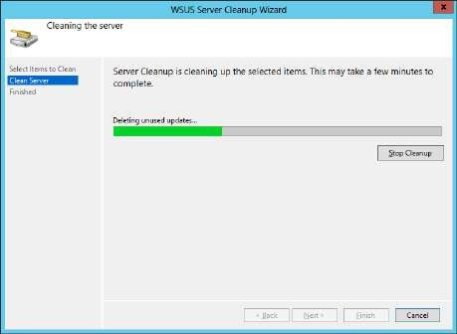

Click on **“Finish”**

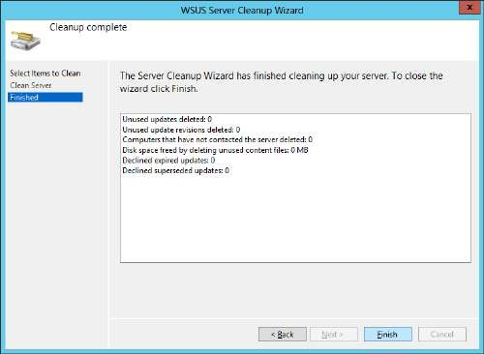

You can check through the options available in WSUS server while MS is updating the server

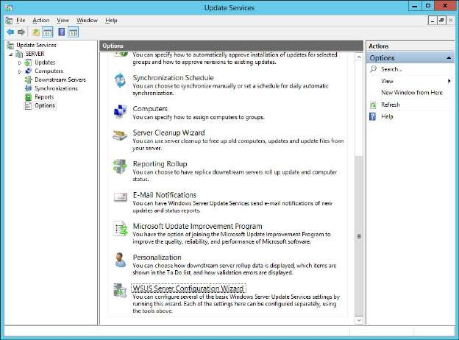

At the main window go to **SERVER**→**Computers**→**All Computers**. For **Status** select the **Any** option.

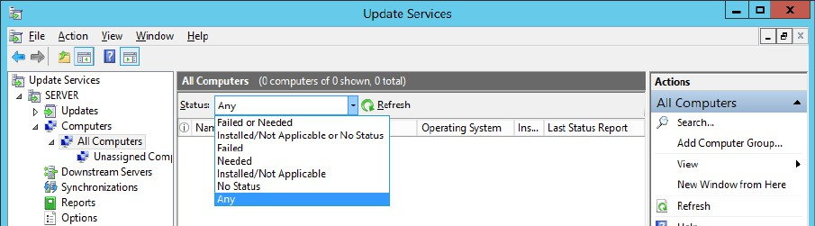

Then click on **Refresh**. There are no items in this list.

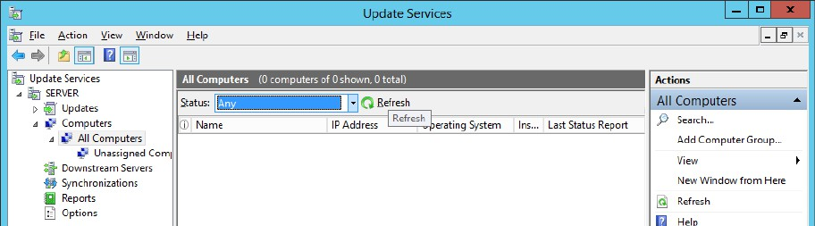

Right click on **All Computers**→**Add Computer Group…** Enter a **name** and click on **“Add”**

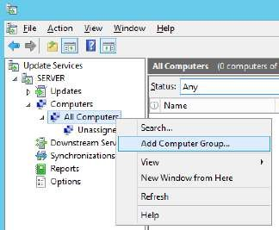 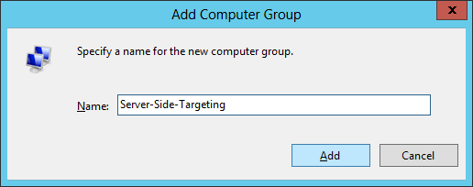

Right click on **All Computers**→**Add Computer Group…** Enter a **name** and click on **“Add”**

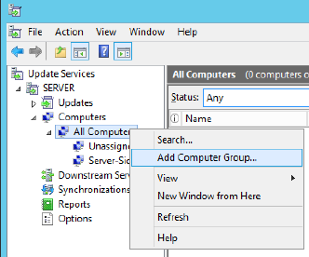 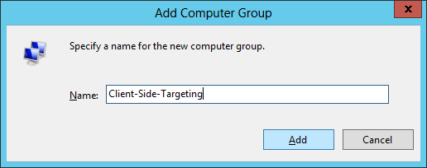

In the left pane under **All Computers** the new computer groups are added.

At the main window go to **SERVER**→**Computers**→**All Computers**. For **Status** select the **Any** option.

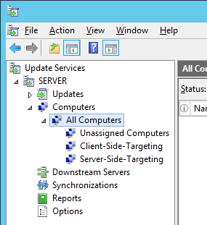 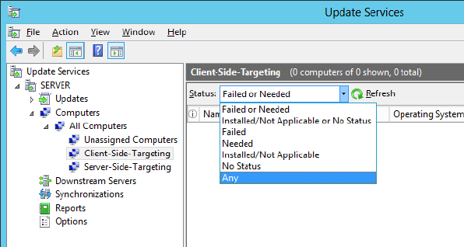

Click on **“Refresh”**

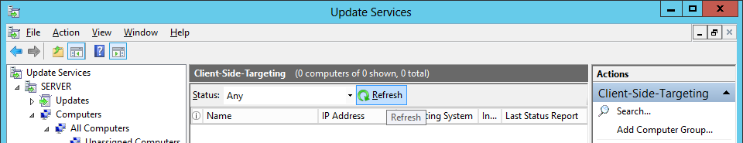

Click on **Synchronizations**. It shows the successful result

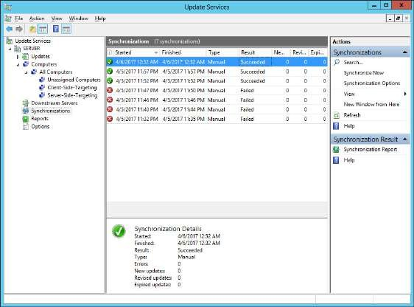

Mount the Configuration Manager ISO file and run the **splash** file.

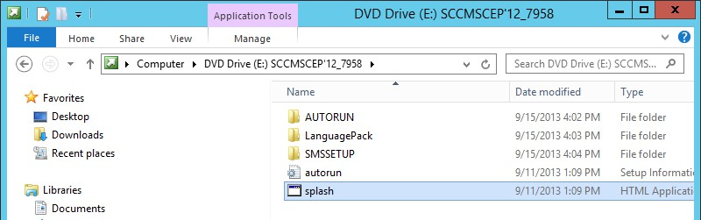

Click on **“Install”**. Then click on **“Next”**

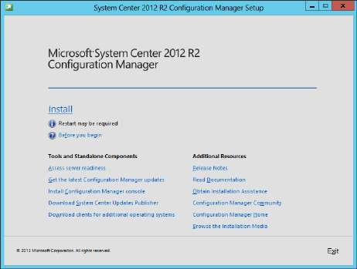 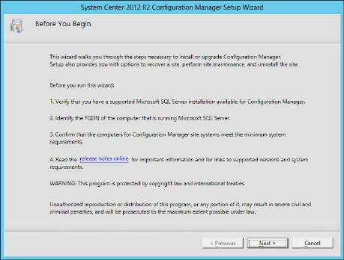

Select **“Install a Configuration Manager primary site”** and its sub option **“Use typical installation options for a stand-alone primary site”**. At message box click on **“Yes”**

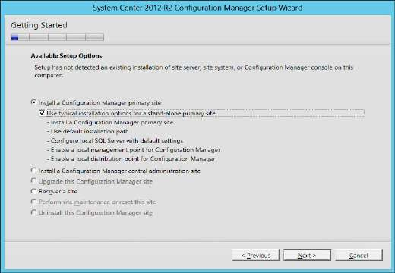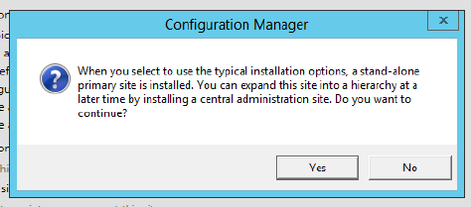

Select the first option and click on **“Next”**

**Accept** the **license agreement** and click on **“Next”**

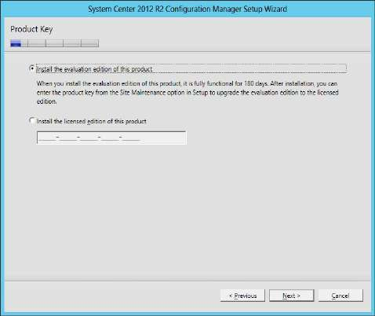 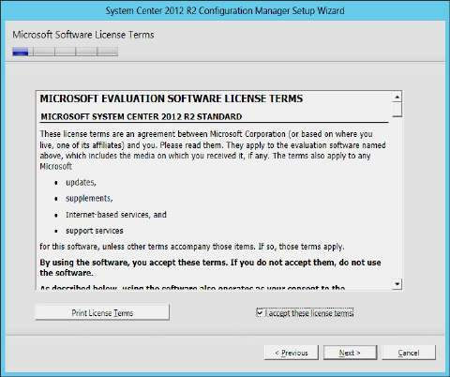

In next step select all the check boxes and click on **“Next”**

In next step click on **“Browse”**

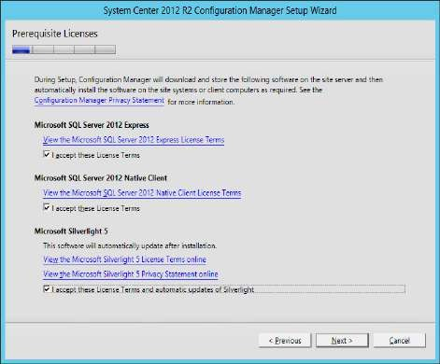 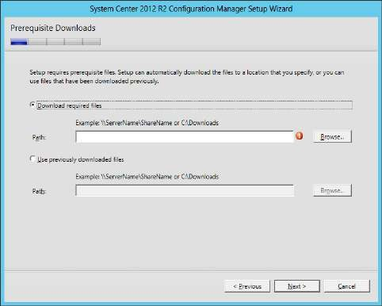

*In the C:\ create a new folder to download the prerequisite files.*

Click on **“Next”**.

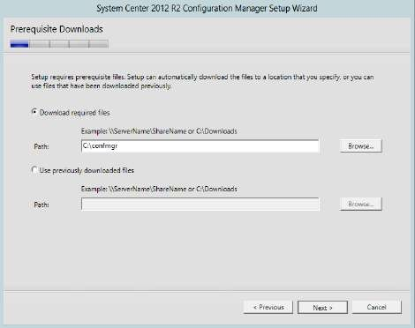 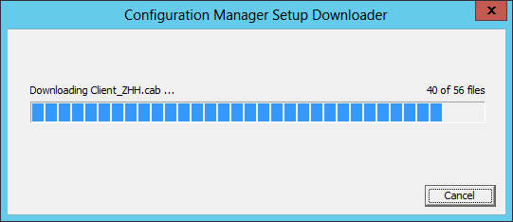

Enter the credentials for site. Click on **“Next”**

For Microsoft offers select **“No…”** and click on **“Next”**

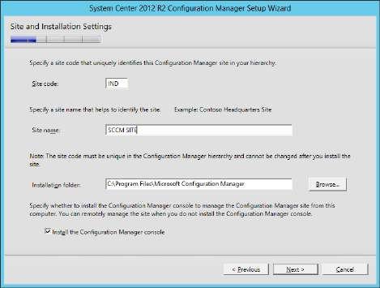 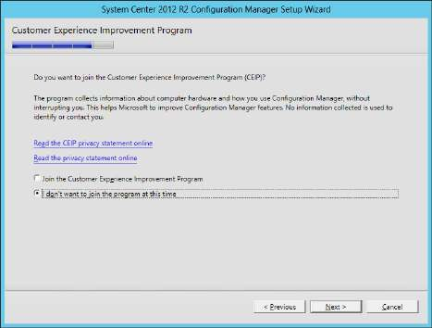

Click on **“Next”**. Click on **“Begin Install”**

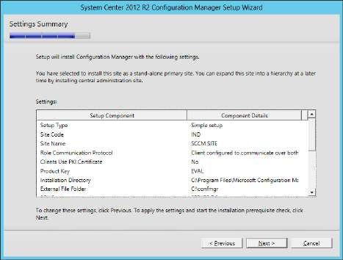 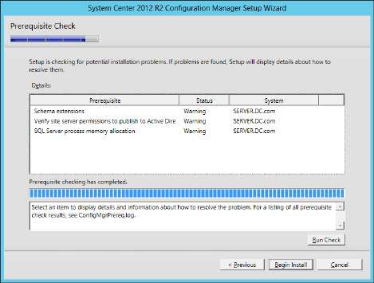

Installation is in progress. While installation is going on perform the following steps. Click on

**“View Log”** button.

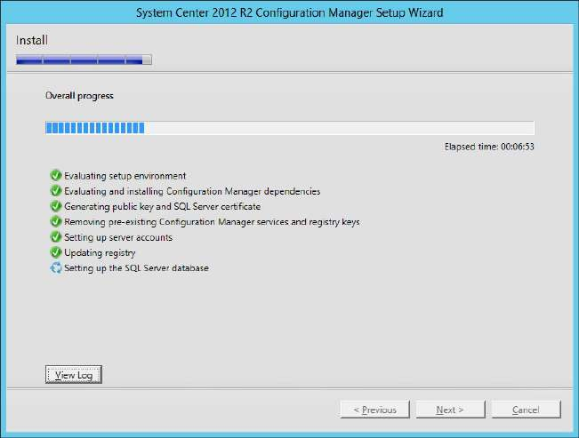

The ConfigMgrSetup notepad file is opened.

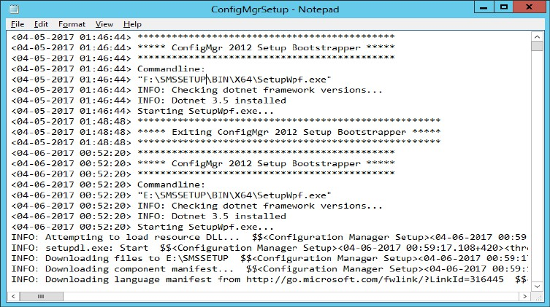

Go to **“ISO file**→**SMSSETUP**→**TOOLS”**. From this location copy the **CMTrace** application and paste it at the desktop.

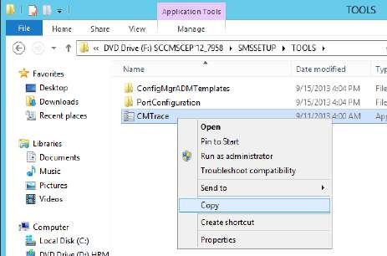 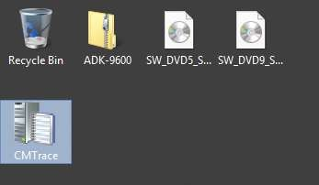

Open **CMTrace**. Go to **File**→**Open**

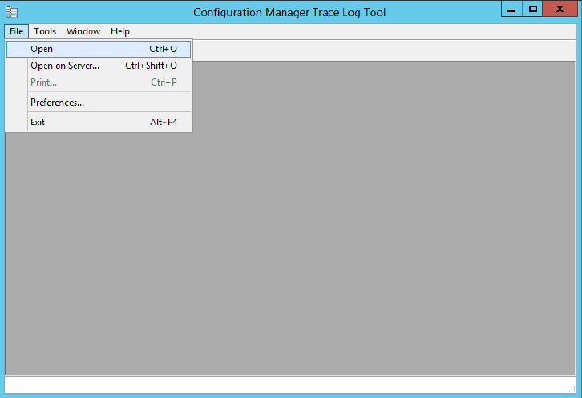

Select **ConfigMgrSetup** and click on **“Open”**

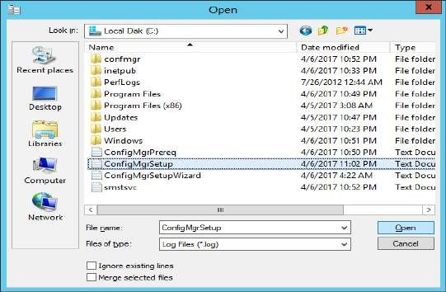

The result is in the below screenshot. To import all the files from the setup file it may take some time.

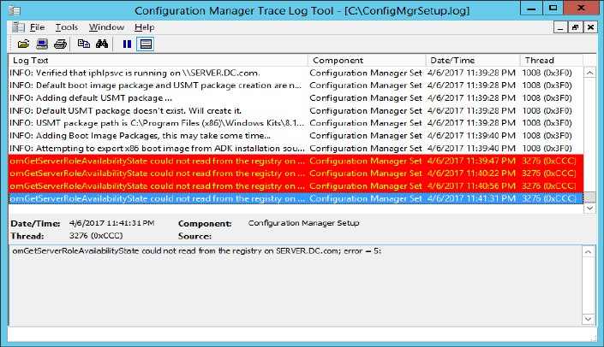

The installation is completed. (It may take around 1 hour). Click on **“Close”**

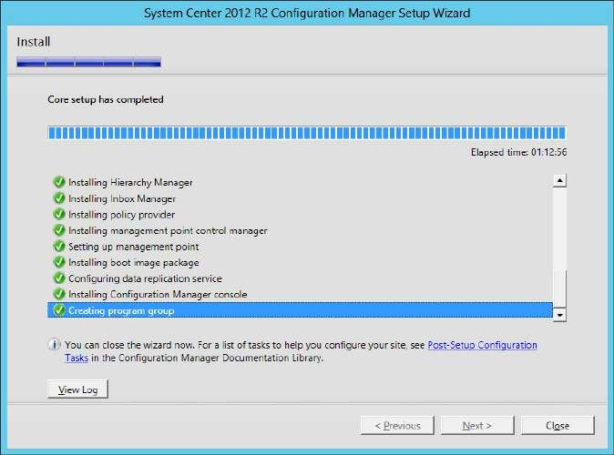

Close the Configuration Manager Trace Log Tool.

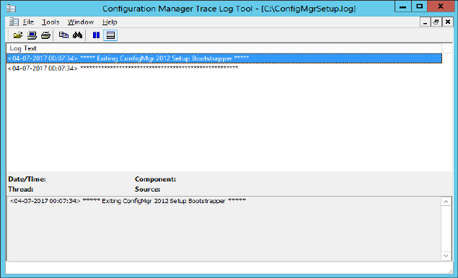

# Open Configuration Manager Console

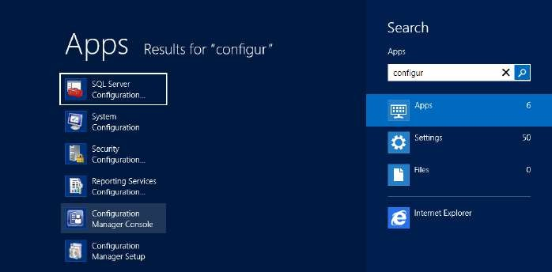

The CM Console looks like

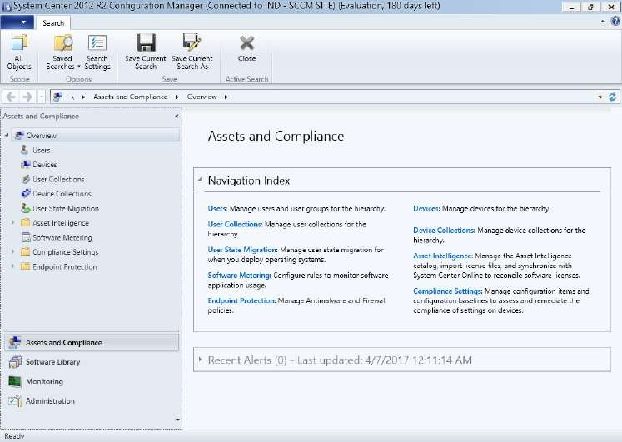

In the left bottom pane click on **Administration**. In the left top pane go to

# Overview→Hierarchy Configuration→Boundaries.

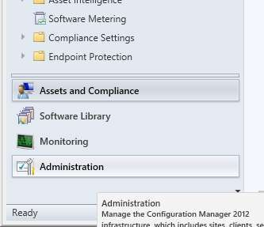 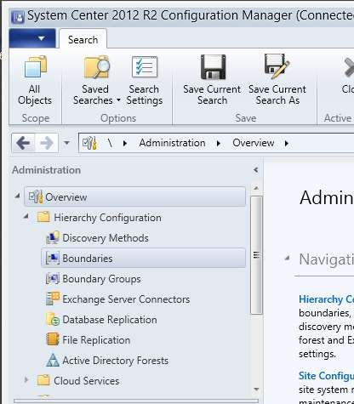

Right click on **Boundaries** and select **Create Boundary** option

Enter the required **credentials** in the **Create Boundary** window. Enter a description. Select type as **“Active Directory site”**

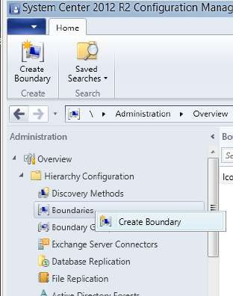 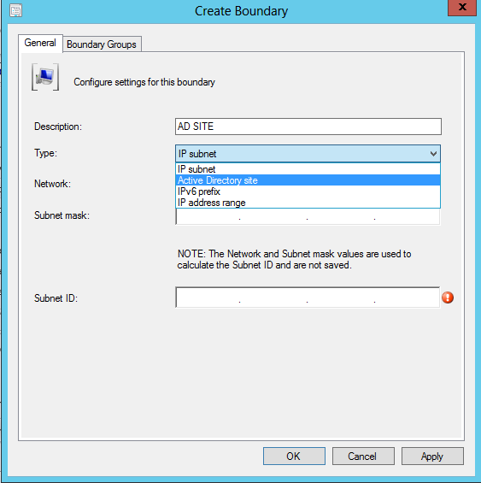

Then click on **Browse**. At the **Browse Active Directory sites** window select **Default-First-Site- Name** and click on **“OK”**

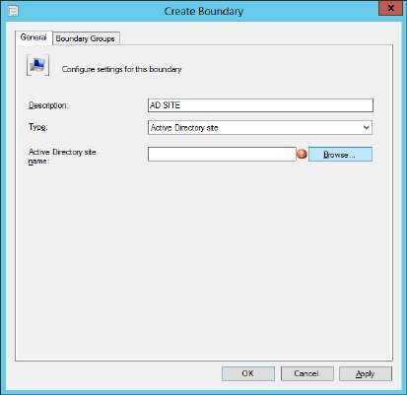 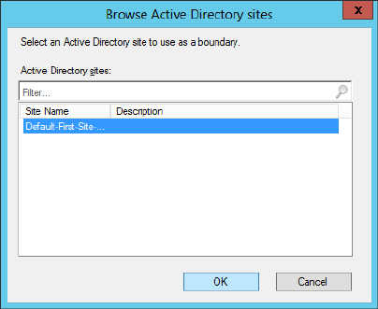

Click on **“OK”**

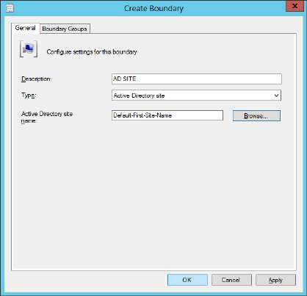

The new boundary is listed in the main window.

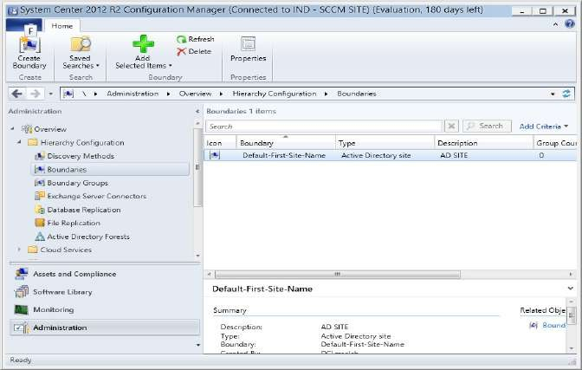

In the left pane go to **Discovery Methods**, in the right pane right click on **“Active Directory System Discovery”** and select **Properties** option.

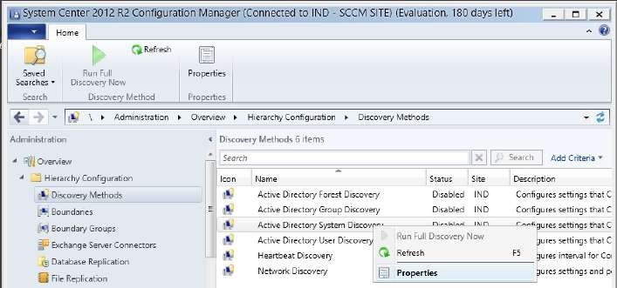

At the **Active Directory System Discovery Properties** select **“Enable Active Directory System Discovery”**. Then click on the **“****”** yellow color button.

At the **Active Directory Container** click on **Browse** to select a path.

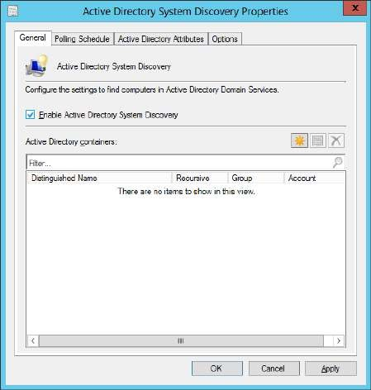 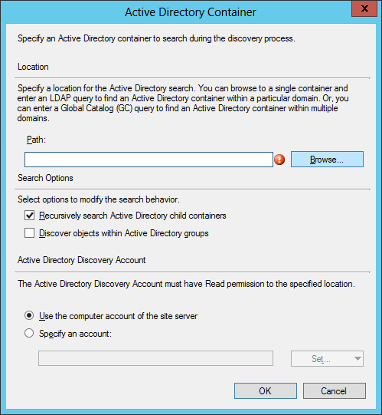

Select the path and click on **“OK”**. Then at the **Active Directory Container** window click on **“OK”**.

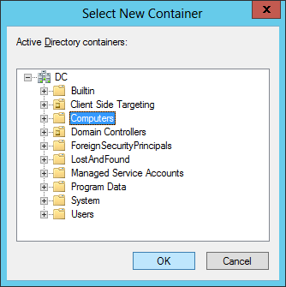 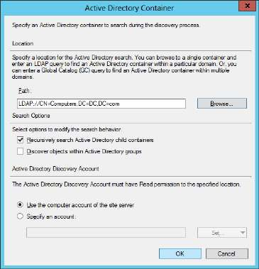

At the **Active Directory System Discovery Properties** go to **Polling Schedule** tab. Click on **Schedule**. At the Custom Schedule window select **Custom interval**, and change the value of Recur every to **1 Days**

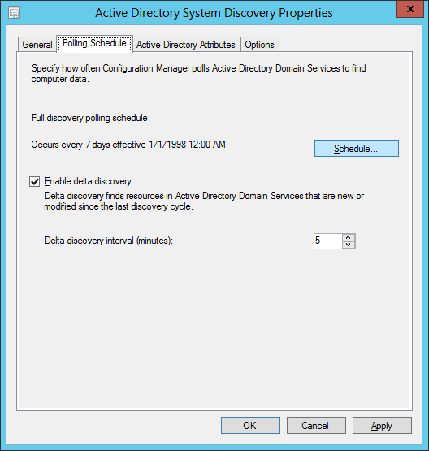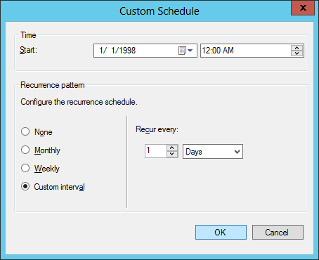

Click on **“OK”**. Click on **“Yes”** in the information message box.

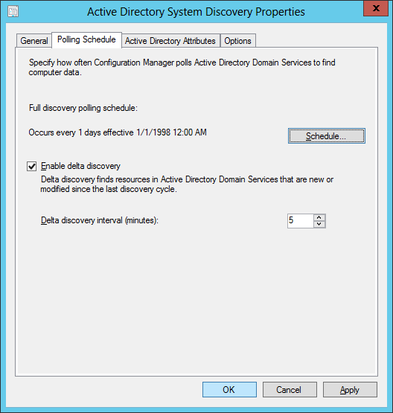 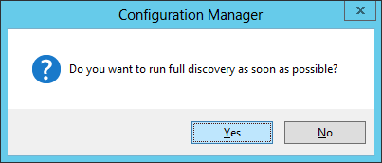

# Go to Servers and Site System Roles

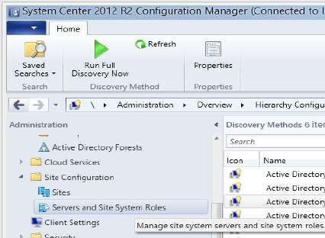

In the right pane right click on the **SERVER.DC.com** and select **Add Site System Roles**.

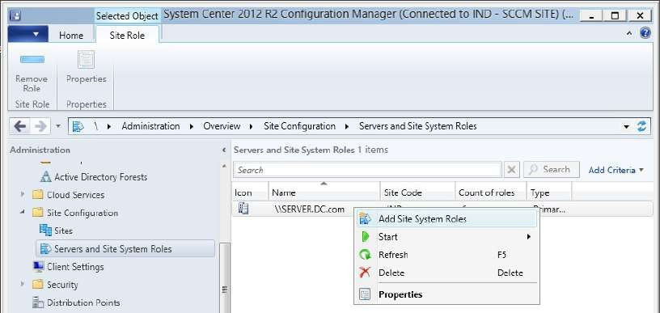

# At the Add Site System Roles Wizard select Use the site server’s computer account to install this site system click on “Next”.

In the next step click on **“Next”**

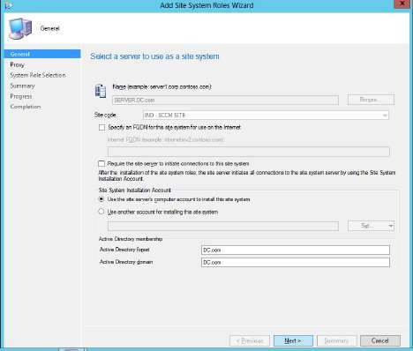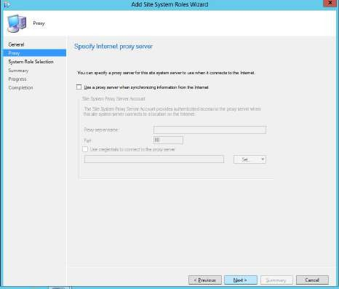

Select **“Software update point”** and click on **“Next”**

Select **“WSUS is configured to sue 8350and 8351 for…”** and click on **“Next”**

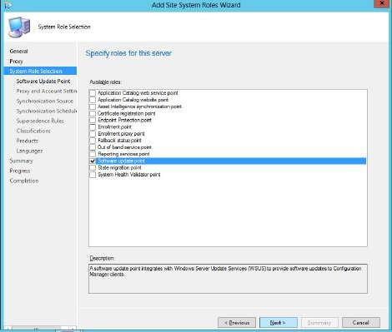 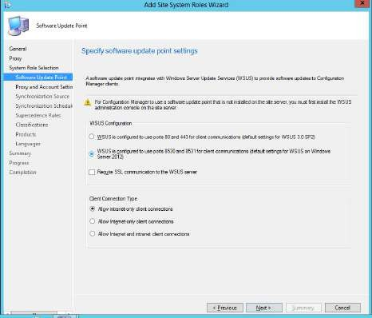

Click on **“Next”** in next two steps.

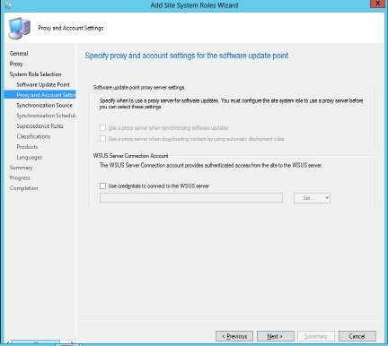 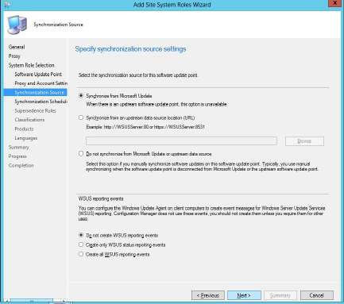

In the next step change the value of **Run every to 1 Days** click on **“Next”**

In the next step select “**Immediately expire a superseded software update”**, click on **“Next”**

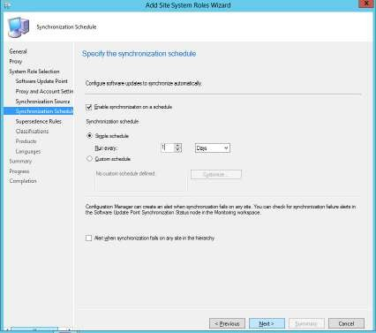 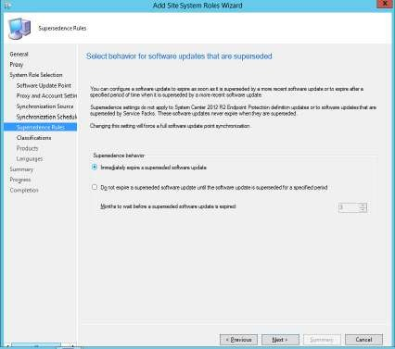

In the next step select classifications: **Critical Updates, Security Updates, Service Packs** and

**Update Rollups**. Click on **“Next”**

At the Products step many options are already selected. Deselect all the options. Select only

**Windows 7** and **Windows Server 2012**. Click on **“Next”**

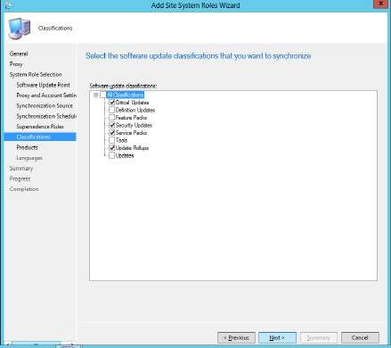 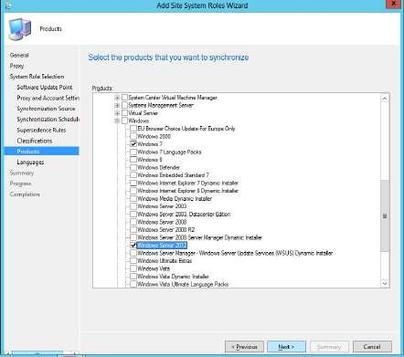

At the languages step select **English** and **deselect other** selected languages. Click on **“Next”**

At **Summary** step click on **“Next”**

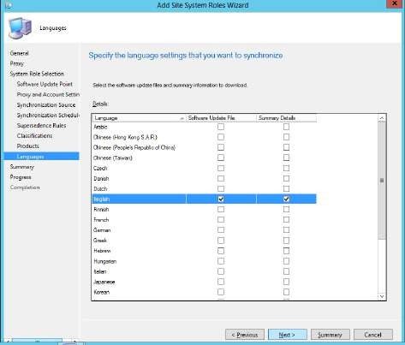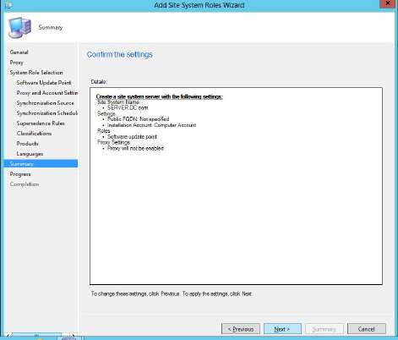

The Installation is in progress…

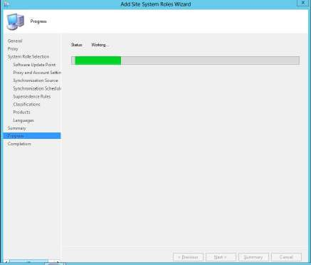

Installation is successfully completed.

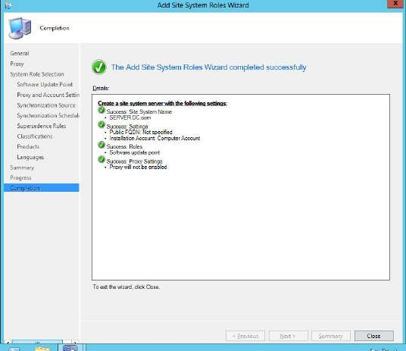

The Site is created.

